Africa: Kenya
Do Now
Primary industry is…… an example of this is…….
The development gap is…..
Two causes of the development gap in Kenya are……
One way countries can close the development gap is…….
an example of a river landform found on the middle course is…..
A secondary impact of an earthquake I studied was…..
Kenya’s main exports are……..
The climate in Kenya is……….
Kenya is located on……….
Please read the following information on Kenya and answer the questions after
Lesson 3: how can Kenya close the development gap?
- Tourism – worth 8.8% of GDP – although decreasing each year – safaris are most popular activity for tourists
- Industry – many TNCs located in Kenya bringing in employment e.g. Nestle, Coca Cola, Mitsubishi
- Chinese Foreign Direct Investment (FDI) - The Chinese have massively improved transport infrastructure by building new roads and railways.
Nairobi – Mombasa High Speed Rail: The Kenyan Government have asked the Chinese to
build a high speed railway line connecting the port city of Mombasa, the capital city Nairobi
and in the future, Uganda and the DR Congo. However, there have been many criticisms, as
the route currently cuts through Tsavo and Nairobi national parks.

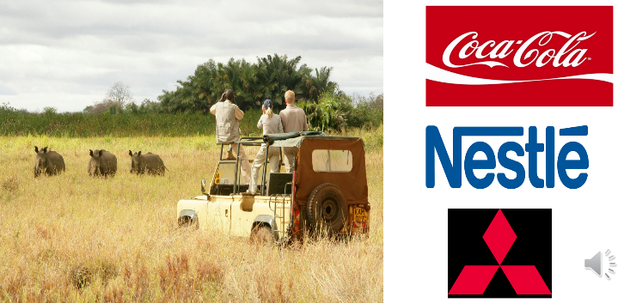
Kenya is the most developed country in East Africa – it is trying many strategies to close the development gap:
- Tourism – worth 8.8% of GDP – although decreasing each year – safaris are most popular activity for tourists
- Industry – many TNCs located in Kenya bringing in employment e.g. Nestle, Coca Cola, Mitsubishi

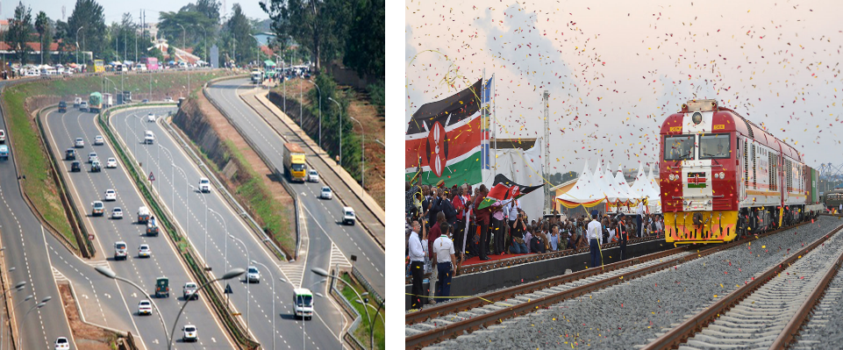
One of the biggest strategies is Chinese Foreign Direct Investment (FDI)
- (image 1) The Chinese have massively improved transport infrastructure by building new roads
- (image 2) and railways
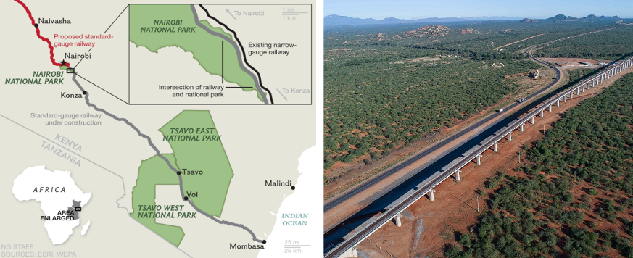
(image 1) The Kenyan Government have asked the Chinese to build a high speed railway line connecting the port city of Mombasa, the capital city Nairobi and in the future, (image 2) Uganda and the DR Congo.
However, there have been many criticisms, as the route currently cuts through Tsavo and Nairobi national parks.

Positives | Negatives
- Improves transport infrastructure  - Improved transport means Kenyans have access to more employment opportunities  - Improved transport encourages more tourism as tourists find it easier to travel around  - Improved trade links with Uganda and DR Congo  - Improved trade links between Mombasa and Nairobi means Kenya can export more goods  - It’s free! Chinese are footing the bill  - Has pillars so animals in national park can pass underneath | - Destroying endangered animal habitat  - Some animals have already moved away (10 rhinos relocated and died in transit)  - Negative impact on tourism as less animals can be seen in national park  - Chinese built = no employment in construction for local Kenyans  - Leakage – much of the profit from the railways goes to China

TASK: Categorise the statements into: Positive (P) / negative(N)
Then label each with either: Social (S), economic (E), and environmental (EN)
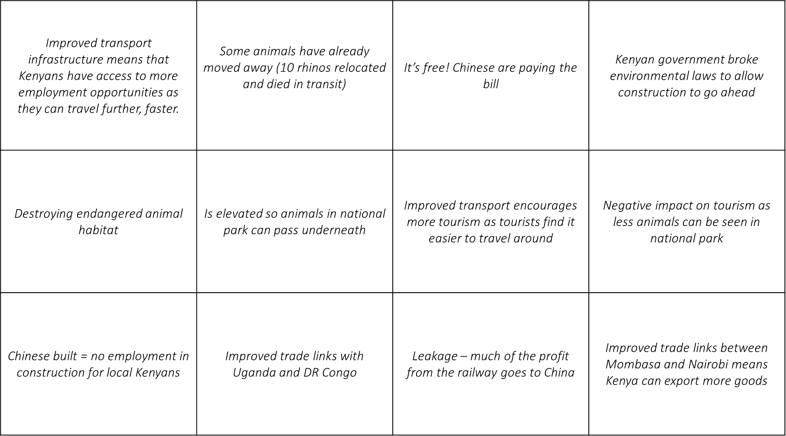

Task: use the writing framework below to answer the question in bold.
