Choose one quiz, either A or B and answer a range of exam questions that add up to 18 marks in total. For example 3x 6markers or 1x9marker + 1x 6 marker + 3marker.

QUIZ A:
- What is a Transnational Corporation?
- How many TNCs operate in Nigeria?
- Why do TNCs open up factories in Nigeria?
- Shell oil drills oil in the………
- Where is Shell Oil’s headquarters?
- State one way Shell has socially benefitted Nigeria.
- State one way Shell has economically benefitted Nigeria.
- State one way Shell had a negative social impact on Nigeria.
- State one way Shell had a negative impact the economy.
- State one way Shell had a negative impact on the environment
Figure 1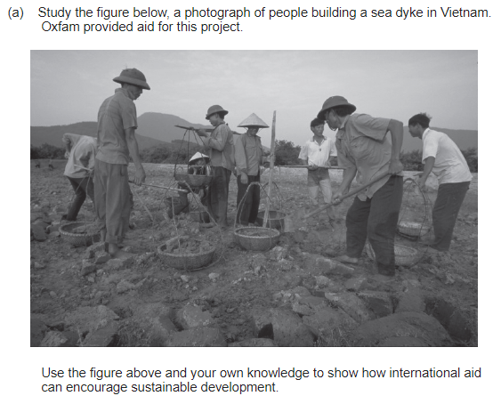
Figure 2
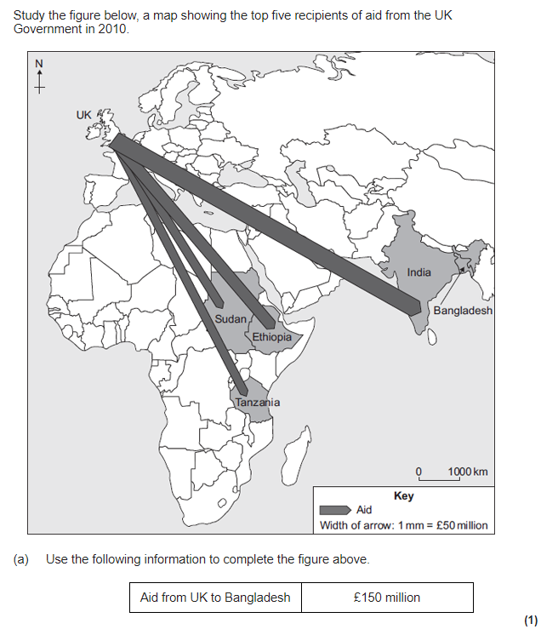

PRACTICE EXAM QUESTIONS
- Using a case study of a LIC or NEE country, explain the link between Transnational Corporations (TNCs) and industrial development in the country. (6 marks)
- Transnational corporations (TNCs) mainly bring advantages to the host country.
Do you agree with this statement: YES or NO?
Justify your decision. (9 marks)
- Intel is planning to build a new chip assembly and testing factory in China.
- China is a good place for a TNC to build a new factory. Suggest two reasons why. (2 marks)
- A new factory might benefit the area in which it is built. Describe some of the benefits. (4 marks)
- Outline how international aid can have social and economic impacts. Use an example of an LIC or NEE that you have studied. (6 marks)
- Study Figure 1, a photograph of people building a sea dyke in Vietnam. Oxfam provided aid for this project. Use the figure above and your own knowledge to show how international aid can encourage sustainable development. (6 marks)
- Study Figure 2, a map showing the top five recipients of aid from the UK Government in 2010. Use the following information to complete the figure: Aid from UK to Bangladesh: £150 million. (1 mark)
- Explain how rapid economic growth can impact on the environment. Use an example of an LIC or NEE that you have studied. (6 marks)
- Describe the effects of air pollution and water pollution in urban areas in poorer parts of the world. (4 marks)
- To what extent has economic development benefitted a LIC or NEE that you have studied. (9 marks)

