Choose one quiz, either A or B and answer a range of exam questions that add up to 18 marks in total. For example 3x 6markers or 1x9marker + 1x 6 marker + 3marker.
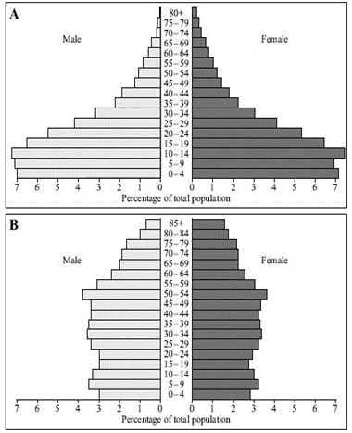
QUIZ A
- Development is…
- Development indicators are….
- List the four indicators that the UN uses in the Human Development Index (HDI)
- The development gap is….
- Explain one human cause of the development gap: education, trade, colonialism.
- Explain one physical cause of the development gap: landlocked, climate.
- Differential wealth is an effect of the gap. How this impact on quality of life in Africa and the USA?
- How does development affect migration?
- A population pyramid is…..
- Do LICs or HICs have a wide base? Why?
- Do LICs or HICs have wide bars at the top of the pyramid? Why?
- What happens to the width of the bars in an LIC population pyramid?

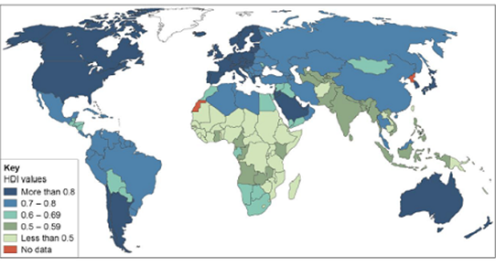
PRACTICE EXAM QUESTIONS
- Study Figure 1, a world map showing the global distribution of Human Development Index (HBI) values.
- Compare HDI values in Africa & South America. (2 marks)
- Outline one disadvantage of using a single measure of development. (3)
- Study Figure 2. Explain how one of the indicators of development in Figure 2 shows the differences in the quality of life between the three countries. (4)
- Study Figure 3, population pyramids of two countries.
- What % of the population are females, aged between 10 and 14 years of age in pyramid B? (1 mark)
- Compare the shapes of the two pyramids. (3 marks)
- Explain how these population pyramids suggest that these countries are in different stages of the Demographic Transition Model (6 marks)
- Outline one way Fairtrade deals with the issue of unequal development (4)
- Suggest one reason why Fairtrade schemes are not always successful. (2 marks)
- Using an example, assess the impact tourism has on poorer countries. (9 marks)
- Study the text box in Figure 4, an extract from a website about a microfinance programme in Africa. Use the extract and your own knowledge to explain how people in the poorer part of the world can attempt to improve their own quality of life. (4 marks)
- Suggest how the growth of tourism in a LIC or NEE might help to reduce the development gap. (4 marks)
- Study Figure 5 (previous page), a table showing the Gross National Income (GNI) data for selected countries in 2016. Calculate the mean, median and interquartile range value for the GNI data in Figure 5.
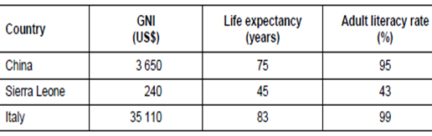
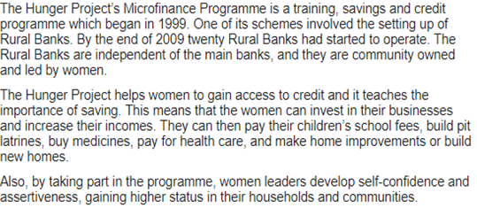

Knowledge organiser:
