Russia
Do now:
- Oil is a ……………………… and will eventually……………
- An example of a renewable energy source is …………
- A dam is ………
- HEP stands for ………………
- A resource is ……………
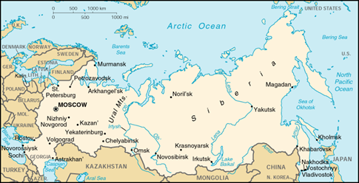
10 Key facts about Russia
Russia is the ………………………………………… country in the world.
Russia’s real name is …………………………………………………………………………………
Russia’s area is ……………………………………………..……
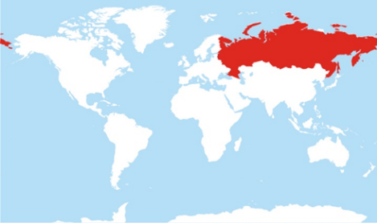
It has……………..……. Neighbouring countries including……………………
Russia also has ……………………..………….. time zones.
Russia is found on …………………………. Continents which are………………………. and ……………………………………………………………………

The mountains that separate Europe and Asia are the …………………………………………………………………………………………………………………
It has a coastline on …………….. Oceans which are………………..……………………. And the …………………………………………………………………………..………………………..

Russia is …………………………………………………….. Times bigger than the UK
The population of Russia is……………………………………………

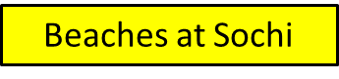
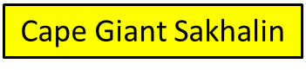
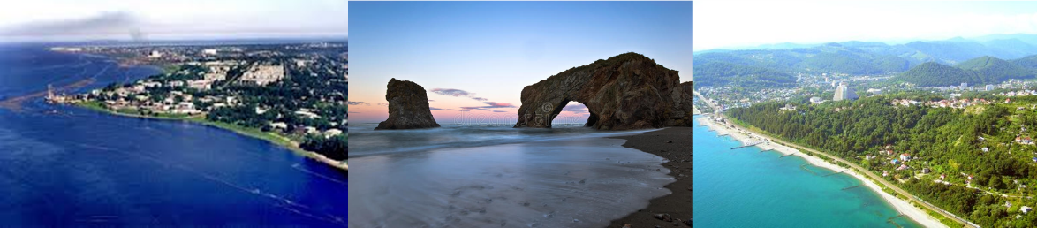

Russia has a very large coastline; this means it has many coastal features. Such as arches, stumps and stack. Also they will have headlands and bays. Read the information below on how these formations are created.

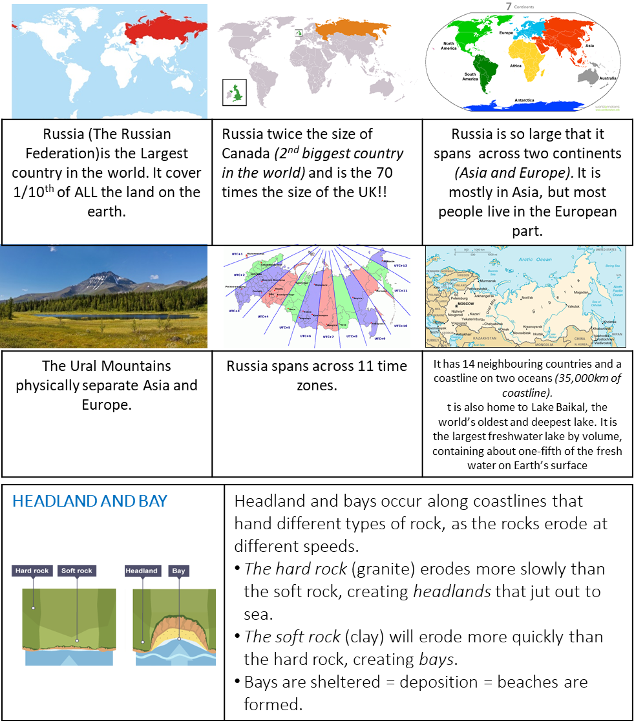

Exam question:
What is Russia like and what Natural Features are found there?

Russia is located in ……..
It has a coastline of ……………..km, therefore, has many coastal features

A headland and Bay are formed……
It is formed due to differential erosion. More specifically…..
As a result……..

Other key facts about Russia’s physical geography are…..

