Do now
- Physical water scarcity is ……
- The continent that faces most economic water scarcity is…
- Explain why double glazed window will help reduce greenhouse gas emissions.
- Suggest two other ways we can reduce greenhouse emissions in our homes?
- Within an ecosystem, a consumer is an organism that gets its energy from producers or other consumers. There are three types of consumer: c……., o……….and h…….
- There are……..layers of vegetation in the tropical rainforest.
- If the bars get smaller as you travel up the population pyramid it means…..
- If the bars are wide at the top of a population pyramid it means…..
- Beach nourishment only has a short lifespan because….
- Managed retreat can cause conflict because…..
Natural Resource | - A natural resource is something that occurs naturally that we can make use of.  - There is an abundance of natural resources in Russia.  - It produces 20% of the world’s natural gas and the worlds leading producer of oil  - Russia is self-sufficient in all major raw materials (e.g. Iron, Bauxite)
The problem | - Many resources are in Siberia, which has very harsh weather and extreme cold temperatures.  - It is very hard to work in these areas as steel become brittle at these low temperatures  - The roads are in poor condition due to the weather, this is not good when they are trying to export goods
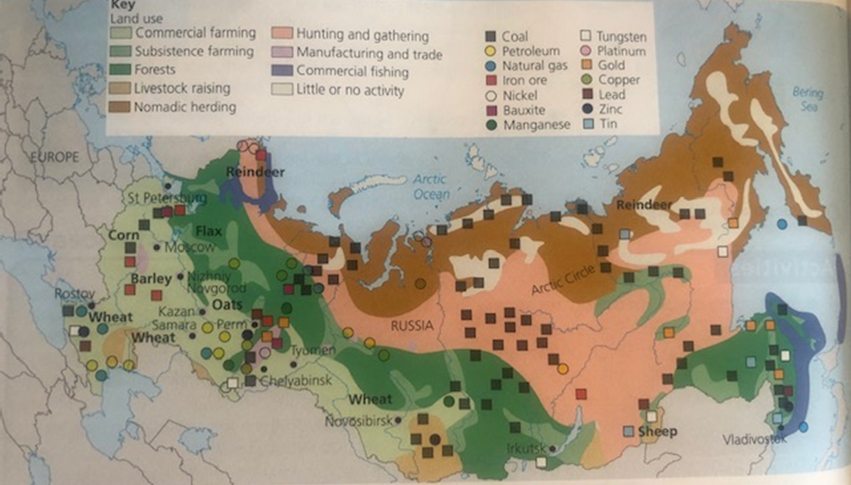
DISTRIBUTION OF RUSSIA’S NATURAL RESOURCES
Russia has an abundance of resources.
Russia has lots of coal, this is found……………………………………………………………………………………………
Natural gas is mainly found ……………………………………………………………………………………………………….
Iron ore is mainly found in …………………………………………………………….. More specifically near ……..
……………………………………………………………………………………………………………………………………………………….
Finally, petroleum is found…………………………………………………………………………………………………………
A problem for Russia is that many resources are in Siberia, this is a challenge because…………….
………………………………………………………………………………………………………………………………………………………. ……………………………………………………………………………………………………………………………………………………And this is due to …………………………………………………………………………………………………………………………..
As a result ……………………………………………………………………………………………………………………………………...

TASK: Look, cover, write check the knowledge organiser below and try to complete the table from memory.
