Exploring the Tana river
DO NOW
- The watershed is….
- One type of erosion in the upper course is……
- One landform found in the upper course is……
- One way people use rivers is…… more specifically…..
- Kenya suffers from extreme weather. For example…… more specifically…..
- Kenya is a ……….. More specifically………
- One way Kenya is trying to close the development gap is….
- One cause of drought in Kenya is….
- One primary impact of drought was…
- One secondary impact of the drought was…

Use the information sheets to complete the table below.
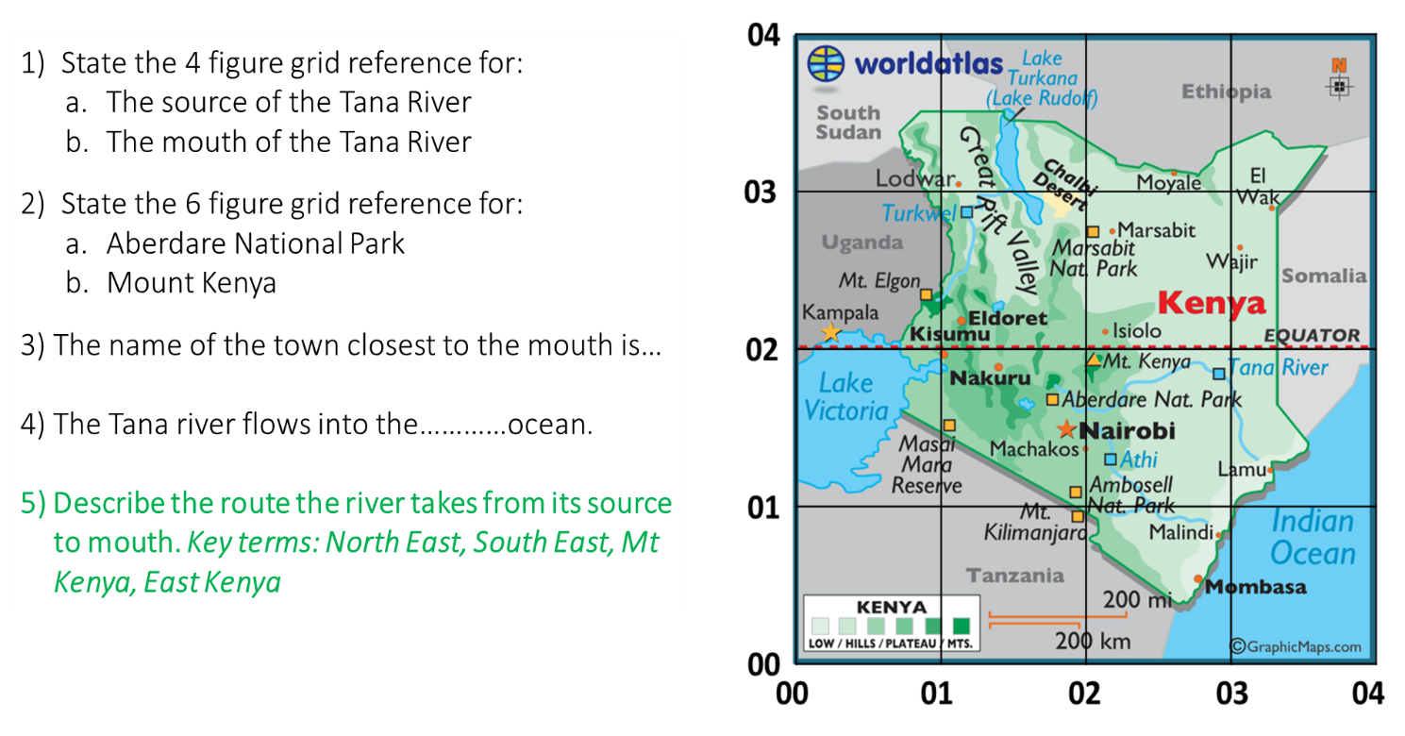

Use the information sheets to complete the table below.
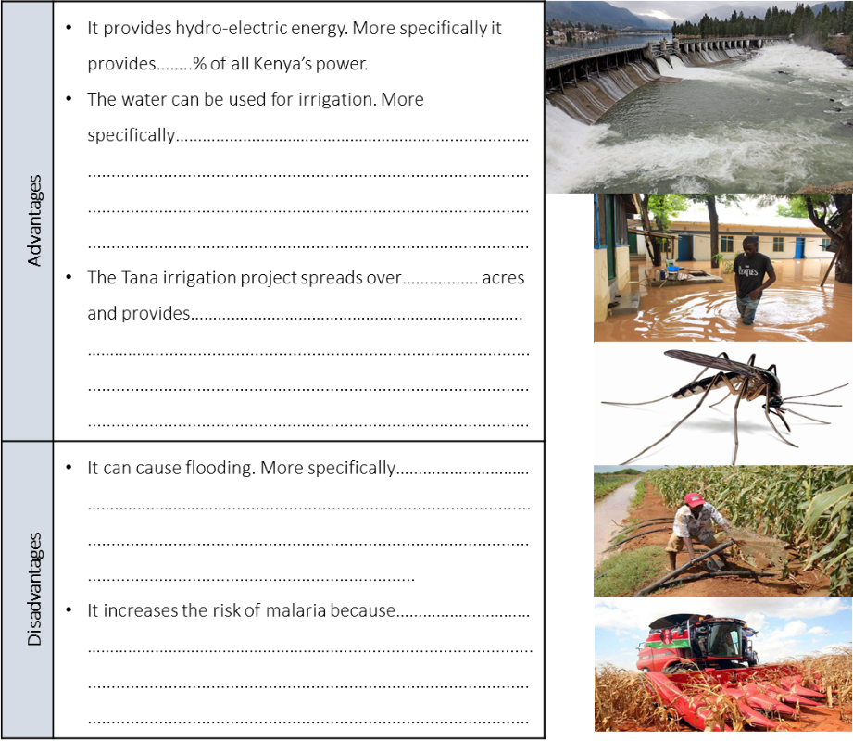
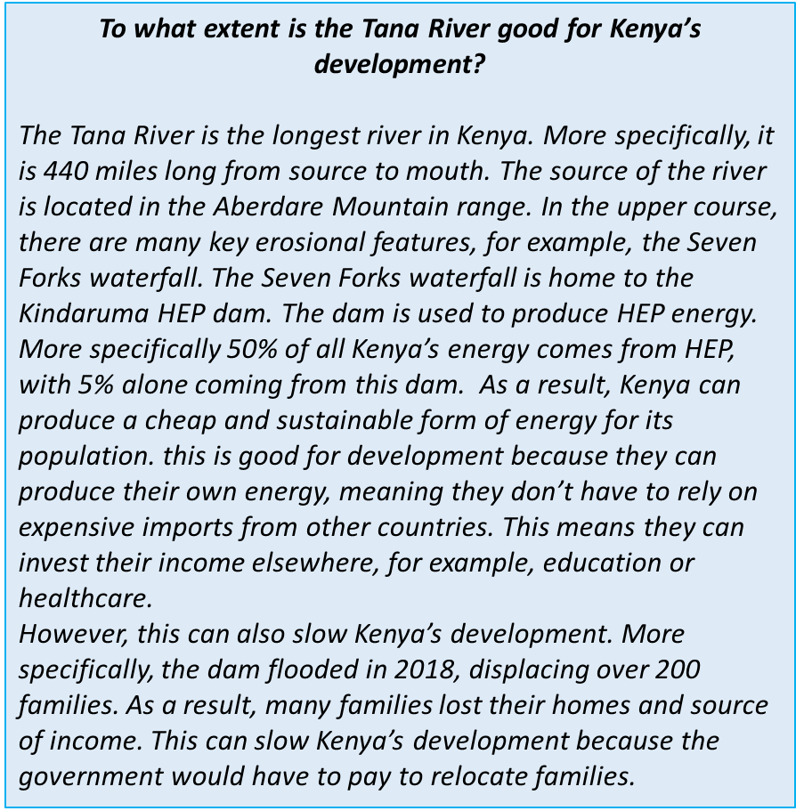
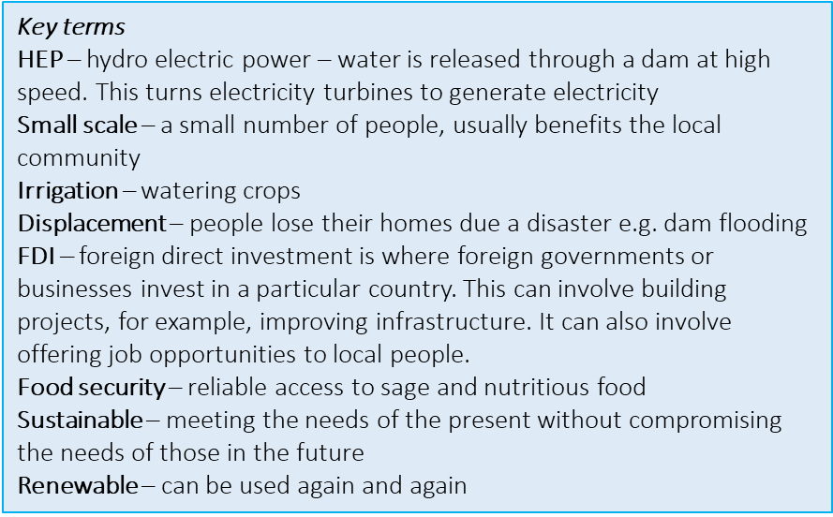

Use the writing frame to talk about the Kindaruma dam along the Tana River.
Discuss the impact of the Kindaruma dam along the Tana River.

The Tana River is the longest river in Kenya. More specifically…………
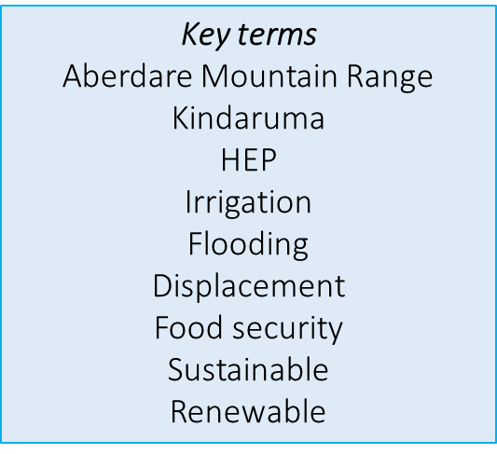
The source of the river is located……….
In the upper course, the……………dam has been created.
This has helped Kenya to develop.

Firstly…… More specifically…..
Furthermore…. More precisely…..

On the other hand, it has prevented development.
Firstly…. More specifically…..
Additionally…. More precisely…..

HINTS
Dam + sustainable, renewable source of energy – cheaper than most alternatives e.g. geothermal
Dam – flooding: loss of homes, income, cost to govt to rebuild destroyed villages and habitats/rehousing etc

Irrigation + small scale – helps move people out of poverty, gives locals food security
Irrigation – only small scale, so doesn’t really help Kenya in terms of exports, selling to foreign investors may result in local farmers losing their source of income

