Complete quiz A and answer a range of exam questions that add up to 18 marks in total. For example 3x 6markers or 1x9marker + 1x 6 marker + 3marker.

QUIZ A
- How much of the UKs food is imported?
- State one reason the UKs food is imported.
- Identify a negative impact of importing food?
- What is organic farming?
- State one advantage and one disadvantage of using organic farming.
- What is agribusiness?
- State one advantage and one disadvantage of using agribusiness.
- Why has water use in the UK increased?
- Why is there a water deficit in south-east England?
- Why is there a water surplus in central Scotland?
- What is a water transfer scheme?
- Identify how much of the UKs water is clean.
- State two causes of water pollution.
- State two impact of water pollution – one social and one environmental.
- State two ways water pollution is managed. Use specific examples.

PRACTICE EXAM QUESTIONS
- Suggest how inequalities in the consumption of resources influence well-being. (3 marks)
- Explain how inequalities in the supply of resources influence social well-being. (3 marks)
- Discuss how modern farming methods in the UK can impact on the people and the environment. (6 marks)
- To what extent is it preferable to source food locally in the UK rather than import from abroad? [6 marks]
- Study Figure 10, comments from a government report into water quality and pollution in the UK. Discuss the challenges of managing water quality and pollution in the UK. Use Figure 10 and your own understanding. (6 marks)
- Assess the effectiveness of water transfer schemes in meeting the UK’s changing demand for water. (6 marks)
- Study Figure 9, a graph showing the UK’s energy mix from 2006 to 2016. Using Figure 10 and your own understanding, discuss the issues arising from the UK’s changing energy mix. (6 marks)

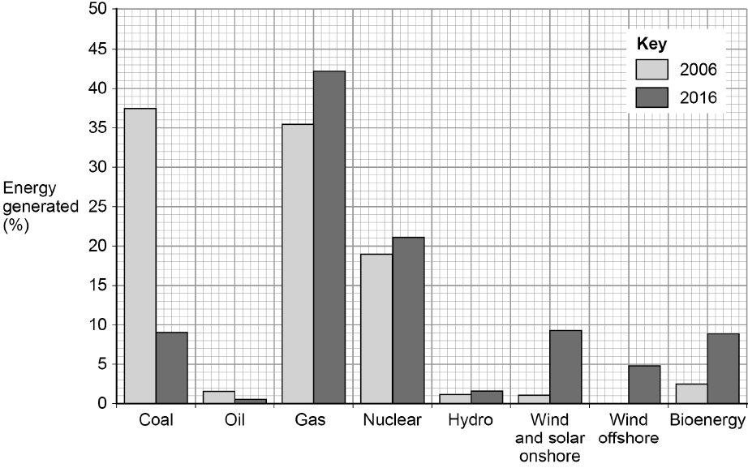
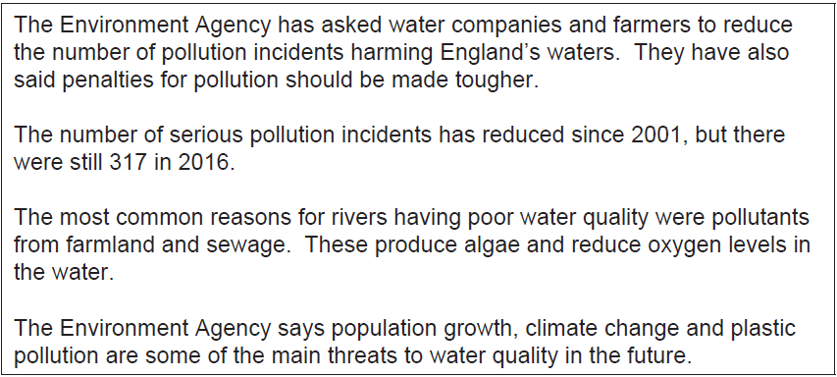
Figure 9 Figure 10

