Choose one quiz, either A or B and answer a range of exam questions that add up to 18 marks in total. For example 3x 6markers or 1x9marker + 1x 6 marker + 3marker.

QUIZ A
- Nigeria is an example of a NEE. Nigeria is located….
- Nigeria’s population is…..
- Nigeria is considered important due to its growing economy. More specifically…..
- Nigeria is considered important due to its oil production. More specifically…..
- Nigeria is considered important due to its international links. More specifically……
- What are Nigeria’s main exports?
Figure 1
Figure 2
- Who does Nigeria trade with?
- Nigeria has a multi-ethnic and multi-faith population. This means….
- Nigeria’s multi-ethnic and multi-faith population often results in conflict. For example…..
- A stable government was establish in…...
- Nigeria is going through industrialisation. More specifically….
- In 1999 people were mainly employed in…
Today, more people are employed in……and…….industries.

PRACTICE EXAM QUESTIONS
- Describe the importance of a LIC/NEE that you have studied. (3)
- Using a named example, describe how development in trade links has helped them develop. (4 marks)
- Many call centres have moved from the UK to India.
- What sector of the economy includes call centres: primary, secondary or tertiary?
- Study Figure 1, statements about why call centres have developed in India. For each statement, identify whether the reason is social, economic or political. (3 marks)
- Explain how developments in ICT and transportation have encouraged globalisation. (4 marks)
- Study Figure 2, a graph that shows how the share of world manufacturing production has changed between 1970 and 2010.
- What percentage of the world’s manufacturing production did the rich world produce in 1970? (1 mark)
- What was the increase in East Asia’s share of world manufacturing production between 1970 and 2010? (1 mark)
- Describe and explain the changes that have happened between 1970 and 2010. (6 marks)
- Using a case study of a LIC/NEE country, explain how manufacturing industry can encourage economic development. (6 marks)
- Describe the benefits of industrial growth in an economically developing area you have studied. Use an example(s) that you have studied. (6 marks)
- Using a case study of a LIC or NEE, describe and explain how their economy has changed. (6 marks)

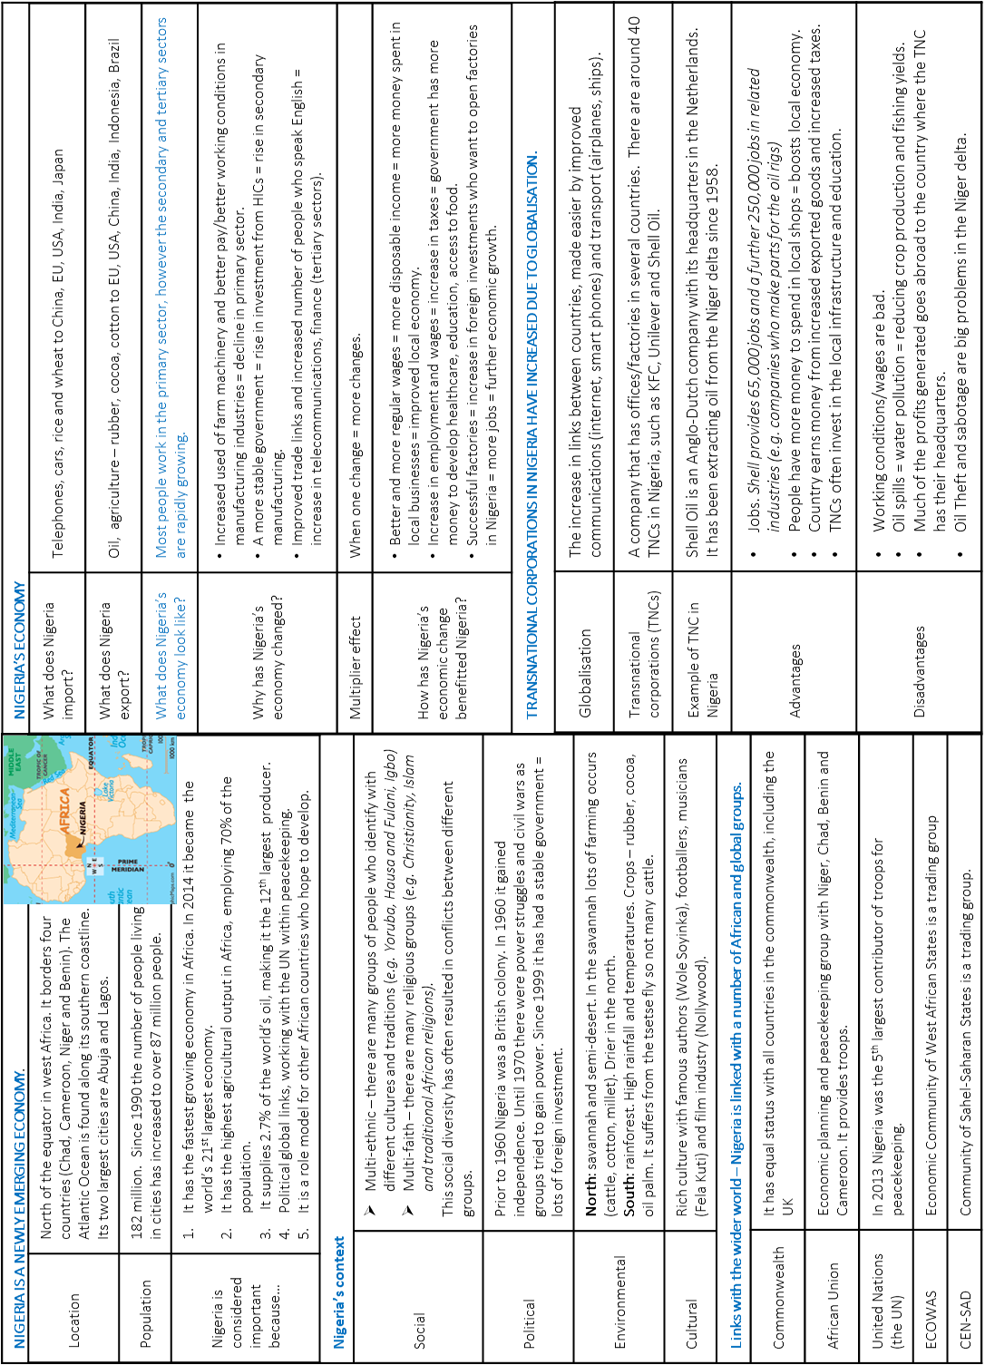
Knowledge organiser.

