Term 5: Rivers Lesson 2
Do Now:
- When rain sleet or hail falls from the sky it is called…
- What is the correct term for where two rivers meet?
- When water from the sea is heated up by the sun, it is called…
- What is the correct term for the end of a river where it meets the sea or ocean?
- What is a drainage basin?
Task: Complete the sentences:
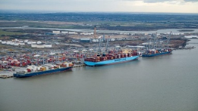
The information sheet is below.
TRANSPORTING GOODS
Goods are transported along Rivers in cargo ships. They dock at ports.
For example,…

PRODUCING ELECTRICITY
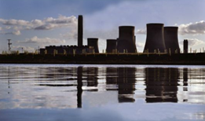
S.…………………..drives turbines in power stations to create energy. Also water from rivers is used to………………..the tanks of steam An example of a power station that uses water from the River Thames is in………………………………..………

IN FACTORIES
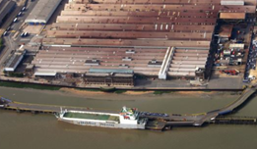
Factories use river water for……………………………………………… An example of a factory that uses water from the River Thames is……………………

AGRICULTURE (FARMING)
Water from the River Thames can be used to irrigate crops. In other words ……..
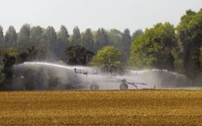

Extension: The Thames is more socially / economically important because…….
Complete the sentences:
- The River Thames is located…
- A social / economic use of the River Thames is….
- More specifically
Exam question:
Explain how we use the River Thames for social and economic activities. (4 marks)
Writing frame
- The River Thames is located…...
- Socially….. + More specifically…..
- Furthermore…. + More precisely….
- Economically…. + More specifically…..
- Additionally…. + More precisely…..
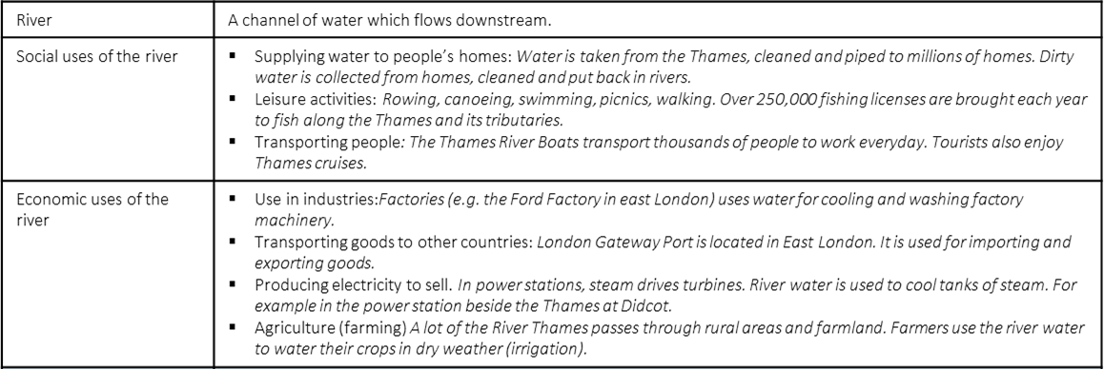

Lesson 2 Knowledge organiser.

