1. 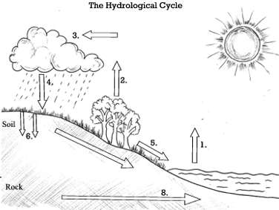Annotate the diagram of the water cycle.

………………………………………………………………………………………………………………………………………………………………………… …………………………………………………………………………………………………………………………………………………………………………

…………………………………………………………………………………………………………………………………………………………………………

…………………………………………………………………………………………………………………………………………………………………………

…………………………………………………………………………………………………………………………………………………………………………

…………………………………………………………………………………………………………………………………………………………………………

…………………………………………………………………………………………………………………………………………………………………………

…………………………………………………………………………………………………………………………………………………………………………

…………………………………………………………………………………………………………………………………………………………………………

1. Explain how the water cycle works.
2. Explain how deforestation would impact on the water cycle.

………………………………………………………………………………………………………………………………………………………………………… …………………………………………………………………………………………………………………………………………………………………………

…………………………………………………………………………………………………………………………………………………………………………

…………………………………………………………………………………………………………………………………………………………………………

…………………………………………………………………………………………………………………………………………………………………………

1. If it was a hot, sunny day, how would the water cycle be affected?

………………………………………………………………………………………………………………………………………………………………………… …………………………………………………………………………………………………………………………………………………………………………

…………………………………………………………………………………………………………………………………………………………………………

…………………………………………………………………………………………………………………………………………………………………………

…………………………………………………………………………………………………………………………………………………………………………

1. How would the water cycle be affected if it rained really heavily?

………………………………………………………………………………………………………………………………………………………………………… …………………………………………………………………………………………………………………………………………………………………………

…………………………………………………………………………………………………………………………………………………………………………

…………………………………………………………………………………………………………………………………………………………………………

…………………………………………………………………………………………………………………………………………………………………………

1. **Knowledge Quiz:**
2. When rain sleet or hail falls from the sky it is called…
3. What is the correct term for where two rivers meet?
4. When water from the sea is heated up by the sun, it is called…
5. What is the correct term for the end of a river where it meets the sea or ocean?
6. When water moves over the ground it is called…
7. When water moves under the ground it is called…
8. What is a drainage basin?
9. What is the correct term for a small river or stream which meets up with a larger river?
10. When water is evaporated from plants it is called…
11. What is the start of a river called?
12. Where does the Thames River start?
13. What sea does the Thames River flow into?

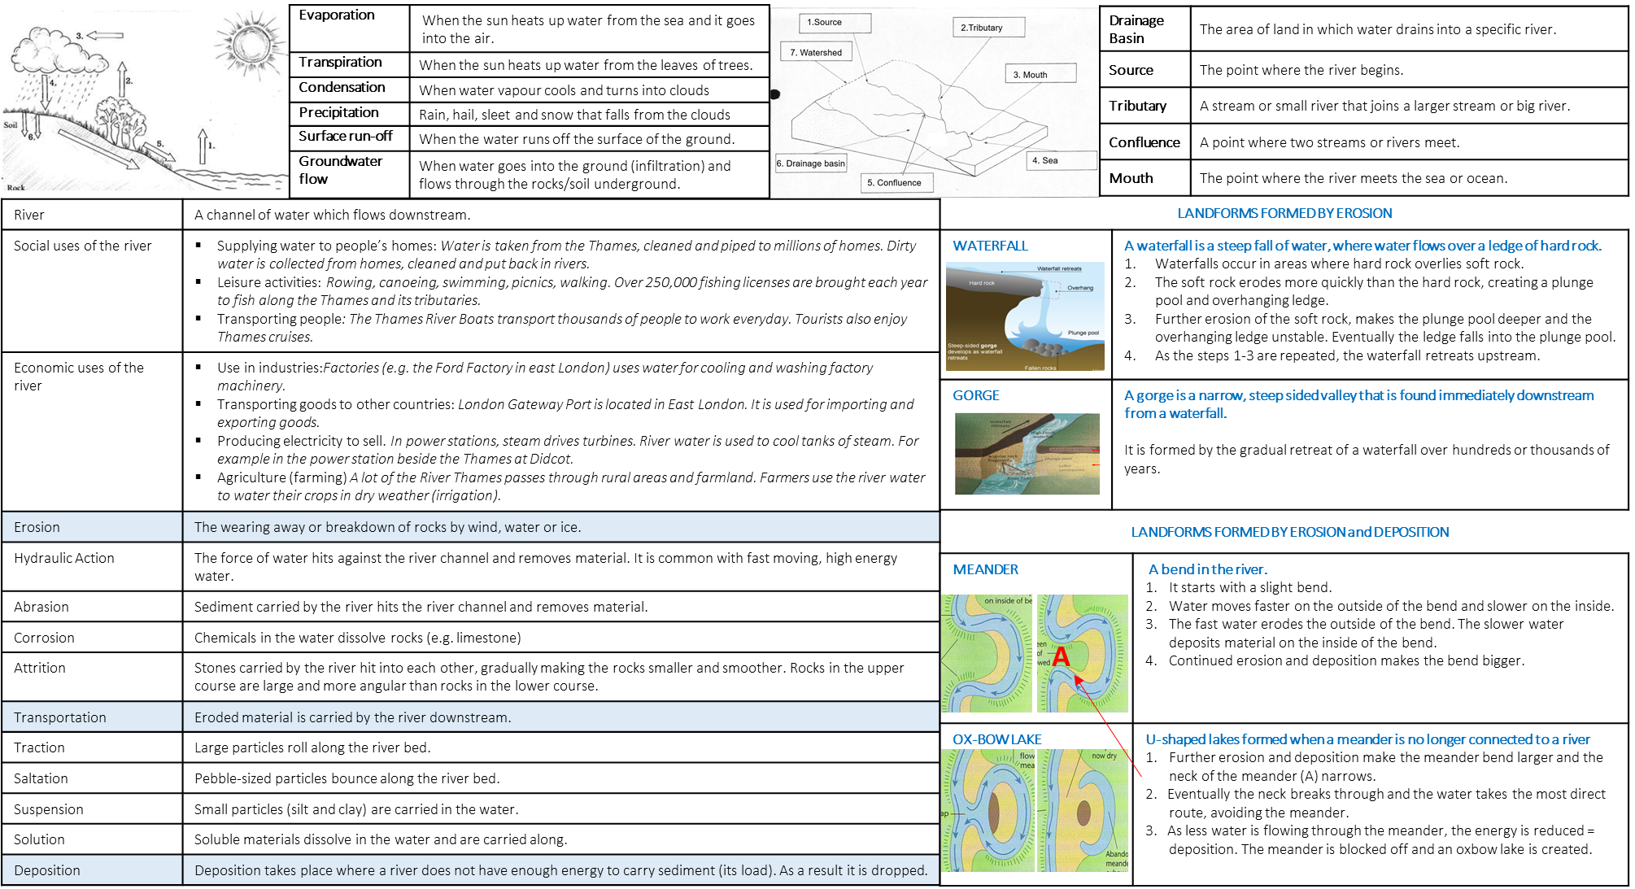**Knowledge organiser. Rivers page 1.**