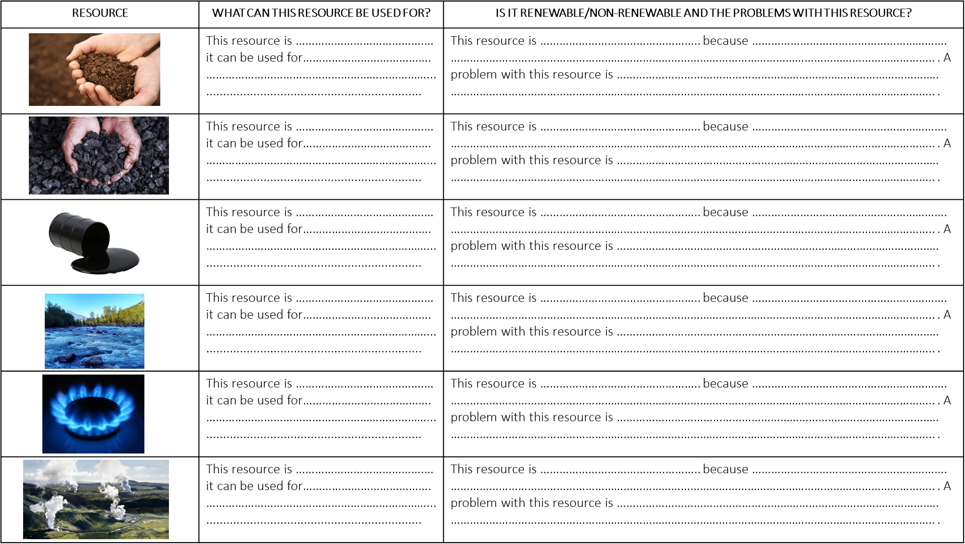
- Using the resource on the next page, complete the table

Resource 1.

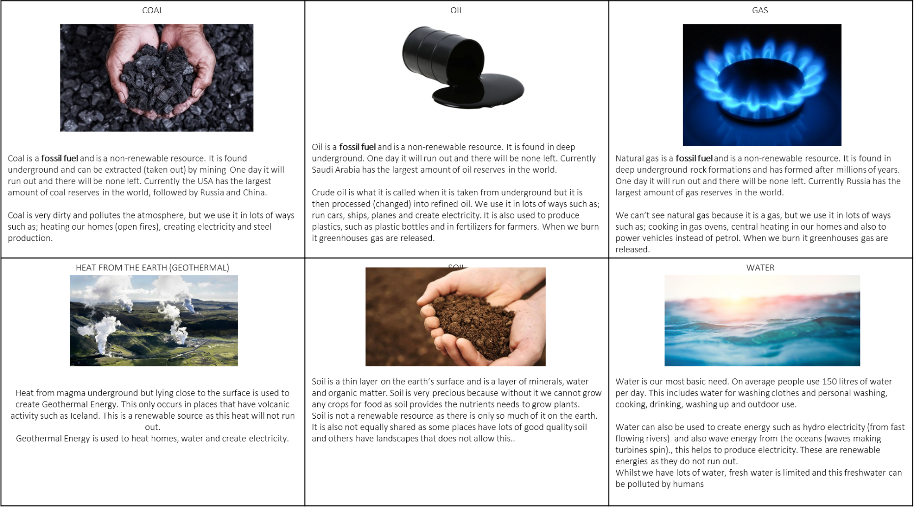

- What are Natural Resources and why are they important?

Writing frame:
A NATURAL RESOURCE is something that occurs naturally and which we can make use of. Resources can be categorized into renewable and non-renewable.

A renewable resource is…. + More specifically…..
A way we can use this resource is……..
As a result……

A non-renewable resource is…. + More specifically…..
A way we can use this resource is……..
As a result……
………………………………………………………………………………………………………………………………………………………………………… …………………………………………………………………………………………………………………………………………………………………………
…………………………………………………………………………………………………………………………………………………………………………
…………………………………………………………………………………………………………………………………………………………………………
…………………………………………………………………………………………………………………………………………………………………………
…………………………………………………………………………………………………………………………………………………………………………
…………………………………………………………………………………………………………………………………………………………………………
…………………………………………………………………………………………………………………………………………………………………………
…………………………………………………………………………………………………………………………………………………………………………
………………………………………………………………………………………………………………………………………………………………………… …………………………………………………………………………………………………………………………………………………………………………
…………………………………………………………………………………………………………………………………………………………………………
…………………………………………………………………………………………………………………………………………………………………………
…………………………………………………………………………………………………………………………………………………………………………
…………………………………………………………………………………………………………………………………………………………………………
…………………………………………………………………………………………………………………………………………………………………………
…………………………………………………………………………………………………………………………………………………………………………
…………………………………………………………………………………………………………………………………………………………………………

