Choose one quiz, either A or B and answer a range of exam questions that add up to 18 marks in total. For example 3x 6markers or 1x9marker + 1x 6 marker + 3marker.

QUIZ A
Figure 1
Figure 2
Figure 4
Figure 6
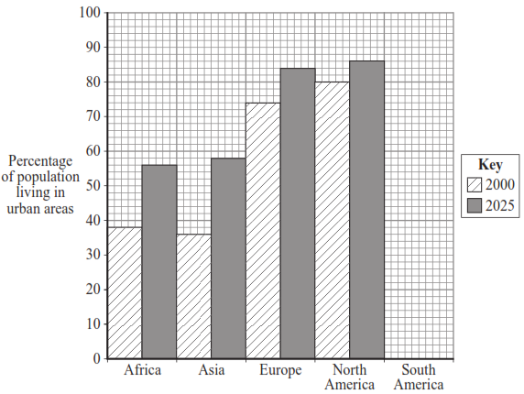
- Urban means…
- Rural means…..
- Urbanisation is…..
- In 2015……..% of the world’s population lived in urban areas.
- In 2050 it is predicted that……..% will live in urban areas.
- Urban growth is….
- Two causes of urban growth are…..
- A megacity has a population of….
- Natural increase occurs when there is a………..birth rate and…………death rate = population………
- Natural increase is common in NEE/LICs. True or false?
- Rural to urban migration is the movement of people from……to……
- State two push factors that result in urbanisation.
- State two pull factors that result in urbanisation.

QUIZ B
- Urbanisation is more common in LICs / HICs.
- Urbanisation is caused due to industrialisation which pulls people to cities. Industrialisation is…….
- The UK went through industrialisation in……………..
- LICs and NEEs are currently going through industrialisation. As a result…..
- Urbanisation is also happening due to natural increase. Natural increase when the birth rate is………..than the death rate. This occurs in stages……………….of the DTM.
- Are LICs or HICs currently experiencing natural increase?
- How does this affect their population?
- The UK is currently in stage………..of the DTM. Therefore there is a……….birth rate and…………death rate
- How does this affect their population?
- The 2 case studies we learn about in this unit are……

PRACTICE EXAM QUESTIONS
- Study Figure 1, a map showing the percentage of the population living in urban settlements in different parts of the world.
- Describe two differences in the percentages of population living in urban settlements in South America and Africa. (2)
- Suggest two reasons for the slow rate of urban growth in many higher income countries. (2 marks)
- Study Figure 2, a graph showing changes in the world’s rural and urban population from 1950 to 2050 (predicted). Describe how urban populations have changed. (4 marks)
- Study Figure 4, a table showing estimated population change in a number of cities.
- Which city is predicted to have the largest increase in population between 2000 and 2015? (1 mark)
- Use the figure to compare the estimated population changes of cities in more developed countries and less developed countries. (4 marks)
- Give two reasons why people in LICs are attracted to urban areas. (2 marks)
- Study Figure 6, a graph showing information about the percentage of the population living in urban areas.
- Compare the estimated rate of change in Asia with that in North America. (2 marks)
- Suggest one reason for the estimated rate of change in North America (2 marks)
- In which continent is the percentage of population living in urban areas estimated to increase the most between 2000 – 2025? (1 mark)
- Suggest one reason why the percentage increase in urban population in Asia is high. (1 mark)

Knowledge organiser page 17

