Do now:
- A development indicator is …..
- HDI stands for …
- The term rural refers to …..
- A megacity has …………. Million people plus living there.
- Rural to urban migration is …..
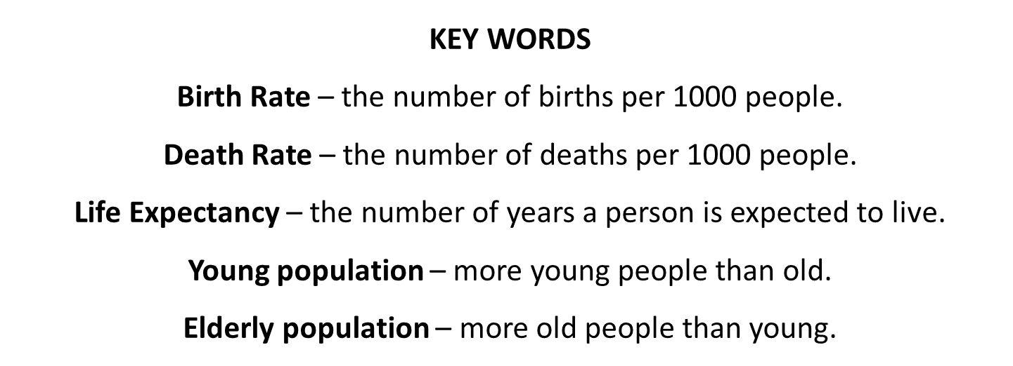
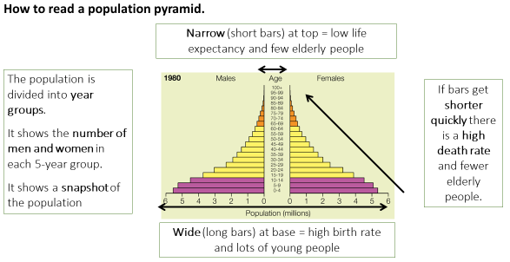

Figure 2
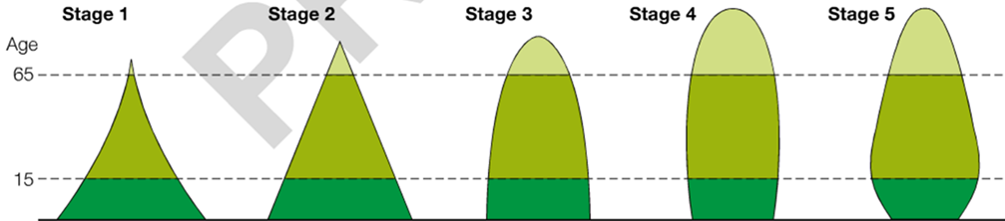

Task 2: Complete the follow table.
POPULATION PYRAMID | BIRTH RATE  Evidence? | DEATH RATE  Evidence? | INFANT MOTALITY RATE  Evidence? | LIFE EXPECTANCY  Evidence?
A | ………………birth rate  I know this because there are……………… …………………………….. at the bottom of the pyramid.  The bottom bar shows..........million alive between ………………................ years old. | ……………death rate  I know this because …………….…………….... ……………………………. ……………………………. ……………………………. …………………………….  For example…………. ……………………………. ……………………………. ……………………………. | ………infant morality  I know this because the bottom bar is ………………………than the second bottom bar.  More specifically…… ……………………………… ……………………………… ……………………………… ……………………………… | ………..life expectancy  I know this because …………….…………….... ……………………………. ……………………………. ……………………………. …………………………….  For example…………. ……………………………. ……………………………. …………………………….
D | ………………birth rate  I know this because …………….…………….... ……………………………. ……………………………. ……………………………. …………………………….  For example…………. ……………………………. ……………………………. ……………………………. | ……………death rate  I know this because …………….…………….... ……………………………. ……………………………. ……………………………. …………………………….  For example…………. ……………………………. ……………………………. ……………………………. | ……...infant mortality  I know this because …………….…………….... ……………………………. ……………………………. ……………………………. …………………………….  For example…………. ……………………………. ……………………………. ……………………………. | .........life expectancy  I know this because …………….…………….... ……………………………. ……………………………. ……………………………. …………………………….  For example…………. ……………………………. ……………………………. …………………………….

Task 3: Countries at different stages of development/of the DTM have different shaped population pyramids. Using figure 2, answer the following questions.
How can you tell:
- In stage 1 there is a lack of health care?
- In stage 1 they need workers on the farms?
- In stage 2 health care improve?
- In stage 3 education of family planning is more widespread?
- In stage 4 there is good access to food, healthcare and clean water?
- In stage 5 women have children later in life?

