Appearance and Personal Hygiene

Do now –
Identify the names of two professional organisations that help to regulate the hair and beauty industry.
[2 marks]

I do –
Hair and beauty professionals must ensure they present themselves in a professional manner to make a good first impression to clients. If clients are impressed with the appearance of an industry professional they have an expectation that the service will be of a professional standard as well. Look at the two images below- what image do you think looks more professional and why?
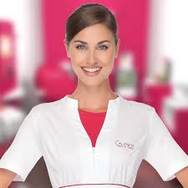

We do-
Task- Can you describe how a hair &beauty professional should present themselves using the sentences on the below?
Uniform- An appropriate uniform made of material that is easy to keep clean, wash well and durable enough to offer adequate protection. Traditionally beauty and spa professionals have worn white but all colours are work now.
Appropriate footwear - Think about full coverage (ie no sliders) and heel height.
Hair- Think about it being clean, tied up.
Hand and nails- Think clean, washed, why extensions are not a good idea.
Make-up- Think about make-up, professionally applied.
You do- Exam question
Describe the importance of personal hygiene in the hair and beauty sector using examples. ( 6 marks)

Examples to use-
Personal hygiene
- A daily shower or bath is recommended. The use of good quality deodorants and antiperspirants, to ensure no poor odours.
- Good oral hygiene, regular brushing and use of mouth wash. Avoidance of eating strong smelling foods and smoking.
- Wash hair regularly.
- Light perfume or body sprays; avoid overpowering aromas.

