Year 10: Elizabeth
Do now: Copy and complete these sentences
The leader of The Soviet Union during World War 2 was…
One consequence of the Fall of the Berlin wall was…

The SS were led by…
There was a golden age of Weimar Republic, this was when…

The punishment for treason during the Early Modern Period was…
A modern crime is…

Read the following information:
When Elizabeth became queen in 1558, there had not been a single theatre in England since Roman times.
However, by the 1570s theatres were being opened in London.
Travelling actors attracted large audiences performing plays in market squares and inns around the country.
Elizabeth enjoyed watching plays performed at court. In 1583 she even paid to set up her own company of actors – ‘The Queen’s Men’.
Elizabeth also enjoyed music and dancing. Her court was entertained by around thirty musicians.
Elizabeth would not go to the theatre, but she invited actors to Court to perform their plays.

The Renaissance that had started in Europe as early as the 14th century had led to a new flourishing of arts and culture all over Europe. England began to see a growth of the arts in Tudor times, and Elizabeth encouraged this through her patronage of the theatre, music and art. Before Elizabeth’s reign, drama mainly focused on religious plays that were performed in public, and Greek and Roman dramas performed in Oxford and Cambridge universities. During the 1570s permanent groups of actors were set up under the patronage of wealthy nobles and there was even a group called Queen Elizabeth’s Men set up in 1583.

Shakespeare began writing his plays during Elizabeth’s reign, and a number of them had themes connected to English history. His plays always supported the monarch and the Tudor dynasty, such as his drama about Richard III who had been defeated by Elizabeth’s grandfather Henry VII and was shown as an evil deformed murderer in the play.

Purpose-built theatres were encouraged and had tiered seating with prices accessible for people from all ranks of society. Many nobles protected groups of actors and became their patrons.

The queen went on tours of the country every summer, when she would stay at the homes of her wealthy nobles. These ‘royal progresses’ encouraged these nobles to build grand stately homes and organise lavish entertainments for the queen.

Opposition to the theatre

Not everyone approved of theatres. There was some opposition from:
The Puritans - they believed theatres were the work of the devil, spreading rude and lewd ideas encouraging poor moral behaviour. They also associated the theatre with the Romans, who had persecuted Christians.
The authorities - an extract from a law passed in 1572 stated that: “All common players…who wander about and have not a license shall be taken, adjudged and deemed rogues, vagabonds and sturdy beggars.”

Pastimes

By Elizabeth’s time the upper classes saw their culture as superior. Huge inequalities existed within Tudor society and whilst the theatre was universally popular there were two cultures:
Higher society - the invention of the printing press and spread of education meant that gentlemen were part of an elitist culture involved in intellectual pursuits, such as reading the classics, studying music, hunting and hawking.
Lower society - the vast majority were involved in popular cultural pursuits, which gave them a brief escape from their harsh living conditions. Inns and taverns were an important part of every social ritual. Drinking, gambling on bear-baiting, cockfighting, cards, dice and racing were popular. Tobacco smoking was new and expensive but it was growing in popularity by the end of Elizabeth’s reign. Ordinary people also took part in wrestling, running races and football.

Now copy and complete the following sentences:
There had not been theatres in England since…
Theatre was attended by…
Famous playwrights of the time included…
Some of the most famous theatres of the time were…
‘Groundlings’ were…
Elizabeth would watch plays by…
People opposed the theatre because . . .
:
Read the following sources
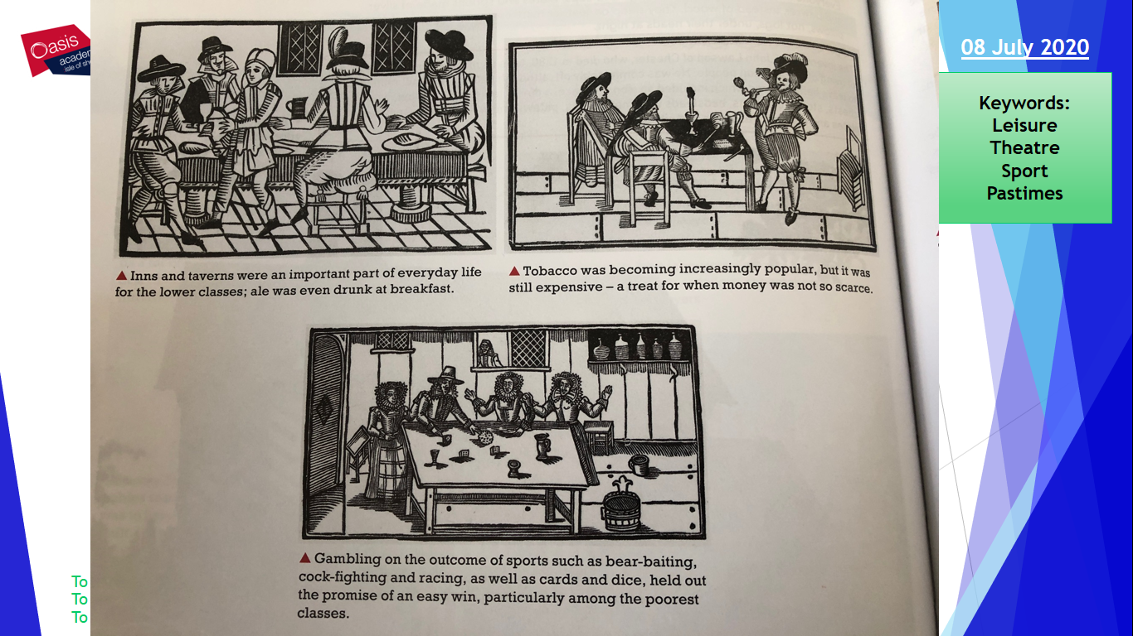
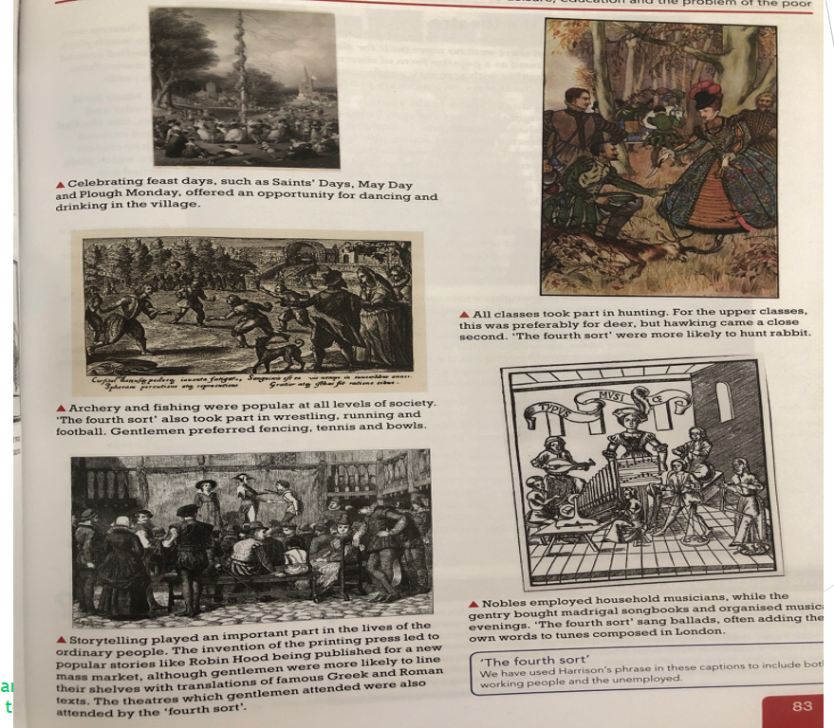

Describe two features of Elizabethan theatre.

One feature was… This was…
Another feature was… This was…

Describe two features of Elizabethan sport

Lesson 2: Poverty.
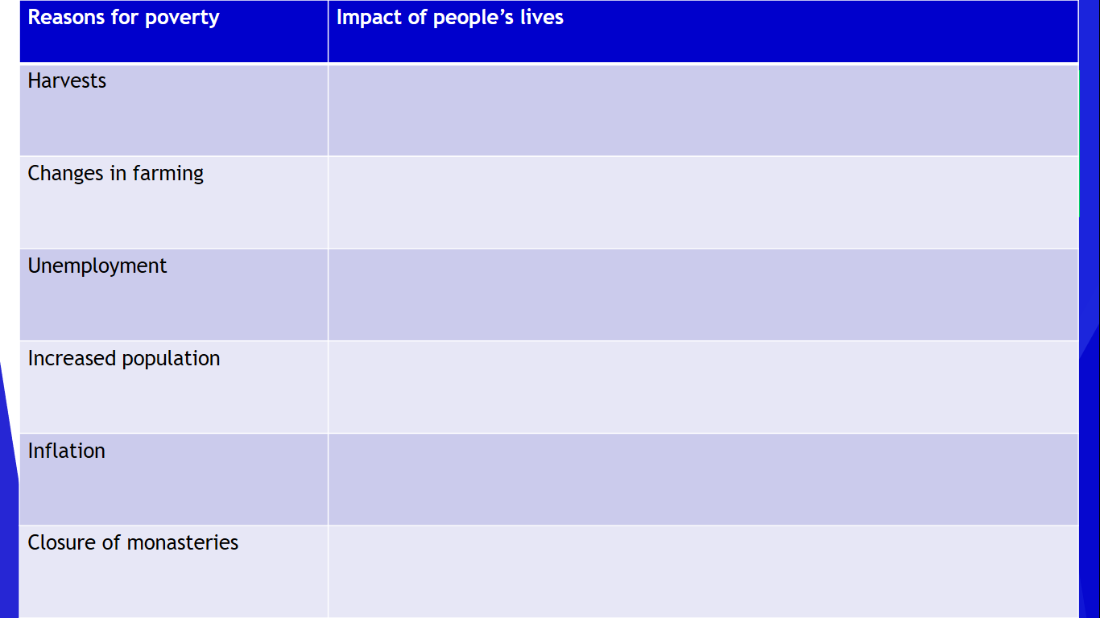
Use the following information to compete the table above.
Harvests:
Farmers were at the mercy of the weather.
Just before Elizabeth became Queen England had the worst harvest of the century.
During Elizabeth’s reign there were two bad sequences of harvests in the early 1570s and the mid 1590s.
Harvests would cause food shortages and meant that the price of bread and other foods went up.
The poor struggled the most because they could not afford the higher priced bread.
Changes to farming:
Many farmers began to look for more profitable ways to earn their living, by using different methods of agriculture.
Farmers started to enclose their land with hedges so that they could keep sheep rather than grow crops. This saved farmers money as they did not need to employ as many people.
As a result labourers lost their jobs and homes, and many moved to towns to try and find work.
Some landlords increased the cost of rent – this was called rack-renting. Many could not afford to pay these higher rents.
Unemployment:
The most important trade was the cloth trade – the English would sell woollen cloth to Europe.
Many people had been employed as spinners and weavers.
However the cloth trade collapsed in the 1550s and led to thousands of people losing their jobs.
Increased population:
The country’s population had fallen by nearly half at the time of the Black Death.
The population remained low until the 16 Century when it began to increase.
The rise in population became steeper during Elizabeth’s reign. This meant that more people required work.
However there were fewer jobs in farming and the cloth industry. This led to more people not being able to find work and could not earn money.
Inflation:
Prices were rising across Europe. Between the 1550s and 1570 wages had began to rise rapidly, however after that wages rose more slowly.
After 1570 the price of food rose much more rapidly than wages. People on lower wages struggled most to buy food.
Most historians believe that it was caused by an increased demand for food, most likely due to the increased population.
During the reign of Henry VIII, the coinage had been debased, reducing it’s value. People started to mistrust the value of money as it no longer had valuable metals in it.
Closure of the monasteries:
Until the 1530s, the monasteries provided food and shelter for the homeless and unemployed.
However after Henry closed the monasteries in the 1530s, there was less help for the poor, and this led to many wandering the streets in search for work.

Now copy and complete the following sentences:
Bad harvests were caused by…
Enclosures were…
Unemployment increased because…
During the Elizabethan period, the population…
Inflation was a problem because…
The closure of the monasteries led to…

Explain why there was poverty during the Elizabethan period.
You may wish to include:
Increasing population
Poor harvests

One reason was…
For example…
More specifically…
Therefore…

