Why was Mary Queen of Scots a threat to Elizabeth 1558-68?
1. Put these events in chronological order. 1-6
Mary married Lord Darnley in 1565 who was a member of the Tudor family. This strengthened Mary’s claim to the English throne |  | When the King of France died and she returned to Scotland. She was Catholic but Scotland had become Protestant with Elizabeth's help
Mary married the future King Francis of France in 1549 |  | Darnley was an abusive and jealous husband. He murdered Mary’s secretary in front of her, stabbing him 50 times.
Scottish nobles wanted to arrest Mary. In 1568 Mary fled to England and threw herself on the mercy of her cousin, Elizabeth I |  | Darnley’s house was blown up with gunpowder as he slept. Many suspected Mary was behind the murder.
2. Mary’s religion made her a threat to Elizabeth because......

- Mary’s marriage to Lord Darnley made her more of a threat to Elizabeth because…

- The death of Lord Darnley would have made Elizabeth suspicious/wary of Mary because…

- Whilst Elizabeth remained childless, Mary was a threat because…

6. Mary I, (Mary Tudor) (Bloody Mary) was Elizabeth’s
Stepsister OR Cousin
7. Mary, Queen of Scots was Elizabeth’s
Stepsister OR Cousin

Elizabeth did not execute Mary Queen of Scots, even though there were some strong reasons to execute Mary.
Label each speech bubble:
- Reason TO execute Mary
- Reason NOT TO execute Mary
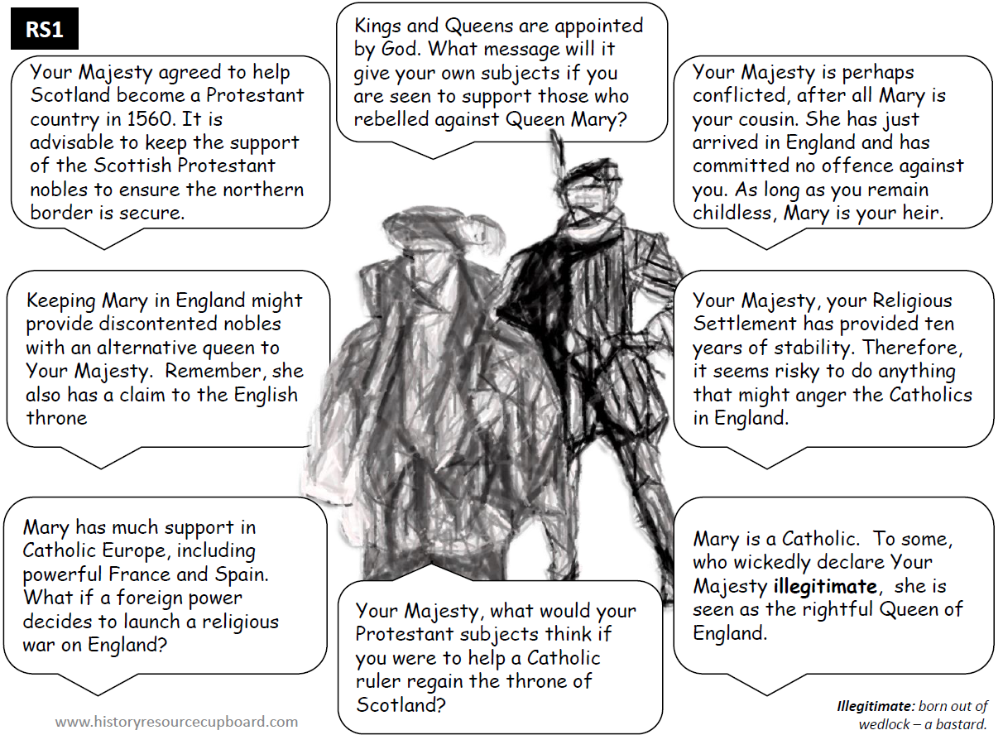
Conclusion:
Despite there being several persuasive reason to execute Mary in 1868, for example….

It is ultimately unsurprising that Elizabeth ultimately decided the negative consequences of doing so outweighed the benefits, on other words…
For example, the biggest negative consequence was…
Because

KNOWLEDGE Tasks: | Tick when complete
Topic 1 Early threats to Elizabeth; Look, cover write check on blank knowledge organiser
Topic 1 Early threats to Elizabeth; multiple choice quiz (repeat till 100% correct)
Topic 1 Early threats to Elizabeth; free recall quiz (repeat till 100% correct)

QUSETION Tasks:
4 marks | Tick when complete
Describe two features of Elizabeth’s early life
Describe two features of economic threats to Elizabeth in 1558
Describe two features of the threat from Mary Queen of Scots 1558
Describe two features of the threat to Elizabeth’s succession because of her gender
Describe two features of religious threats to Elizabeth in 1558
Describe two features of threats to Elizabeth form English Catholics in 1558
Describe two features of the threat to Elizabeth’s succession because questions about her legitimacy

