Was Dunkirk a success or failure for Britain?
Do Now: Copy and complete.
- WWII started on . . .
2. The Nazi-Soviet Pact was . .
3. A ghetto was . . .
4. Anti-Semitism means . . .
5. Women benefitted from WWI because . . .
6. Women were given the vote in . . .

What can you infer from the following source?
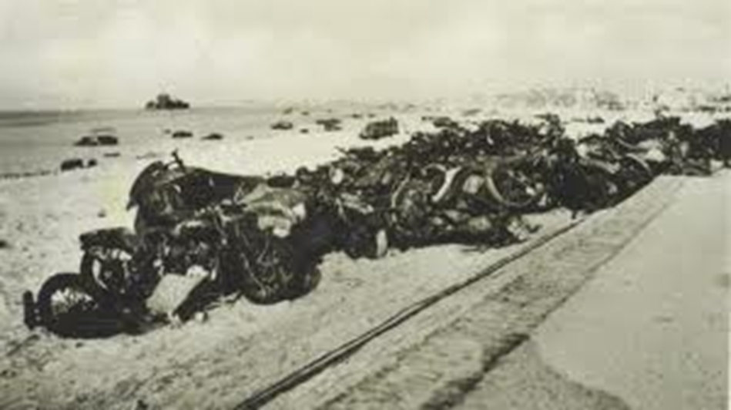

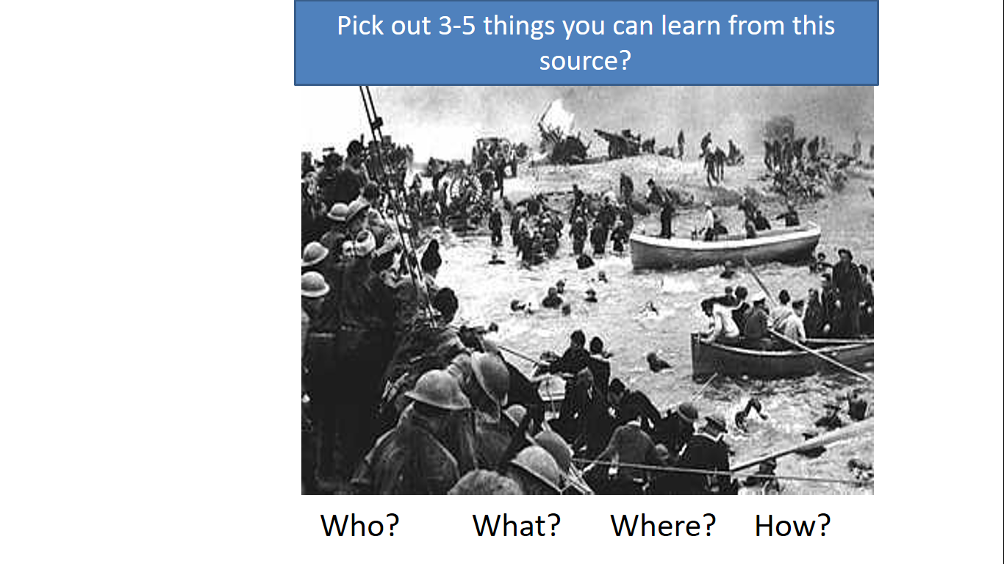

Read the following information:
In 1940 Nazi Germany started it’s attack on the Western Allies. (France and Britain)
The British with the French sent 400, 000 soldiers into France known as the British expeditionary force.
On the 10th May 1940 the Nazis unleashed their new method of Warfare on the allies.
The Germans cut the British and French armies in half and pushed them back.
The French and British were in trouble. They were trapped and Germany’s forces were closing down on them.
The British had to act quickly as their troops were trapped in France.
The evacuation of Dunkirk, also known as Operation Dynamo, was an evacuation of more 300, 000 soldiers French and British using more than 800 ships, small boats, fishing vessels etc. It was a real example of British morale and people coming together for the war effort. The Germans had the potential to wipe out more than 340, 000 soldiers and destroy the British and French forces.

We are going to look at some sources describing this event.
Read the source and discover where the information has come from and tell me how this might affect our understanding of it. (think about the purpose of why they are writing it and for which audience).

Then decide if it describes Dunkirk as a success or failure and explain why by picking out what quotes gave support this idea
Tell me what was the greatest success and the greatest failure for Britain and tell me why?

Write a PEE answering: Was Dunkirk a success or failure for Britain?

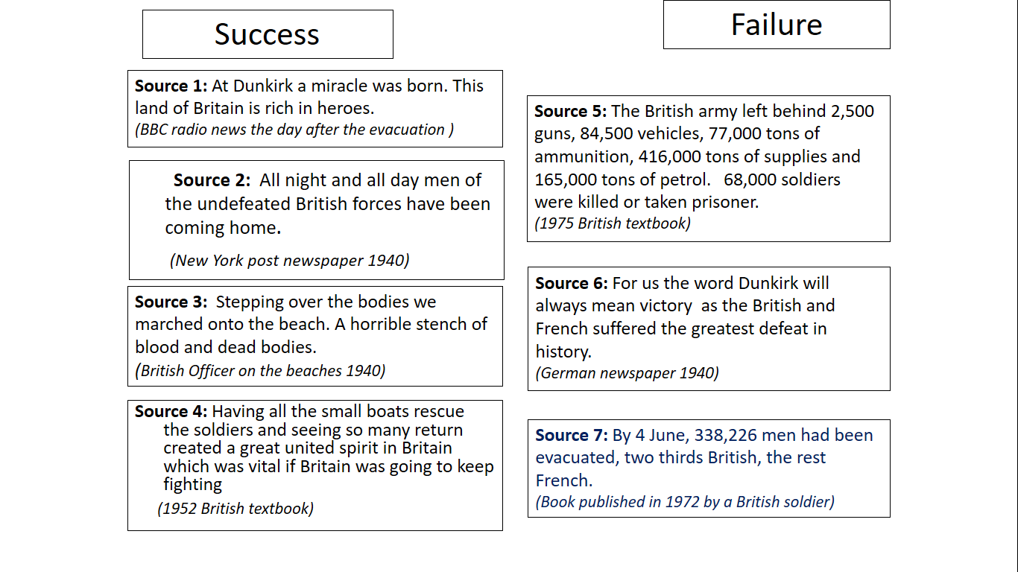

An Example of what you should do is on the next page.

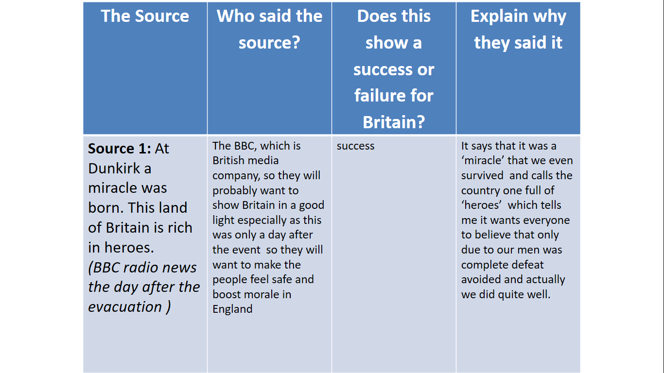
Final Task:
Create your own Newspaper Front page; Headline, picture and most importantly a report on what happened. (what angle will you take; failure or success?)
OR
Create a soldiers letter home; you must include details of what happened and your morale

