Year 10 week 4: Rivalry with Spain: Political and Religious.
Do now: complete these sentences

Détente means…
A consequence of the building of the Berlin wall was . . .
LAMB stands for…
Germany had to pay ______________ in reparations.
Poaching was the crime of . . .
One example of a Medieval crime was . . .

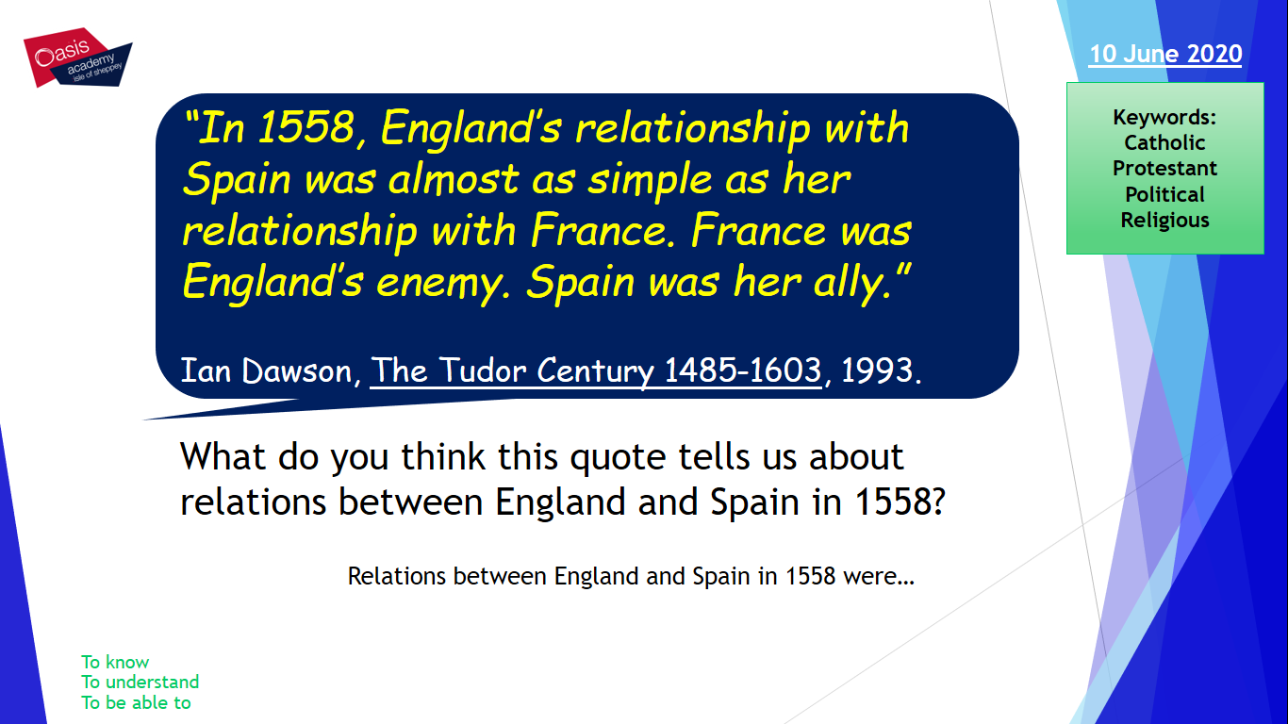

Read the following information:
Religion
One of the main reasons for the outbreak of war between England and Spain was religious rivalry.

It was almost inevitable that war would begin after Elizabeth set up a Protestant Church in 1559 and, from 1570s, began to increase penalties against Catholics.

With Catholics priests began arriving in England there was increased fears of a religious crusade.

Philip II was a devout Catholic who saw his life’s work to return countries to the Catholic faith. Philip did not take action when Elizabeth created a Protestant Church or when the Pope excommunicated Elizabeth in 1571.
Politics
Philip II, apart from being a strong Catholic, was ruler of the most powerful country in the world. As well, Philip ruled the Netherlands, owned land in South America, and became King of Portugal in 1580.

Treasure from the ‘New World’ (South America) made Spain a wealthy country and able to support a strong army and navy. The interference of Francis Drake and the Earl of Leicester in the Netherlands would have worsened relations.

Philip did not want any country interfering in Spain’s power, but he was more concerned about France. This meant Philip preferred Elizabeth as Queen of England rather than Mary Queen of Scots due to her links with France.
English involvement in the Netherlands

Many historians agreed that war with Spain was caused by England’s involvement in the Netherlands.

The English channel was important for England and Spain for trade, security, and, for Philip, access to his territories in the Netherlands.

In 1572, Protestants in the Netherlands rebelled against Spanish rule. The Dutch Protestants asked Elizabeth for support.

Complete the following:
England was a ___________________ country.
Spain was a ______________________ country.
The Pope excommunicated Elizabeth in…
Fears about crusade was caused by…
Philip II believed it was his duty to…
Philip II was the most…
Philip as well as being King of Spain had land in…
Spain was a wealthy country with a…
Philip was more concerned about the role of…
Francis Drake and the Earl of Leicester interference led to…

The English Channel was important for…
In 1572 in the Netherlands…
The Dutch Protestants asked…

Describe two features of religious differences between England and Spain.

One feature was…
This was…
Another feature was…
This was…

Describe two features of political difference between England and Spain.

Describe two features of England’s involvement in the Netherlands.

Do now: complete these sentences

The Grand Alliance was …
A consequence of the development of the A bomb was…
WWI ended on . . .
Germany had to pay reparations to . . .
The ‘Bloody Code’ was . . .
Treason was punished by . . .

Read the following information and complete the questions and sentences:
A marriage proposal

1. Philip II of Spain had been married to Elizabeth’s Catholic sister, Queen Mary. After Mary died, Philip proposed to Elizabeth.
2. In 1559, Elizabeth turned Philip down. Philip was deeply disappointed as he had hoped that the marriage would ensure England remained Catholic and that he would control the country. Philip was also disappointed because he had hoped to bring England into an alliance against France
3. A marriage would have made the prospect of any future war between Spain and England very unlikely.
4. Despite Elizabeth turning Phillip down, Spain and England remained on good terms for a number of years.
Piracy

1. English sailors began to make money by attacking Spanish treasure ships. These ships carried gold and silver from the mines of South America back to Spain. Such piracy made a lot of money for England. Even Elizabeth unofficially supported these voyages in return for a share of the riches! This angered the Spanish who made several complaints to Elizabeth.
2. Francis Drake was regarded as the most famous of all English pirates. In 1572, he stole silver worth 20,000 (about 30 million at today’s prices). An even bigger haul came in 1579 when Drake stole 140,000 worth of cargo from a Spanish cargo ship – the Cacafuego. However, these events took place years before the war broke out in 1585.

A marriage proposal
Who wanted to marry Elizabeth in 1558 and had been previously married to her sister?

Why was this person disappointed when Elizabeth said no?

Why do you think Elizabeth turned him down?

Why is this not the most important cause of the war between England and Spain in 1585?

Piracy.
English ships stole from Spanish ships, more specifically…

Elizabeth encouraged this because…

The most famous English pirate was…
In 1572 he stole…

In 1579 he stole…

Piracy made the Spanish very angry but was not the most important cause of war because…

‘English inference in the Netherlands was the driving force of worsening relations.’ How far do you agree?
You may wish to include:
English role in the Netherlands
Religious rivalry

Remember this question needs 3 PEEL paragraphs and clear judgement.

On the one hand the most important reason was…
For example…
More specifically…
Therefore…

On the other hand it was…
For example…
More specifically….
Therefore…

Overall, the main reason was…

This was the main reason because…

