The Story of Emmett Till.

Do Now –complete:

Jesse Owens was . . .

Jesse was significant because . . .

One example of a Jim Crow Law was . . .

. . . . Won the battle of Hastings.

What can you infer about the German attack on the Soviet Union?
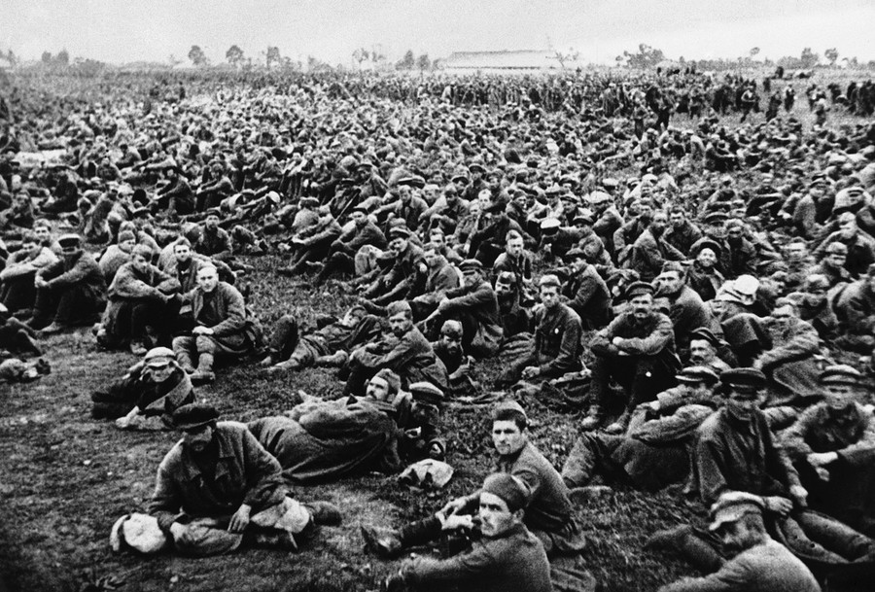
One thing I can infer is . . .

Because I can see . . .

Another thing I can infer is . . .

Because I can see . . .

Read the following information:

Roots of war

On 22 June 1941, some three million soldiers of Germany and her allies began an attack on the Soviet Union. This war was supposed to be over in a matter of months, but it lasted for four years, and grew into the largest and most costly conflict in all history.
It was here, in the vast struggle between the two dictatorships, that the German army was defeated and the outcome of World War Two was decided in favour of the Allied powers - the British Empire, the United States and the USSR. The cost to the Soviet Union was an estimated 27 million dead.
The roots of the war lie in the appointment of Adolf Hitler as German chancellor in 1933. His hatred of Soviet Communism and his crude ideas of economic imperialism, expressed in the pursuit of Lebensraum ('living-space'), made the Soviet Union a natural area for Hitler's warlike ambitions.
After the outbreak of war in 1939 came the added fear of Soviet expansion in Eastern Europe, while Germany was fighting the British Empire and France in the west. All of these factors contributed to the decision taken by Hitler in July 1940, after the German defeat of France, to plan for an all-out assault on the Soviet Union.
Not until December 1940, however, did Hitler make a final decision to go ahead with what became known as Operation Barbarossa. The original date, set for May 1941, had to be revised to complete the vast preparations for the attack - following other German attacks on Yugoslavia and Greece in April.
The date of 22 June was late for starting a campaign over such a vast area, but German commanders were confident that the Soviet armed forces were primitive, and that the Soviet people were waiting for liberation. Victory was expected by the early autumn.
The German invasion of the USSR

Please answer in full sentences:

1.use the information to complete the following tasks.

Key words: USSR =
Untermenschen =
Operation Barbarossa =
Scorched Earth =
Counter-attack =

2. Russia followed the teachings of Karl Marx. What did he say workers should do?

3. List 3 problems the Germans faced in Russia

4. Which 2 problems did the soldiers face against the cold?

5. explain how and why the Russians were able to counter-attack against the Germans

6. Make a list of all the weapons that were used in the fighting

7. Why was Stalingrad so hard for the Germans to capture?

8. Why was Hitler so determined to capture Stalingrad? (Clue: Think of the name)

9. How many Germans were killed in Russia?

10. How many Russians were killed fighting the Germans?

Extension essay:

Hitler’s attack on Russia led ultimately to his defeat. How far do you agree with this statement?
You may wish to think of using: key words, weather, Stalingrad, the size of Russia

