Rosa Parks.
Do Now: Copy and complete.
The KKK were/are . . .
Members of the KKK were usually . . .
Emmett Till was Lynched because . . .
Jesse Owens broke . . .
A Plantation is . . .
Henry reformed the English Church because . . .

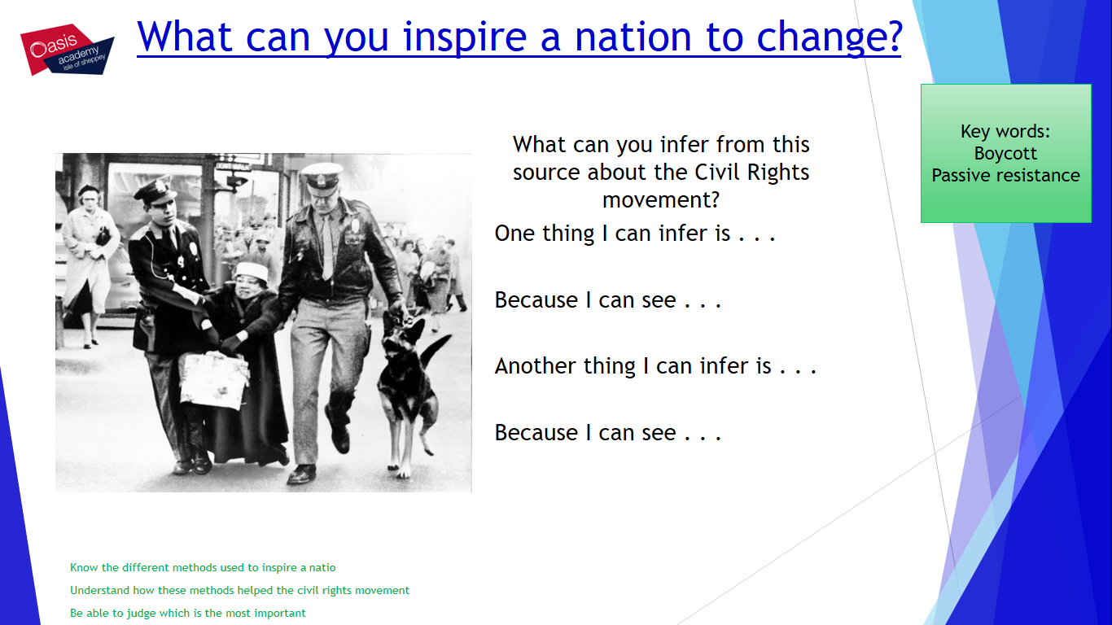

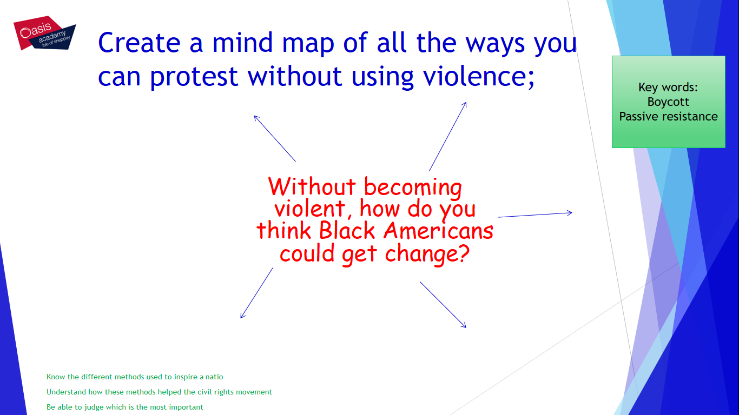

Read the following Information on Rosa Parks:
Rosa Parks was arrested in Montgomery Alabama in 1955, On the buses of Montgomery, Alabama in 1955, it was the law in that black people had to give up their seats for a white person on the buses. This was just one way that black people were segregated.
Black people could sit or stand in the back section; they could sit in the middle section unless a white person wanted to sit in that section. If the bus was full, even at the back the black people had to give up their seats for a white person.
Rosa parks refused to give up her seat and was arrested as a result. Leaders of the black community were shocked at this action and so they decided to act. They formed the Montgomery Improvement association. Martin Luther King as their president and gave a speech. He said;

“If you will protest courageously and with dignity and Christian love, people in the future will say; ‘there lived a great people”.
The Bus Boycott was organised for Monday Dec 5th 1955. 40,000 leaflets were sent out.

On that day the buses were empty; instead the black community shared their cars or walked. Many took the day off work or stayed off school to join in the protests. The bus company lost 65% of their takings.
The boycott continued for 381 days, until the White leaders gave in!
Segregation on the buses was declared illegal! And this meant that all other forms of segregation could be questioned.

The bus boycott was the first big success of the civil rights movement!
Now using the information answer the following questions:
The Jim Crow Laws affected Rosa because . . .
To protest she . . .
As a result she . . .
Rosa inspired others because . . .
White people reacted by . . .
The main reason the Boycott worked was . . .

Read the following information:
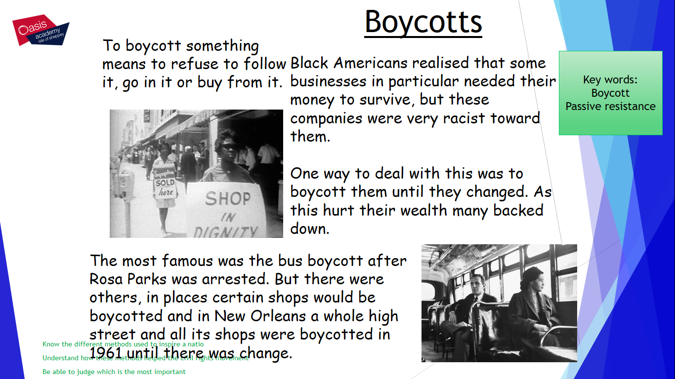
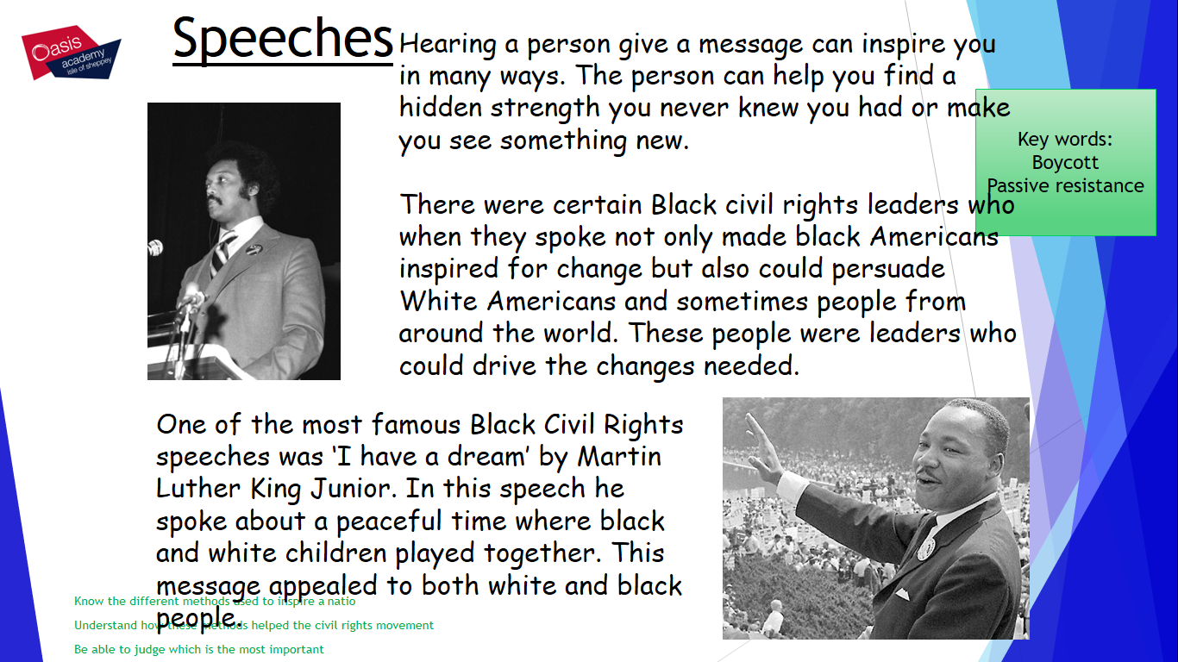
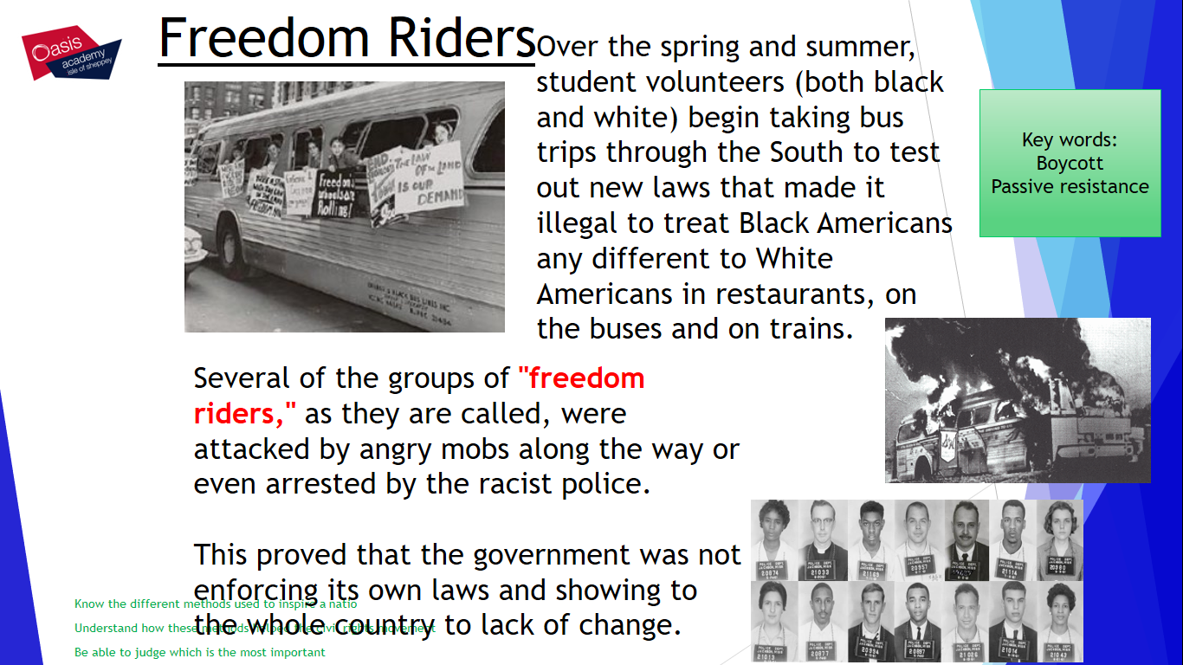
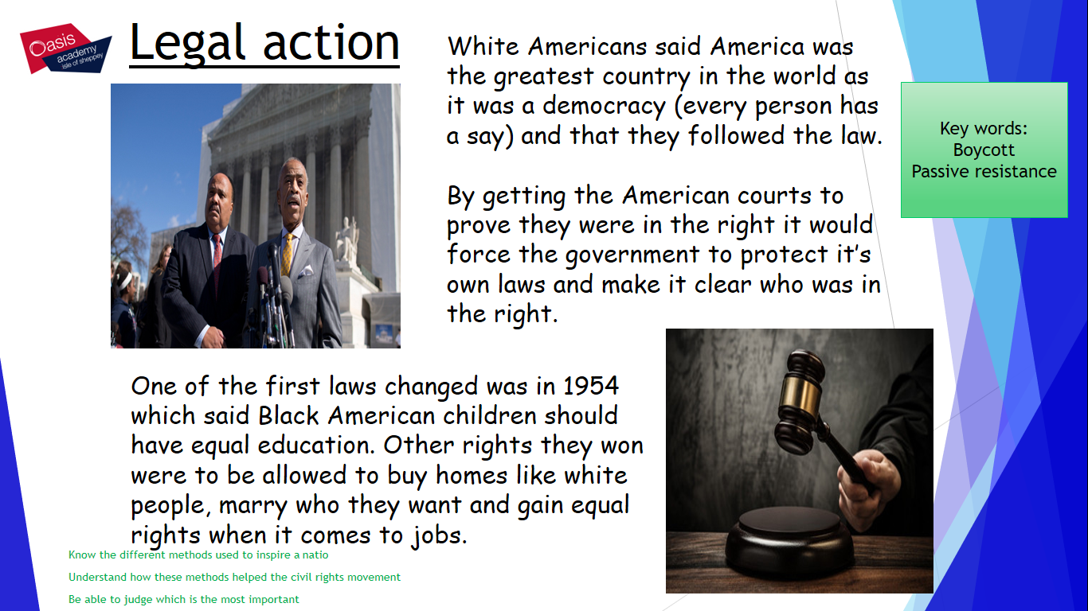
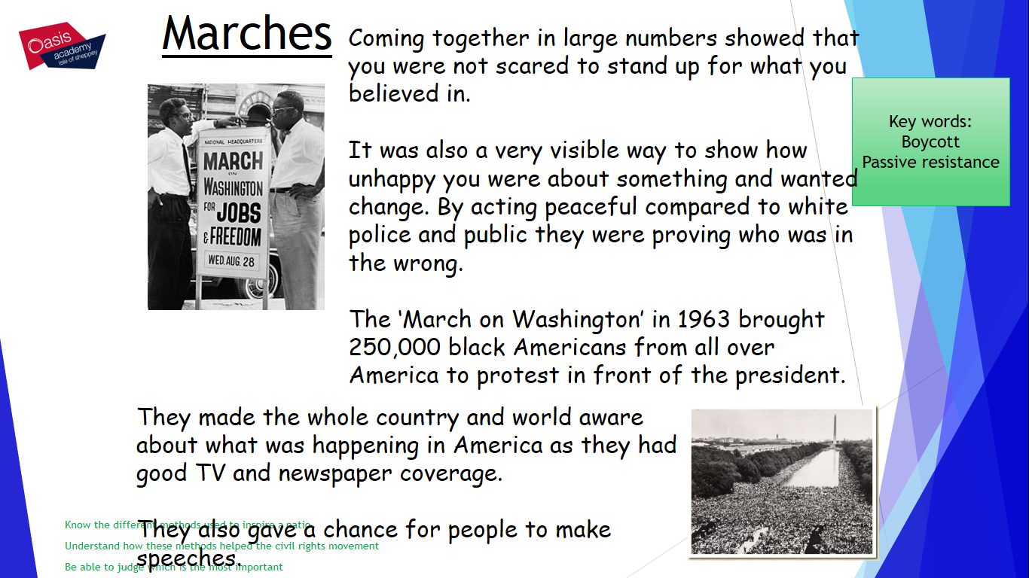
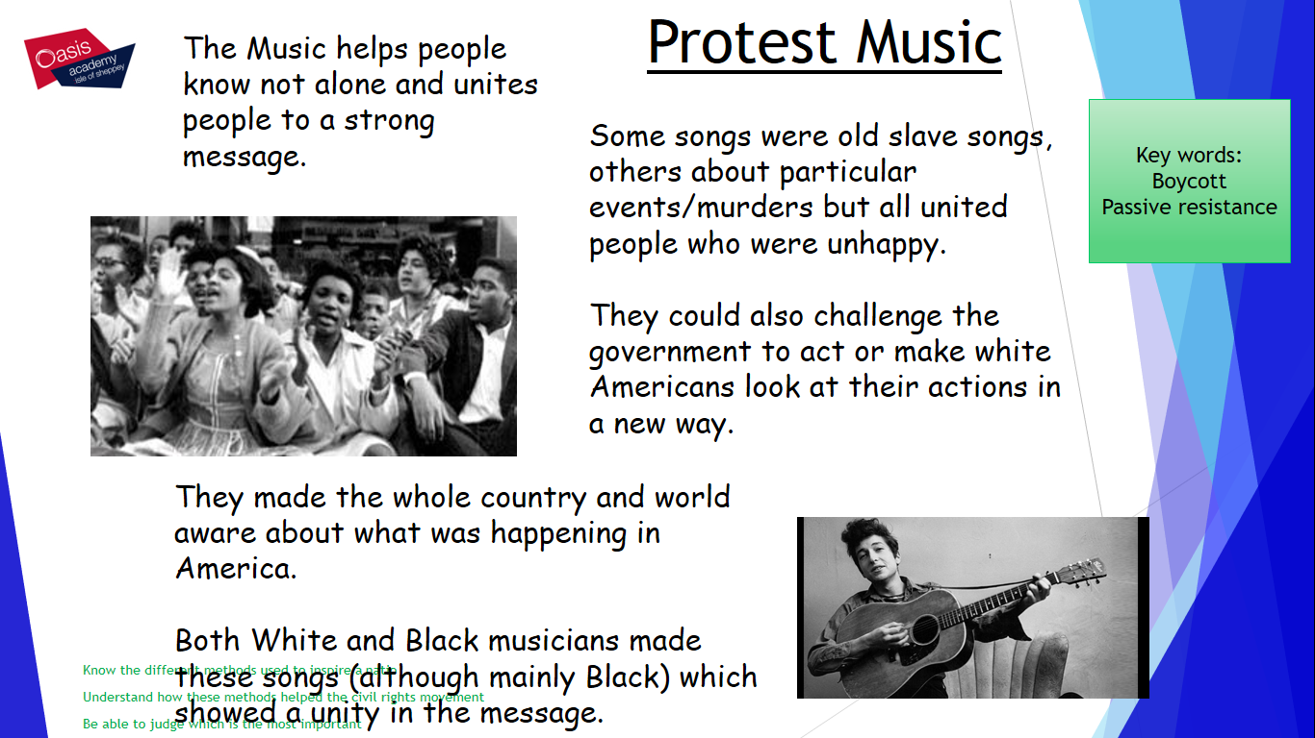

Using the information – judge which method of protesting you think was most effective.
Overall I believe that the best method of protesting was . . .

This is because . . .

