Causes of WWII.
Do Now:
- The Short brothers were…
- One of the ways the Nazi’s policed Germany was through the use of…
- Kristallnacht was when…
- The Suffragettes were led by
- World War One started in… and ended in…
- Explain one way the Nazis controlled Germany through Propaganda

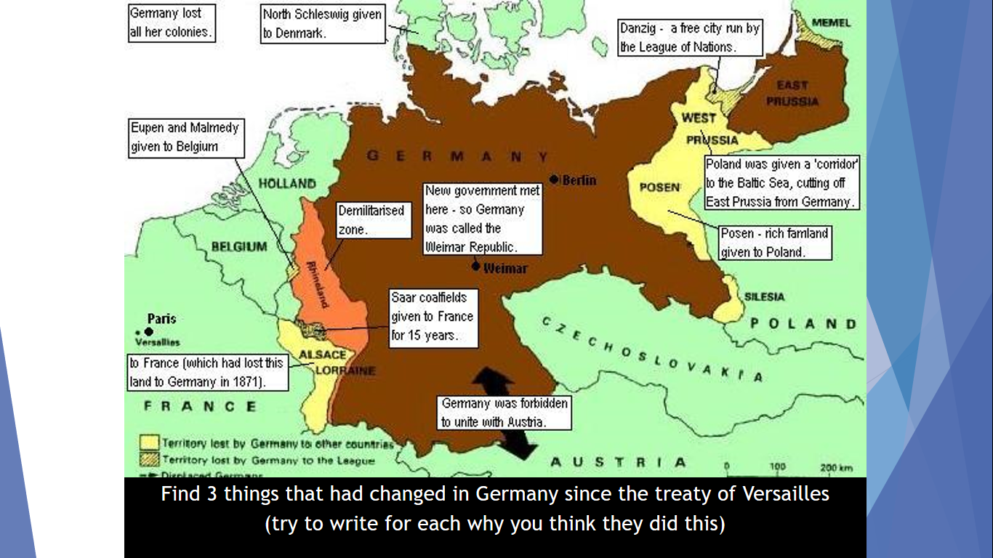

No imagine less than 30 years since the last war there is the threat of another one from Adolf Hitler, imagine you are the Prime minister of Great Britain.
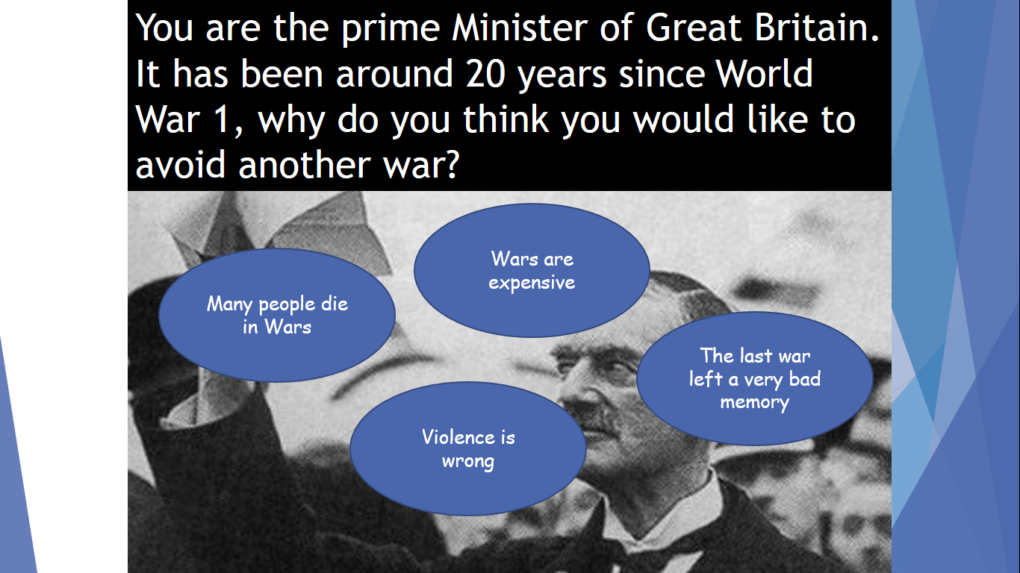
Which option do you think Britain should choose and why?

What happened? | What would you have done? Pick from the 4 potential reasons.
In 1935 the people of the Saar voted to rejoin Germany. This is banned.
Also in 1935 Hitler started building Germany’s army. This is banned.
1936 Hitler marched in his very small army to retake The Rhineland which acted as a safe zone between France.
Hitler first encouraged the Germans in Austria to ask for a union, then in invaded them to take it all in 1938.
1938 Hitler took the Sudetenland (German speaking Czechoslovakia).
1939 Hitler invaded and took all of Czechoslovakia
In 1939 Hitler made a deal with Russia that they would not attack each other and both take parts of Poland.
In 1939 Hitler invaded Poland.

Chamberlain did nothing until 1938 – he tried to guarantee peace in Europe – his policy was known as appeasement – basically giving Hitler what he wanted to keep him Happy. By 1938 Britain had decided Hitler had enough and declared they would go to War if he continued. When Hitler invaded Poland in 1939 Britain and France declared war on Nazi Germany.

Now using the information below I want you to decide what you think was the main cause of WWII. 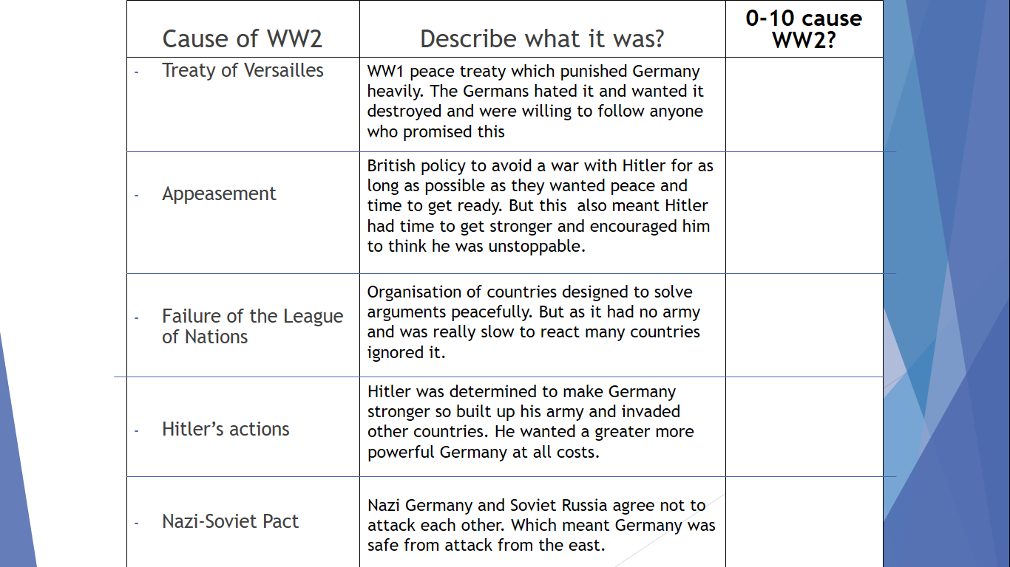

Which one do you think was the most important reason? Explain your answer.

