Year 7: Summer 1
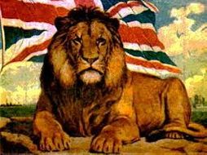
“Good thing” vs “Era of Darkness”, why has the British Empire been seen so differently?

Name: _____________________ Class:__________________ Teacher: ______________

Contents
Lesson/Resource | Page Numbers | Tick when complete
Knowledge Organiser | 2-4
Do Now – Lesson 1 | 5
- What was the British Empire? | 6-8
- How has the British Empire been portrayed? | 9-11
- What do Ferguson and Tharoor actually say about Empire? | 12-14
- Why do Ferguson and Tharoor see the Empire so differently? | 15-20
- Why do Ferguson and Tharoor actually see the Empire so differently? | 21-23
- What made Tharoor and Ferguson write books about Empire? | 24-25
Learning Ladder | 26
“Because, but, so” vocabulary table | 27

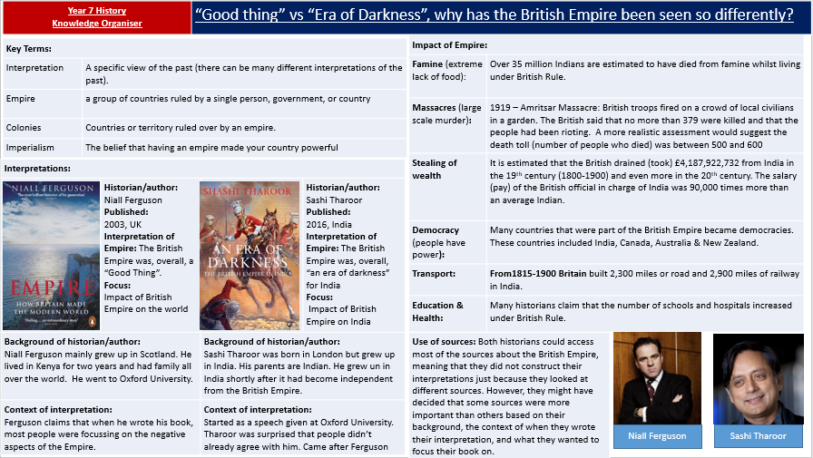

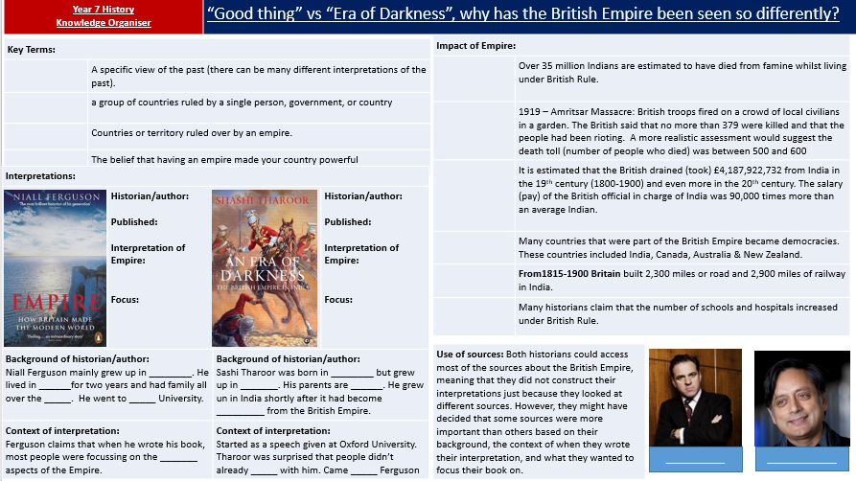

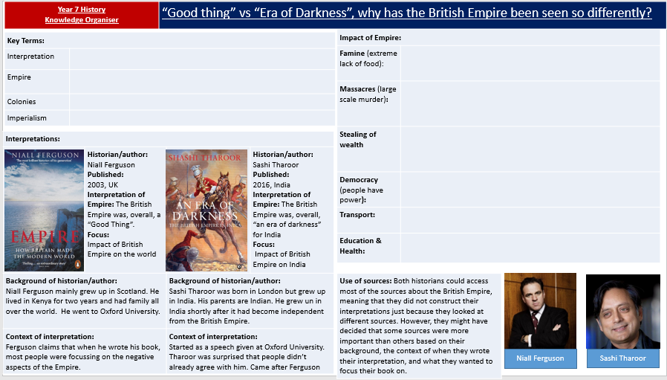

6. “Good thing” vs “Era of Darkness”, why has the British Empire been seen so differently?
What made Tharoor and Ferguson write books about Empire?
- Read through the questions first so you know what answers to look for.
- Read through the extract and answer the questions. Do not worry about understanding every word.

Key terms | Extract: From Empire: How Britain Made The Modern World, by Niall Ferguson. Published in 2003 in Britain. | Questions
Conventional: the normal or most common way of thinking.  Taken for granted:  Something people think is true without really thinking about it. | “Once there was an Empire that governed roughly a quarter of the world’s population, covered about the same proportion of the earth’s land surface and dominated nearly all its oceans. The British Empire was the biggest empire ever, bar none…  [This book attempts to answer] whether the Empire was a good or bad thing.  It is nowadays quite conventional to think that, on balance, it was bad.  The difficulty with the achievements of empire is that they are much more likely to be taken for granted than the sins of empire. | What was the difference between the British Empire and all other empires?  What does Niall Ferguson see as the important debate about the British Empire?  What view does he say most people in 2003 had of the Empire?  Why does he think most people have this view?

- Read through the questions first so you know what answers to look for.
- Read through the extract and answer the questions. Do not worry about understanding every word.

 | Extract: From An Era of Darkness: The British Empire In India, by Sashi Tharoor, published in 2016 in India | Questions
Opened their eyes: helped them to understand  Reiterating: telling someone something again | “Yet the fact that my speech struck a chord with so many listeners suggested that what I considered basic was unfamiliar to many, perhaps most, educated Indians.  They reacted as if I had opened their eyes, instead of merely reiterating what they had already known…  This book is also not about British colonialism as a whole, but simply about India’s experience of it…  As we have seen, [Niall Ferguson] sees in Empire cause for much that is good in the world… a Good thing…  Ferguson merely continues a long-established colonial tradition of the writing of world history with his own people [British] and their interests as the fixed, first and final point of reference. | Who was Sashi Tharoor surprised by because they did not already share his point of view?  Which phrase suggests they seemed to hear that the Empire was ‘an Era of Darkness’ for the first time?  What is the focus of Sashi Tharoor’s book?  Whose work was he reacting to?  He accuses the author of just focussing of viewing the empire from the point of view of the…
What made Tharoor and Ferguson write books about Empire? Match the statement to the historian by ticking the box. Some might be both.
Tharoor -An Era of Darkness: The British Empire in India | Statement | Ferguson – Empire: How Britain Made the Modern World
 | Written in 2003
 | Written in 2016
 | The historian though that most people at the time saw the Empire as a ‘bad thing’
 | The historian thought that people focus too much on the sins of empire
 | The historian was surprised that other educated people in their country didn’t seem to know about the impact of the Empire on their country
 | The Author thought that people didn’t really focus on the achievements of Empire
 | The historian focussed on the impact of Empire on their own country.
 | The historian was concerned about what other historians were saying.
 | The historian wrote their book partly in response to the book written by the other historian

 | Why did Ferguson and Tharoor write their books?
 | Niall Ferguson decided to write a book arguing that the British Empire was a ‘good thing’ because…
 | Sashi Tharoor decided to write a book calling the British Empire an ‘Era of Darkens’ because…
Learning Ladder
I can…. |  | Prove it!
Identify words and terms |  | 1.Define Interpretation  2.What is an ’Empire’?  3.What is the Kohinoor?  4.What was unique about the British Empire?  5.What is Niall Ferguson’s opinion of the British Empire?  6.What is Sashi Tharoor’s opinion of the British Empire?
Describe how the British Empire has been interpreted  Say a lot about a little, try and include at least three details.  - For example…More specifically….  Sashi Tharoor views the British Empire as ‘an era of darkness’ for India. For example, he suggests that the Empire did more harm than good. More specifically, Sashi Tharoor says that British rule lead to massacres of Indian people and the country becoming poorer. |  | 1.Describe how Sashi Tharoor views the British Empire  2.Describe how Niall Ferguson views the British Empire  3.Describe Sashi Tharoor’s background  4.Describe Niall Ferguson’s background  5.Describe the difference between Sashi Tharoor and Niall Ferguson’s views of the British Empire
Explain why historians have different views of the British Empire  Use key words  - Background, context, interpretations  Therefore Shashi Tharoor might view the British Empire negatively due to his background. This is because he grew up in India surrounded by people who had lived under the British Empire and experienced poverty as a result of British rule. He also read the work of a lot of Indian thinkers who criticised the way Britain had treated India. |  | - Explain why Sashi Tharoor’s background may have influenced his views of the British Empire.  - Explain why Niall Ferguson background may have influenced his views of the British Empire  - Explain why Sashi Tharoor’s wrote his book on the British Empire in 2018  - Explain why Niall Ferguson wrote his book on the British Empire in 2003  - Explain why Sashi Tharoor and Niall Ferguson’s interpretations of the British Empire are so different.

Glossary of Academic Vocabulary
Word | Definition | Because | But | So
Interpretation
Kohinoor
Continue in the back of your exercise book

