Year 8: Summer 1
“The Isle of Sheppey has been pivotal in the protection of the realm’ How far do you agree?
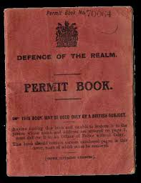
Name: _____________________ Class:__________________ Teacher: ______________

Lesson 7: Sheppey and WWII.
Do Now:
Sheppey Independence Day is . . .
The Dutch invaded Sheppey because . . .
Sheppey was strategically important due to . . .
Napoleon was a threat to Britain because . . .
Sheppey was bombed . . . During WWI.
Sheppey residents were issued passports because . .

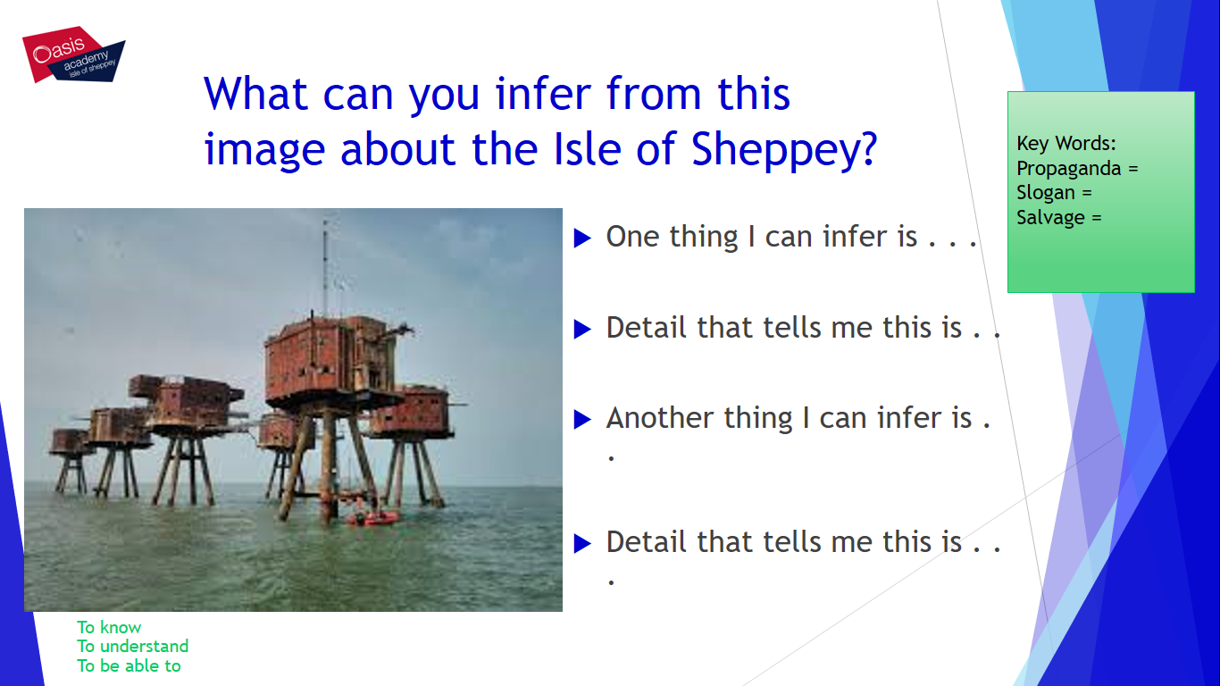

Read the following:
On that Sunday it was a lovely day to go swimming and that was what I WAS doing with a lot more of my friends. It was at the top of Alma road. We had gone along the sea wall to the back of the Seaview Hotel, the radio was on and something big was about to happen. It was the Prime Minister declaring war on Germany. It seemed as though no sooner had he said those fateful words that all hell broke loose .The air-raid siren sounded, there was a man on his bicycle blowing a whistle and telling us to go home. But our clothing was on the beach .He wouldn't let us go and get it so we all ran as fast as we could home, then it came out that I didn’t have a gas mask. This was because when they gave them out I had been in the infirmary, in Hull. We had come to Sheerness about a year ago so my dad could work in the dockyard, which caused a bit of bother. It was the start of a very hard time for Mum. There were ten boys and two girls that she had to think about. Jim was in the army on the guns, Ted, was on oil tankers that were at the start of the war.
I would go cockling at the White House that was the name of the area we could go to scrape for them, then I would go round the tents and houses selling them. I was out on the sand when I was shot at and they missed; the next time I was on my way to school. I was in the middle of the road, kicking a tin along as I came to the turn in the road when a German aeroplane came over the top of the school and started to fire his guns, I could see the marks of the bullets coming towards me. A woman was at the front of her house. She called me to come in, so once again they missed me. I can remember being at the railway station when the men were coming back from Dunkirk and seeing some of the locals meeting their husbands. That was a very sad time. I remember going through a covered way past the rifle range, there was a wall on just one side of the path to shield people. On this day, a fighter craft had crashed and the wall was gone.30 years later, I was to find the last resting place of what was left. It was in an Air force museum somewhere near Folkestone. The people in charge decided to move me to Bedlenog, Wales, where I was to end up in a miner’s cottage. It was white-washed walls and stone floor but I was so tired I went straight to bed. The next morning the sight I was to see lives with me today as if it was only yesterday. Looking out of the window there was a green field at the bottom of which was The River Taff, where I was to spend many happy times.
However, the Germans were not finished with me. The air-raid precautions was a large iron table we should have been under but we were all outside looking at what was going on down the valley when this German bomber went over and dropped a bomb, it landed about 500 yards away ...it missed me again. I came back to the Island to go to the boys’ school. I would always go out of the house and turn up to the sea wall and go along the wall towards the coal pier and then to school. It was on one of these days that I was to see the Dockyard boom defence boat blown up when they hit a mine. I was to see men that lived near to me come swimming to the beach. That was the second time that mines killed men I had known. Mr Foster and Mr Fry went out in a fishing boat and were blown up. Then there were four boys who tried to take a mine to bits with a hammer and spanners: three of them were killed. On another time, an American Air force plane was to land in the mud just off shore. I think they all got off but the thing was that they had ditched the Bomb aimers’ sight and they came and tried to find it. That gave us a good laugh. It was not for long because one of the men from the Dockyard was cutting it up when it blew up. No one had thought to check what fuel was still in the tanks. I can remember the SS Montgomery being grounded on a sandbank. She was full of explosives. It is still there because they say it is still too dangerous to do anything about it .The war was a very exciting time but was a very sad time as well. My sister’s husband Bill, a good Scots man was killed while on a raid to Germany. He had just made Engineering Officer.
Then came the flying bombs and the rockets. I would sit on the sea wall and watch our planes tip them into the sea.
Finally came D-DAY. I was in the dockyard at this time, in the naval dockyard stores so I was able to say that I did my bit.

Wartime Memories from Sidney Crowder in Sheerness during WWII.

Complete the following:
- All hell broke loose on the outbreak of war because . . .

- Sidney needed a gas mask because . . .

- There were . . . In his family and they . . . .

- Cockling is . . .

- I think his time on the Island during the war was never dull because . . .

- Flying bombs and rockets were . . .
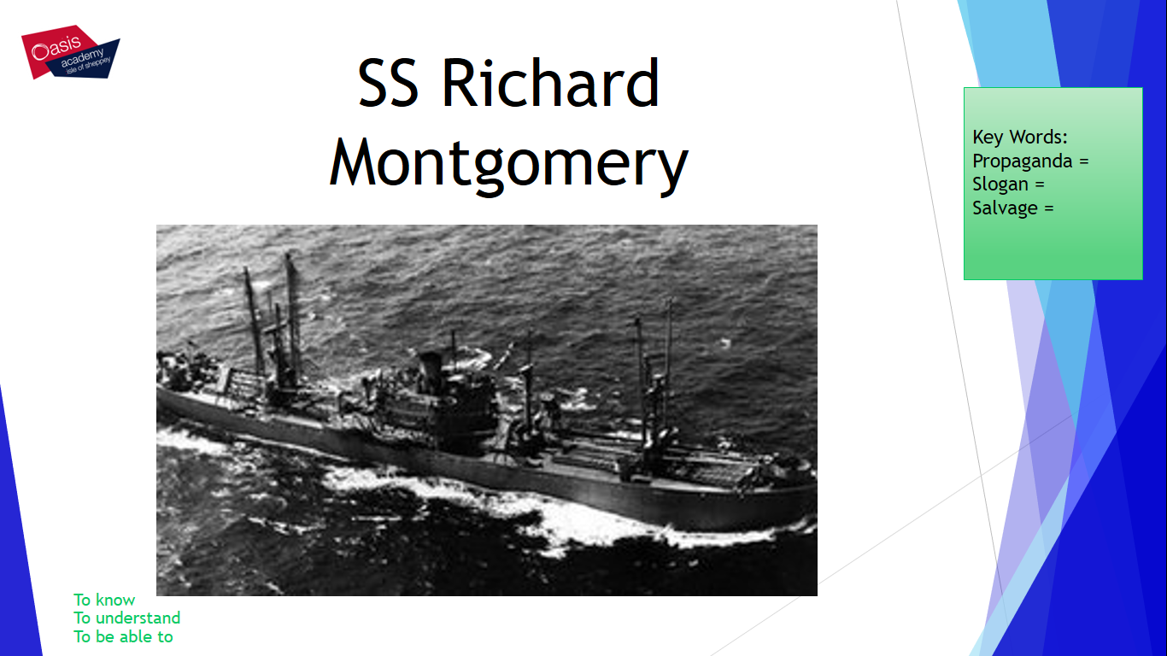

Built in 1943 by the St John's River Shipbuilding Company of Jacksonville, Florida.

The masts of the wrecked ship are visible from the shore.
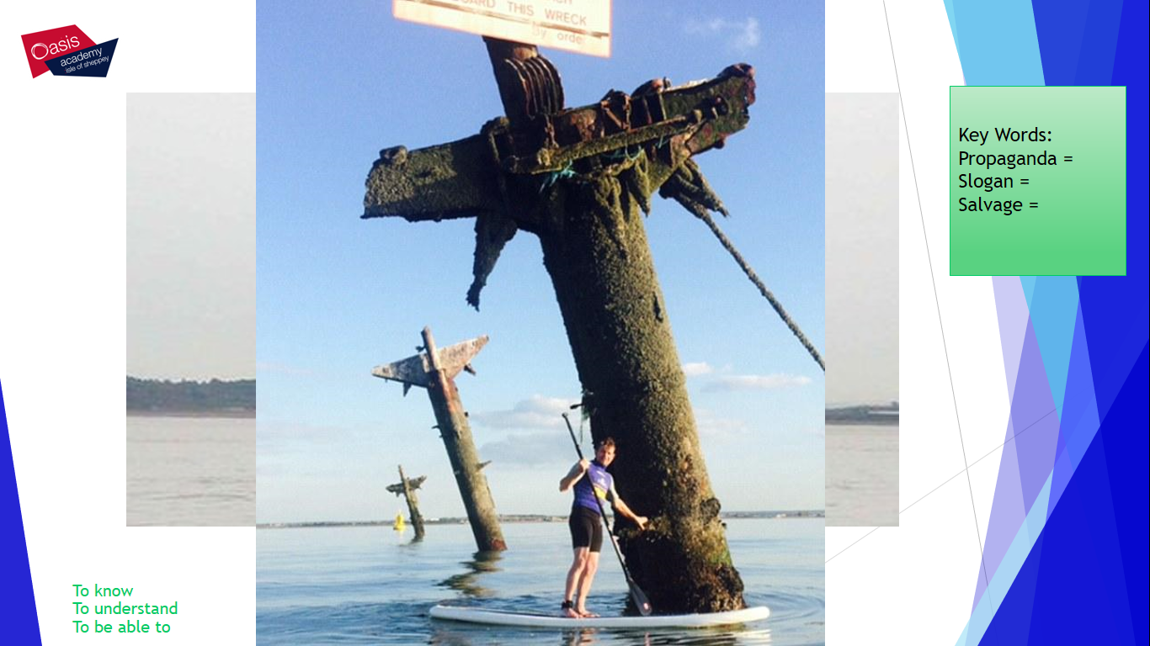

The SS Richard Montgomery was anchored in Sheerness when it grounded and broke up in 1944.
The wreck is monitored 24-hours a day by port authorities and protected by a 500m (1640ft) exclusion zone.

The Royal Navy had four defensive installations on the Isle of Sheppey:
- Sheerness Boom: a small antisubmarine boom on the northern end at Garrison Point, Sheerness stretching across the Medway to Grain Tower Battery on Grain Island.
- Minster Boom: a large boom at Royal Oak Point, Minster stretching across the Thames estuary to Shoeburyness on the Essex coast.
- Sheerness Extended Defence Officer's Post: on the northern end of Sheppey Island at Sheerness; responsible for the Sheerness and Minster antisubmarine booms and Medway minefield.
- Shellness Extended Defence Officer's Post: on the southern end of Sheppey at Shellness; responsible for the East Swale minefield.

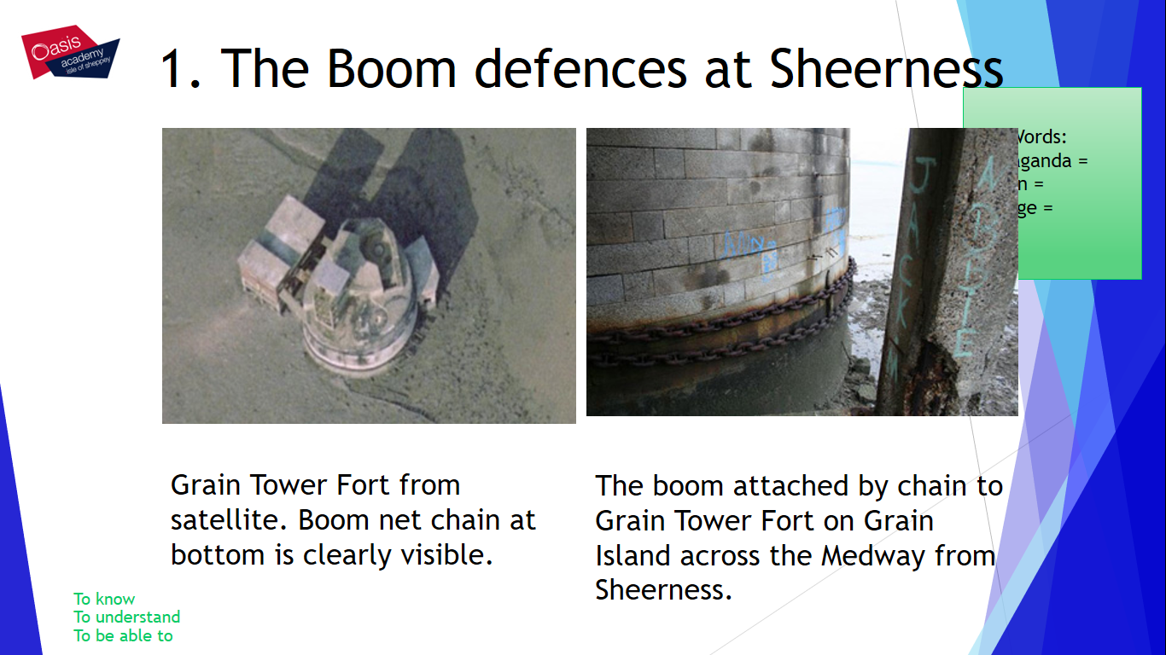
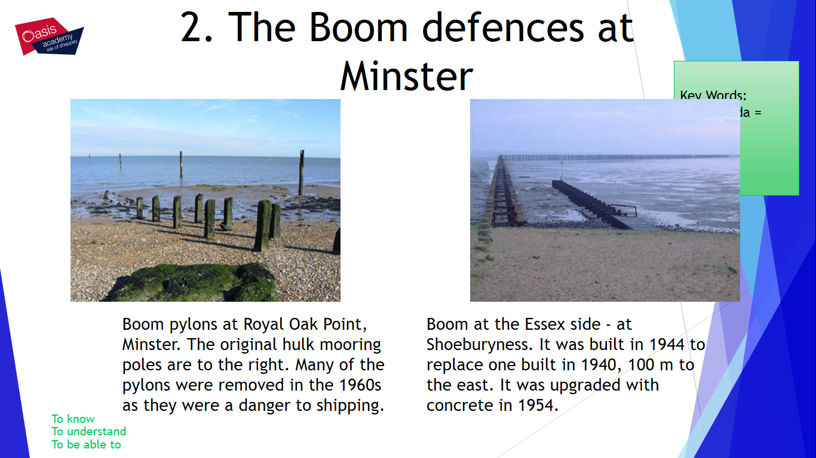
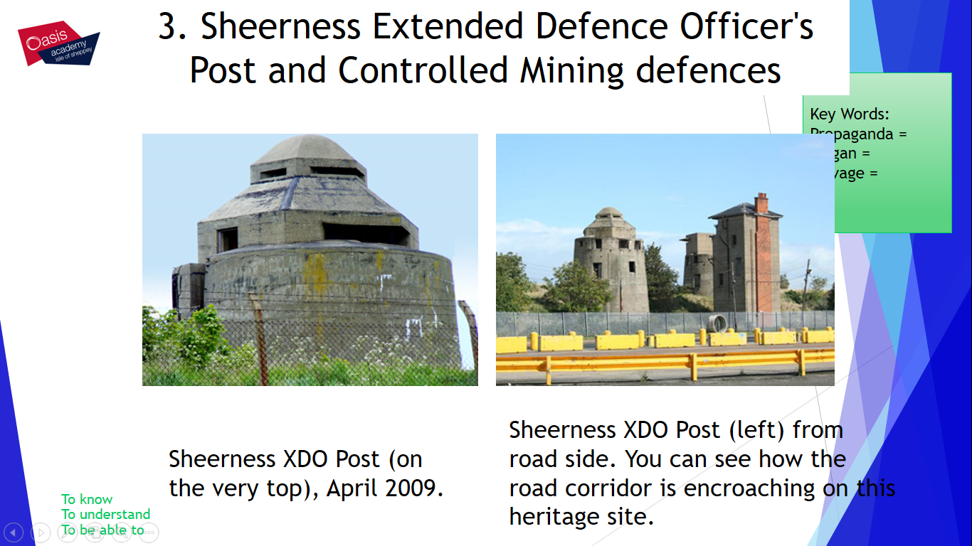
Position 4: Shellness
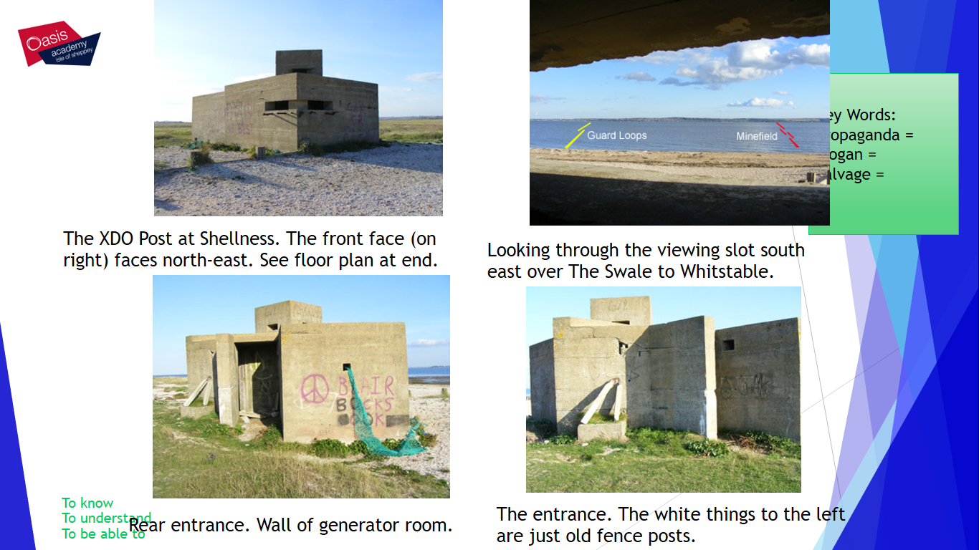

Complete the following:
Sheppey had many defences in WWII for example . . .

Sheerness Boom defences were attached at . . .

The SS Montgomery was stationed off Sheppey because . . .

The SS Montgomery has . . . On board.

Sheerness was important during WWII because . . .

