Year 8: Summer 1
“The Isle of Sheppey has been pivotal in the protection of the realm’ How far do you agree?
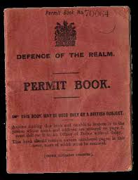
Name: _____________________ Class:__________________ Teacher: ______________

Lesson 5: Sheppey and World War One.

- Do Now:
- Sheppey independence day is . . .
- The Dutch invaded Sheppey because . . .
- Sheppey was strategically important due to . . .
- Napoleon was a threat to Britain because . . .
- The Wright Brothers were . . .
- The Gordon Bennett Trophy was . . .
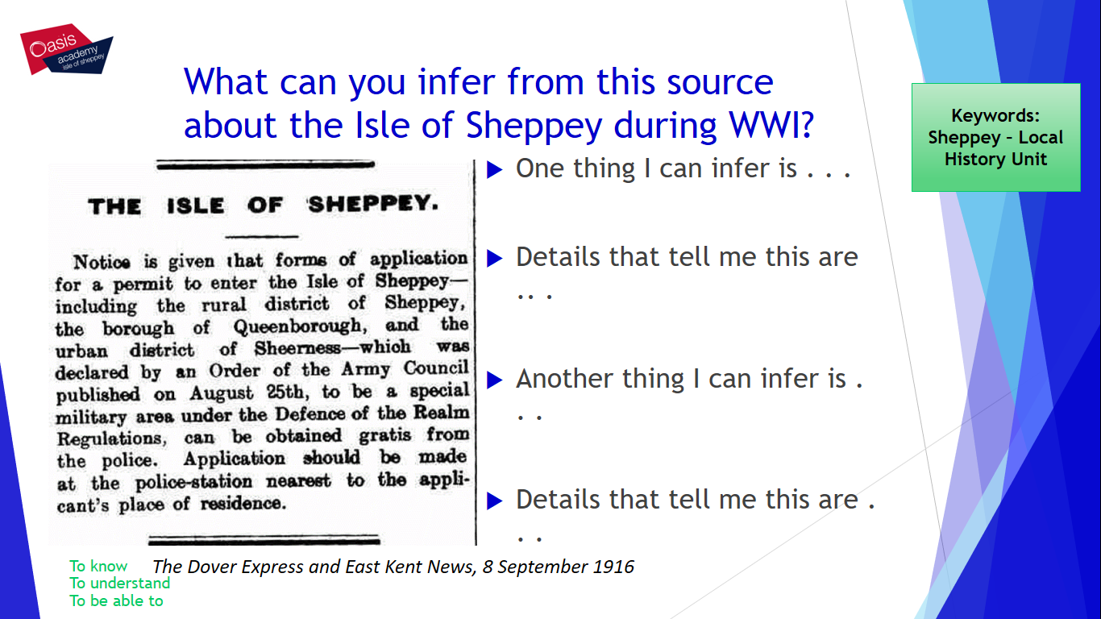

Sheppey was an important Naval base as we have seen before from the Dutch invasion onwards – being so close to London means that strategically the island is important just on geography but as you just saw it was so important you needed special permission to enter and leave during WWI.
If you did not have a fully registered permit book you were unable to enter and leave the Island – the Government were very concerned about German spies.
The Isle of Sheppey lies in the mouth of the River Thames opposite Southend. It has stood guard as a defence for the Dockyard at Chatham and the city of London since the 1800’s. The Royal Naval Dockyard was the centre of activity for the preparation of ships for battle. The Royal Naval air station was at Eastchurch and all the aviation activities for the country were organised from Sheerness Dockyard by Captain Scarlett. There was also a military barracks at Blue Town. Internal passports were issued because this was an area of high security.
Complete the Following:
- The Sheppey passport was . . .

- Sheppey docks was important for ships because . . .

- Sheppey docks was important for the air force because . . .

There were several key events during WWI involving Sheppey.
In 1915, the HMS princess Irene exploded in the Docks – killing many, read the following information.

At 11:14 GMT on 27 May, Princess Irene exploded and disintegrated. A column of flame 300 feet (100 m) high was followed a few seconds later by another of similar height and a pall of smoke hung over the spot where Princess Irene had been, reaching to 1,200 feet (400 m). Two barges laying alongside her were also destroyed. The explosion was larger than that which had destroyed HMS Bulwark in the Medway six months earlier, although the loss of life was less. A total of 352 people were killed, including 273 officers and men, and 76 dockyard workers who were on board Princess Irene. On the Isle of Grain, a girl of nine was killed by flying debris, and a farmhand died of shock. A collier half a mile (800 m) away had its crane blown off its mountings. A part of one of Princess Irene's boilers landed on the ship; a man working on the ship died from injuries sustained when he was struck by a piece of metal weighing 70 pounds (32 kg). Wreckage was flung up to 20 miles (32 km) away, with people near Sittingbourne being injured by flying debris.
A memorial service for the victims was held at the Dockyard Church, Sheerness on 1 June 1915. It was led by Randall Davidson, the Archbishop of Canterbury. Inquests were held on two victims of the disaster. A Court of Inquiry was held into the loss of Princess Irene. Evidence was given that priming of the mines was being carried out hurriedly and by untrained personnel. A faulty primer was blamed for the explosion. Following the loss of HMS Natal on 30 December 1915 and HMS Vanguard on 9 July 1917, both caused by internal explosions, suspicion was raised at the inquiry into the loss of Natal that sabotage was to blame for the loss of all four ships. A worker at Chatham Dockyard was named as a suspect, but a thorough investigation by Special Branch cleared him of any blame.

Complete the Following:
- The Irene exploded at . . .
- Other ships were also destroyed such as . . .

- The explosion was bigger than . ..

- . . . People were killed including . . .

- One reason the explosion happened could have been . . .

- It was suspected that 4 ships destroyed by explosion was because of . . .

The Island was also bombed during WWI by German Zeppelins.
The Germans also had airplanes – there most famous one was the Gotha - On the 5th of June 1917, a German Gotha plane was aiming for the Dockyard at Sheerness and missed. It did leave several shrapnel marks in the historic Dockyard wall and blew up the site of the Criterion Hotel and Criterion Music Hall. The Music Hall has been restored by volunteers from the Blue Town Heritage Centre and is now holding seasons of Music Hall. Inside the theatre is a museum with many more facts about the Island.
One of the most famous pilots ever in the British air force was Jimmy McCudden who was a WWI fighter ace and lived in Alma Street Sheerness.

Complete the following:
- Sheppey was attacked . . . Times.

- Sheppey was targeted because . . .

- The worst attack against Sheppey was . . .

- Jimmy McCudden was . . .

‘Sheppey was the most important location in England during WWI’ how far do you agree?
- I agree/disagree with this statement because . . .

Lesson 6: extended Writing:

- Do Now:
- Sheppey independence day is . . .
- The Dutch invaded Sheppey because . . .
- Sheppey was strategically important due to . . .
- Napoleon was a threat to Britain because . . .
- The Wright Brothers were . . .
The Gordon Bennett Trophy was . .

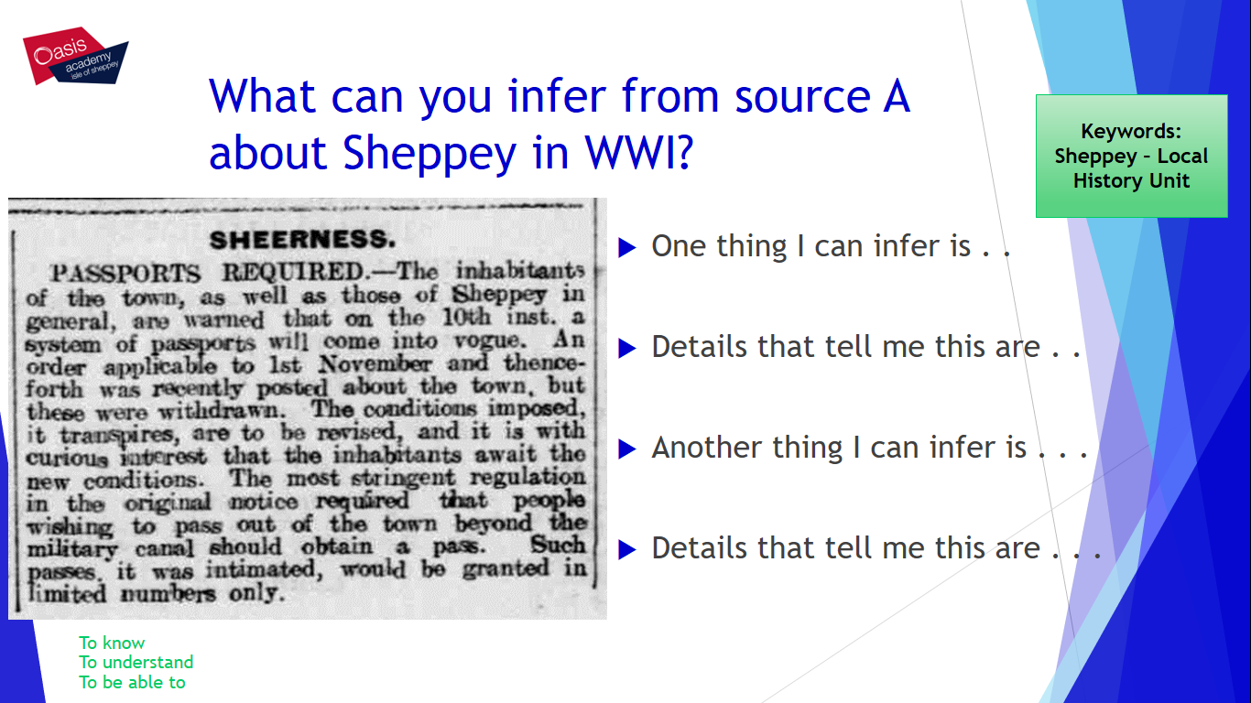
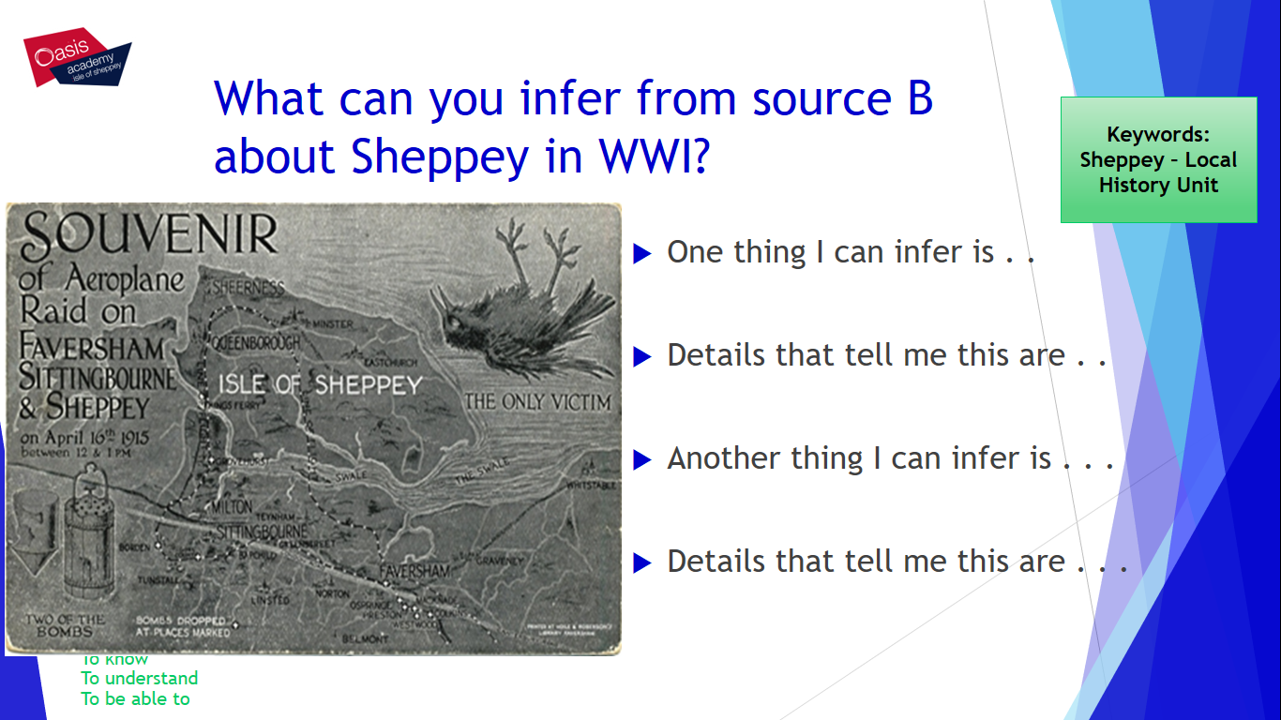

How useful are Sources D and E to a historian studying the role of Sheppey in British History?
- Content: Source D/E is useful because it tells me that . . .
- Own Knowledge: I know from my own knowledge that . .
- Provenance: The Provenance of this source makes it useful because . . .
- Say why it’s useful: Overall this source is useful because . . .

