Student Details

First Name Last Name
[____________________________________________________] [_______________________________________________]

Teacher’s Name
[_________________________________________________]

HOME LEARNING PACK
TERM 6
YEAR 10 - FOUNDATION

Learning Objective: | To expand brackets and simplify expressions. | Name:
 |  | Date:
Do NOW Activity:
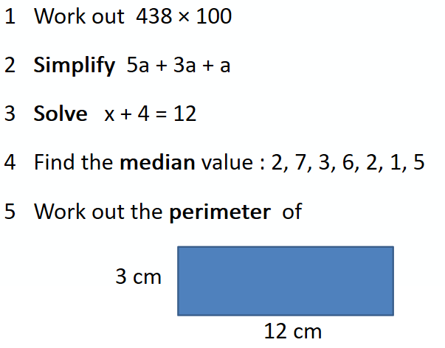

PRIOR KNOWLEDGE CHECK:
1. I can use the four operations in calculations.
THE MAIN EVENT
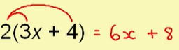
WORKED EXAMPLE #1:
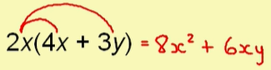
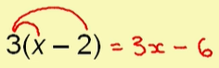
PRACTICE #1: Expand the following sets of brackets.

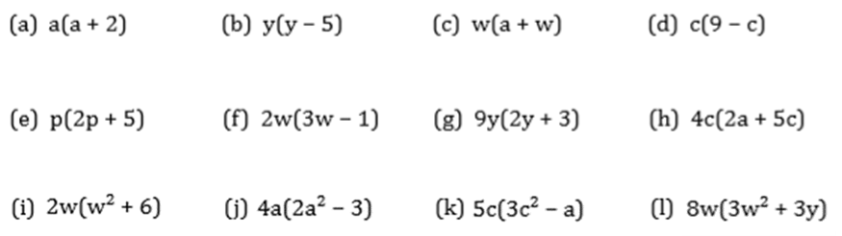
PRACTICE #2: Expand and simplify the following sets of brackets.

WORKED EXAMPLE #2:
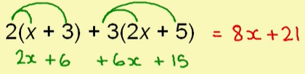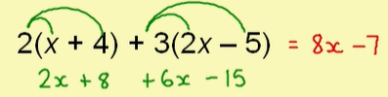
PRACTICE #3:
Expand and simplify the following sets of brackets.

PRACTICE #4:
Can you spot any mistakes in the following.
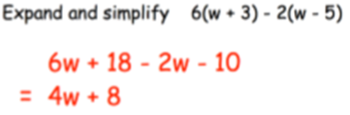
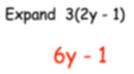
Application
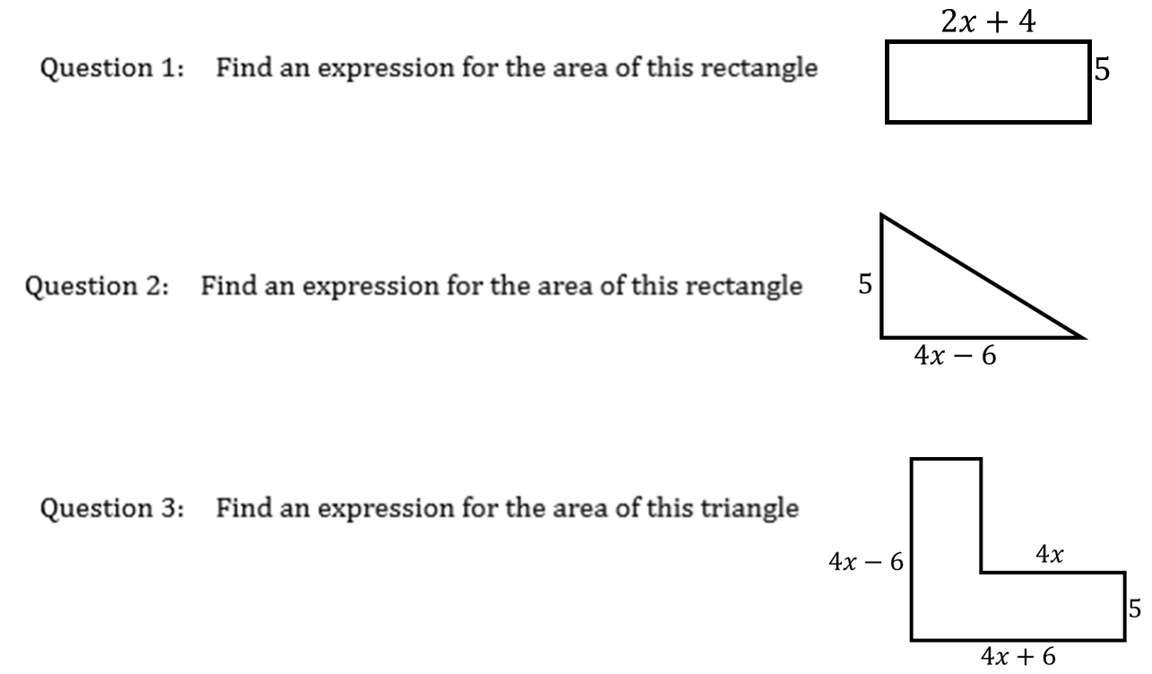

Learning Objective: | To be able to factorise algebraic expressions | Name:
 |  | Date:

Do NOW Activity:
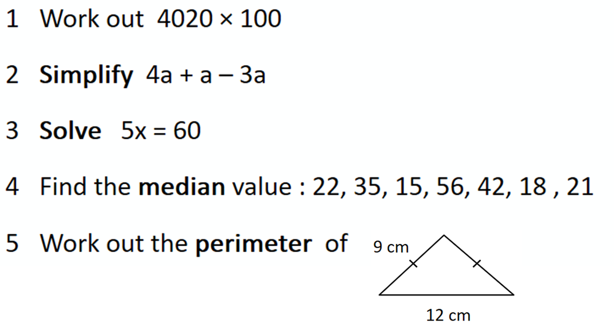
PRIOR KNOWLEDGE CHECK:
You will need to be able to expand single and 2 set of single brackets.
THE MAIN EVENT
WORKED EXAMPLE:
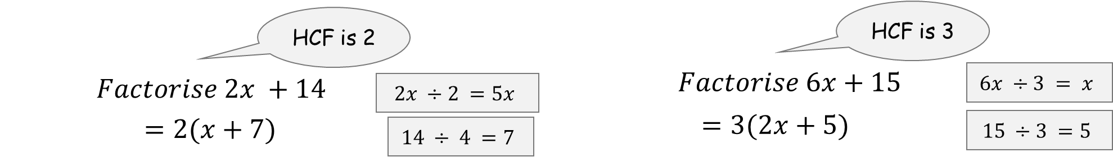

Practice #1. Factorise each of the below:
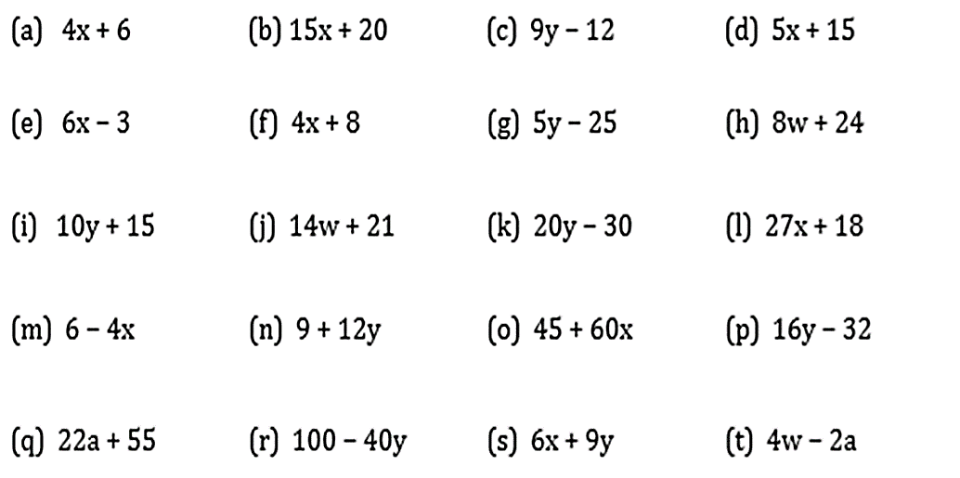

WORKED EXAMPLE:

Practice #2: Factorise fully
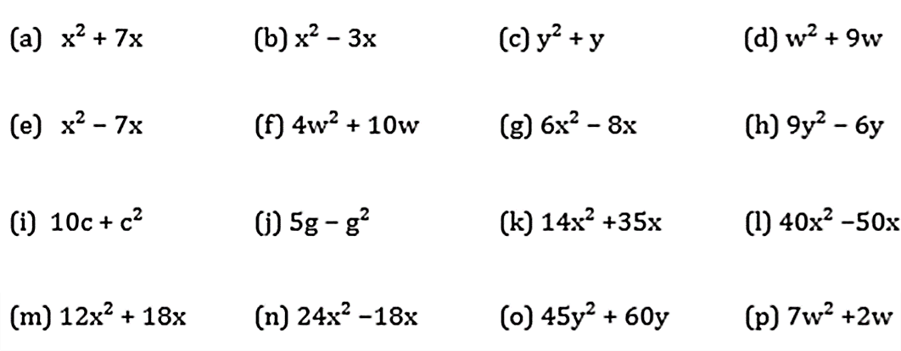

WORKED EXAMPLE #3:

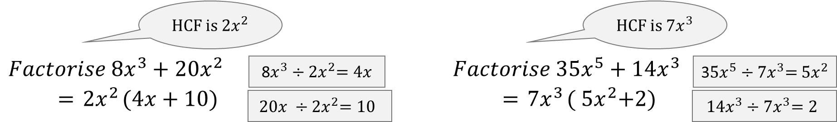

Practice #3: Factorise fully
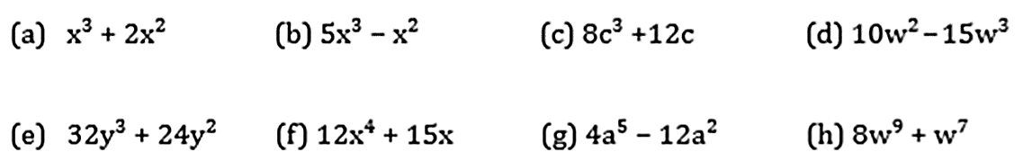

APPLICATION
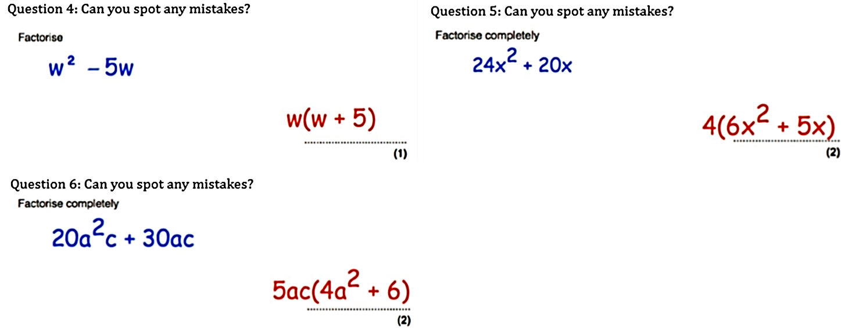

Learning Objective: | To solve multi-step equations. |  |  | Name:
 |  |  |  | Date:
Do NOW Activity:

PRIOR KNOWLEDGE CHECK:
1. I can use the four operations in calculations.
THE MAIN EVENT
WORKED EXAMPLE #1:
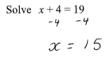 |  | 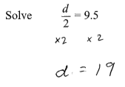 | 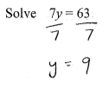 |  |  | 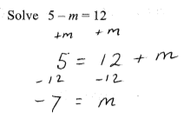
PRACTICE #1:
Solve the following equations.
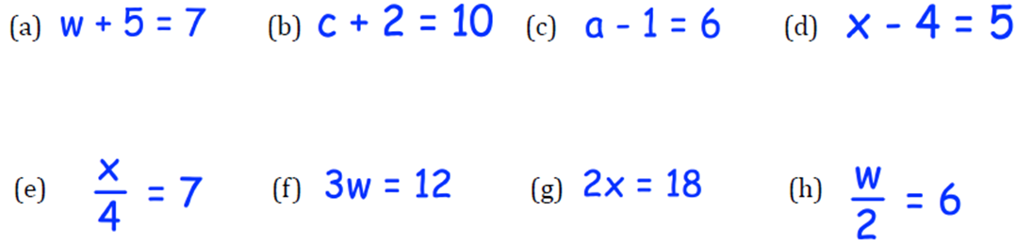

WORKED EXAMPLE #2:
PRACTICE #2:
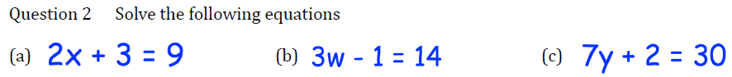

WORKED EXAMPLE #3: SOLVE
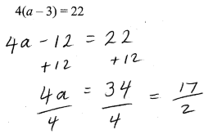 |  | 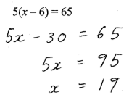 | 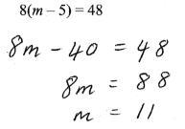 |  |  | 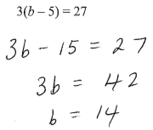
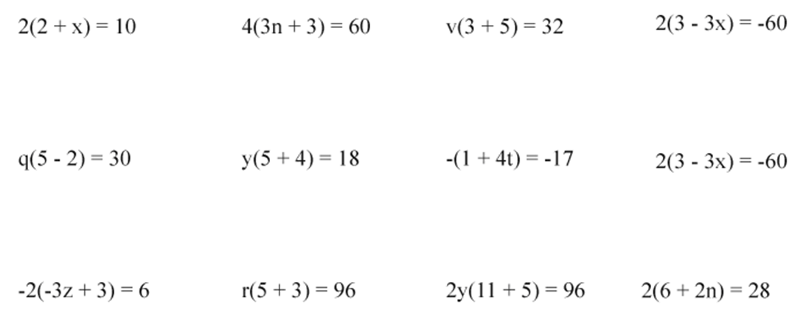

WORKED EXAMPLE #4:
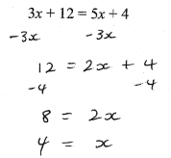 |  | 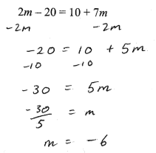 | 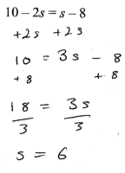 |  |  | 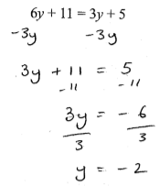
PRACTICE #3:
