Student Details

First Name Last Name
[____________________________________________________] [_______________________________________________]

Teacher’s Name
[_________________________________________________]

HOME LEARNING PACK
TERM 6
YEAR 10 - HIGHER

Learning Objective: | To expand brackets and simplify expressions. | Name:
 |  | Date:
Do NOW Activity:
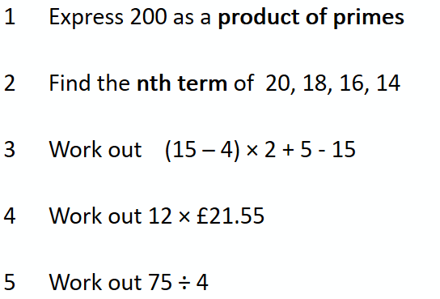
PRIOR KNOWLEDGE CHECK:
1. I can use the four operations in calculations.
THE MAIN EVENT
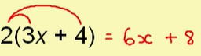
WORKED EXAMPLE #1:
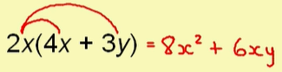
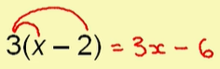
PRACTICE #1: Expand the following sets of brackets.

WORKED EXAMPLE #2:
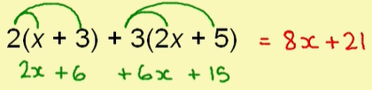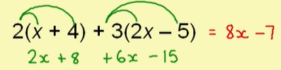
PRACTICE #2:
Expand and simplify the following sets of brackets.

WORKED EXAMPLE #3:
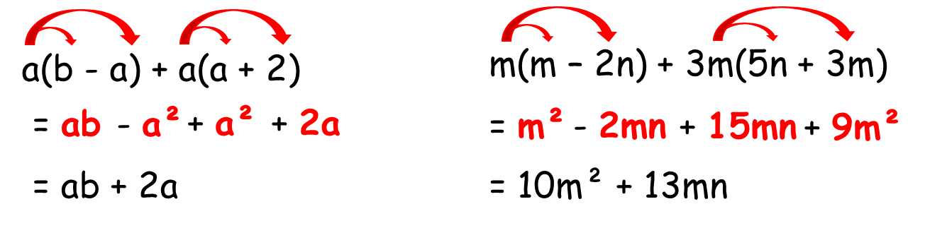

PRACTICE #3:
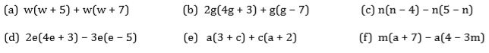
PRACTICE #4:
Can you spot any mistakes in the following.
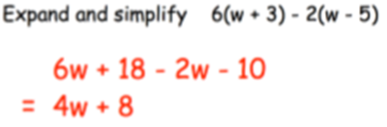
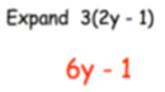
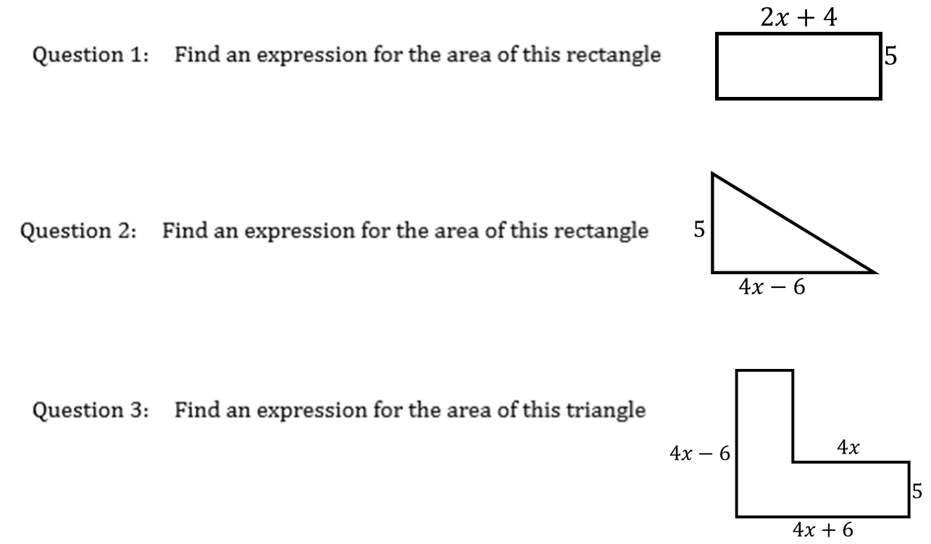
Application

Learning Objective: | To find the product of two binomials – double brackets | Name:
 |  | Date:
Do NOW Activity:
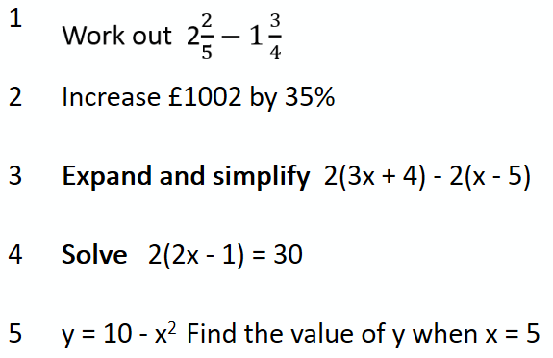
PRIOR KNOWLEDGE CHECK:
1. I can use the four operations in calculations.
THE MAIN EVENT
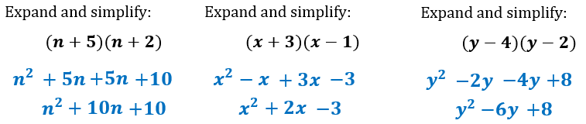
WORKED EXAMPLE #1:

PRACTICE #1: Expand the following sets of brackets.
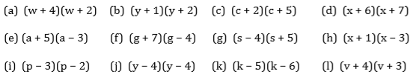

WORKED EXAMPLE #2:
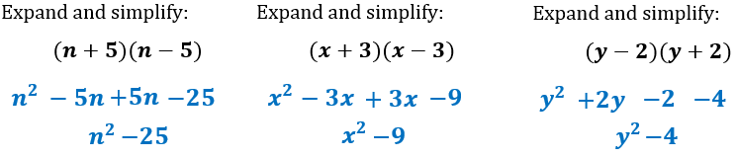
PRACTICE #2:
Expand and simplify the following sets of brackets.
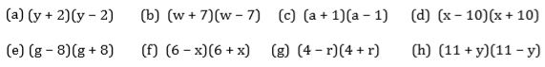
WORKED EXAMPLE #3:
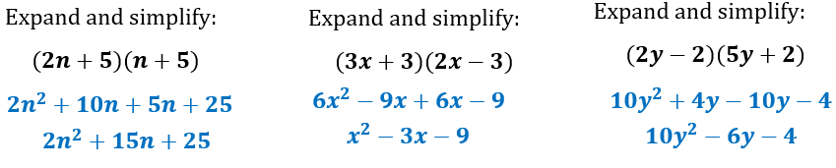

PRACTICE #3:
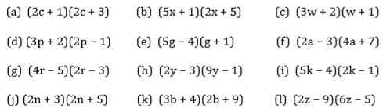
WORKED EXAMPLE #4:
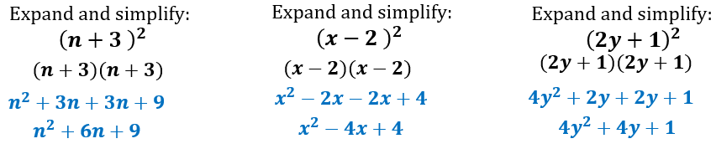

PRACTICE #4:
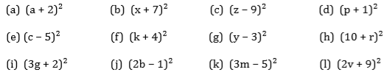

Learning Objective: | To find the product of three binomials | Name:
 |  | Date:
Do NOW Activity:
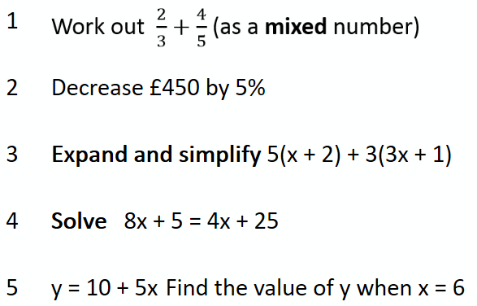
PRIOR KNOWLEDGE CHECK:
1. I can use the four operations in calculations.
THE MAIN EVENT
WORKED EXAMPLE #1:
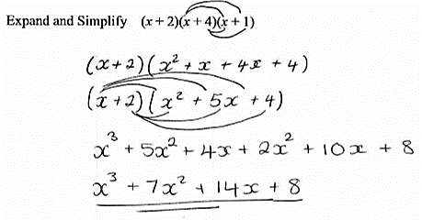
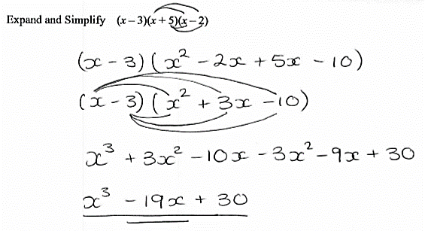

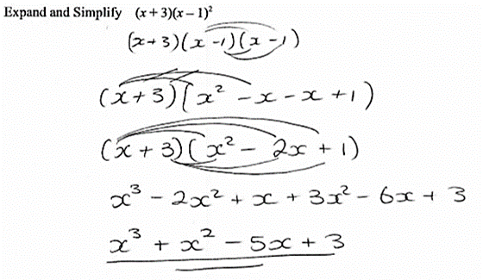

PRACTICE #1: Expand the following sets of brackets.

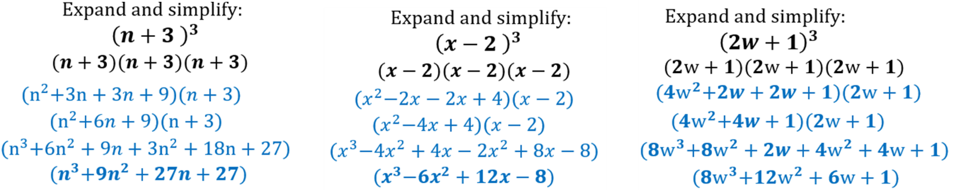
WORKED EXAMPLE #2:

PRACTICE #2:
Expand and simplify the following sets of brackets.
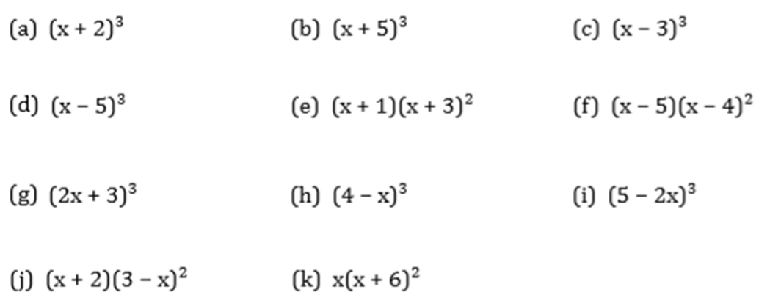

APPLICATION

