Student Details

First Name Last Name
[____________________________________________________] [_______________________________________________]

Teacher’s Name
[_________________________________________________]

HOME LEARNING PACK
TERM 6
YEAR 8
Learning Objective: | To find Factors and Multiples of any number | Name:
 |  | Date:
Do NOW Activity:
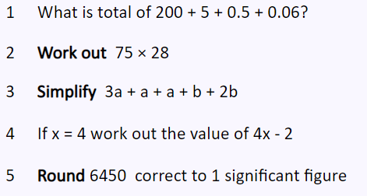
PRIOR KNOWLEDGE CHECK:
1. I can find multiples and factors
THE MAIN EVENT
WORKED EXAMPLE #1:
Factors – Numbers that can be divided equally into another number.
Factors of 20 = 1, 20 , 2, 10, 4, 5
PRACTICE #1:

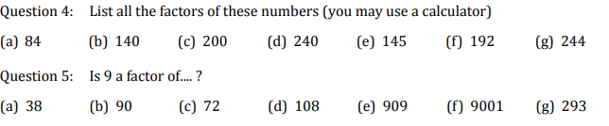

WORKED EXAMPLE #1:
Multiples : Times table of a number
List the multiples of 10: 10, 20, 30, 40
PRACTICE #2
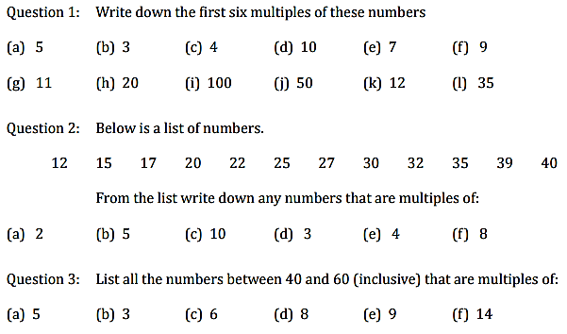

PRACTICE #3
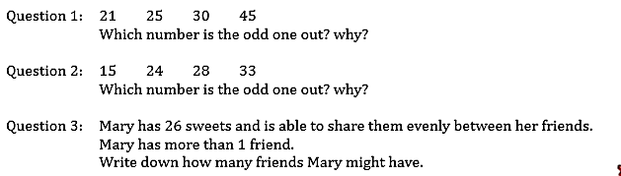

PRACTICE #4
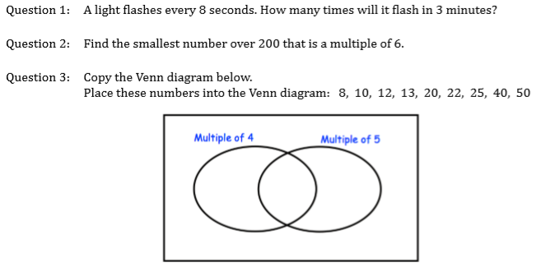

Learning Objective: | To write any number as a product of its prime factors. | Name:
 |  | Date:
Do Now Activity:
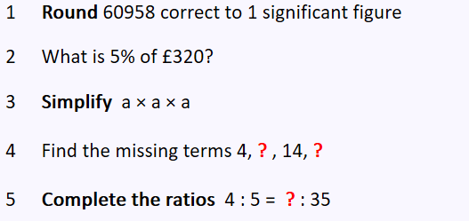
PRIOR KNOWLEDGE CHECK:
1. I can use the four operations in calculations.
THE MAIN EVENT
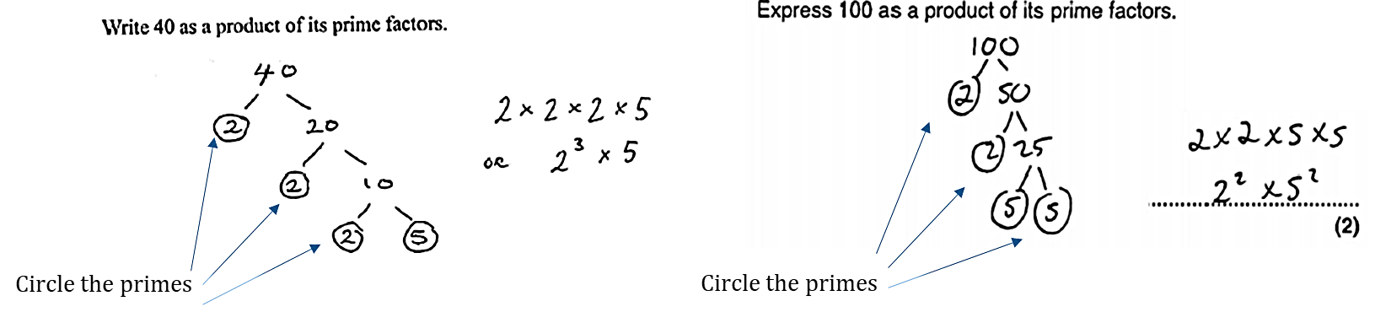
WORKED EXAMPLE #1:

PRACTICE #1:
Simplify each of the following calculations.
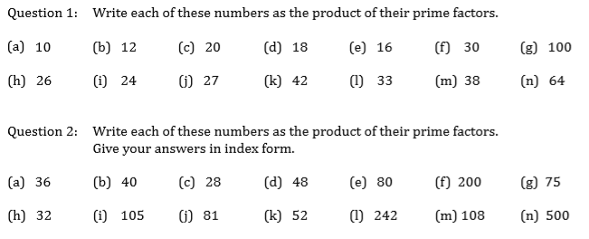
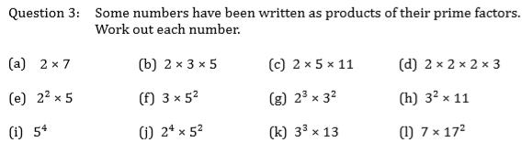
WORKED EXAMPLE #2:
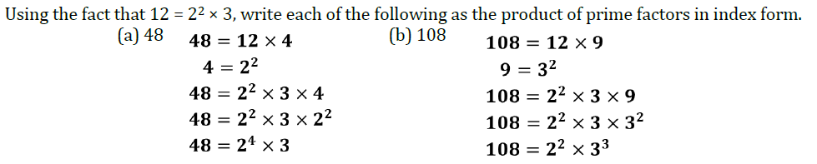

PRACTICE #2:
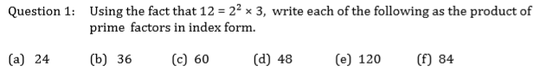

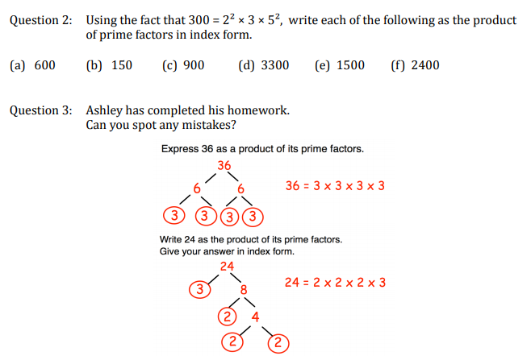

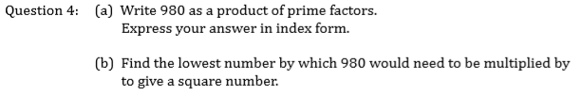

PRACTICE #3:
