Student Details

First Name Last Name
[____________________________________________________] [_______________________________________________]

Teacher’s Name
[_________________________________________________]

HOME LEARNING PACK
TERM 5
YEAR 10
HIGHER
Learning Objective: | To be able to multiply decimals | Name:
 |  | Date:
Do NOW Activity:
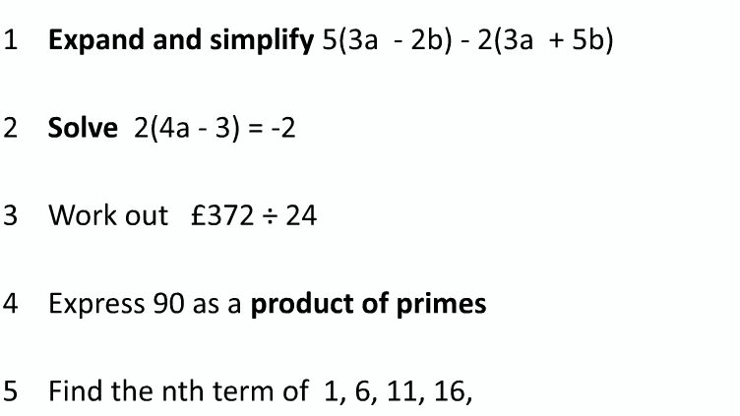
PRIOR KNOWLEDGE CHECK:
1. I am able to multiply integers
THE MAIN EVENT
WORKED EXAMPLE #1:
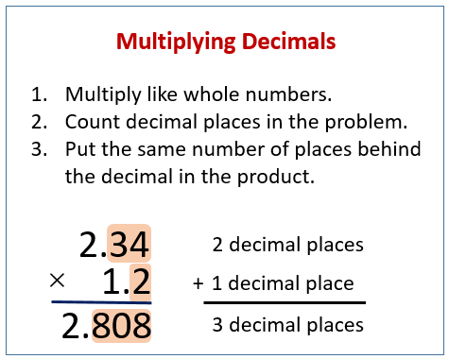

PRACTICE #1:

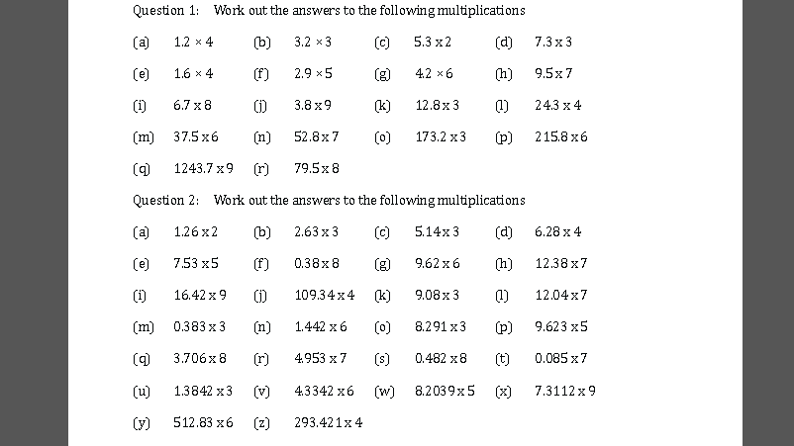

WORKED EXAMPLE #2:
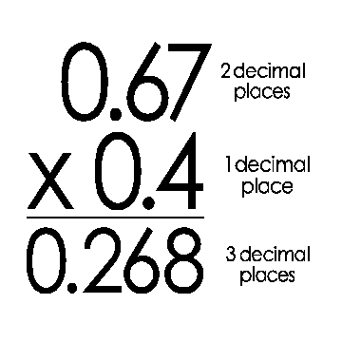
PRACTICE #2:

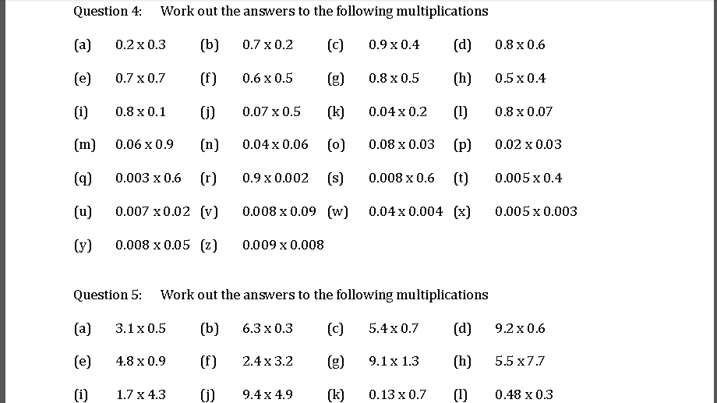
PRACTICE #3:

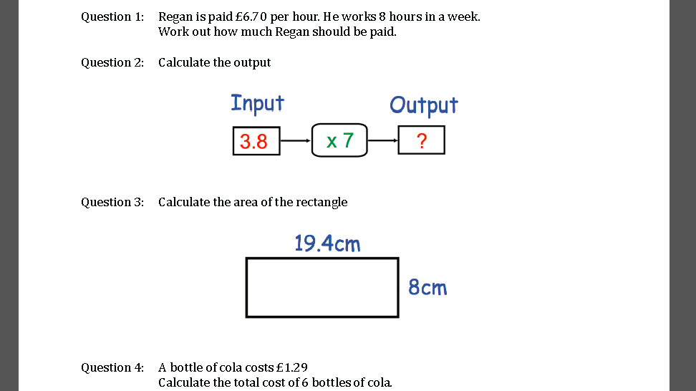

Learning Objective: | To be able to divide decimals | Name:
 |  | Date:
Do NOW Activity:
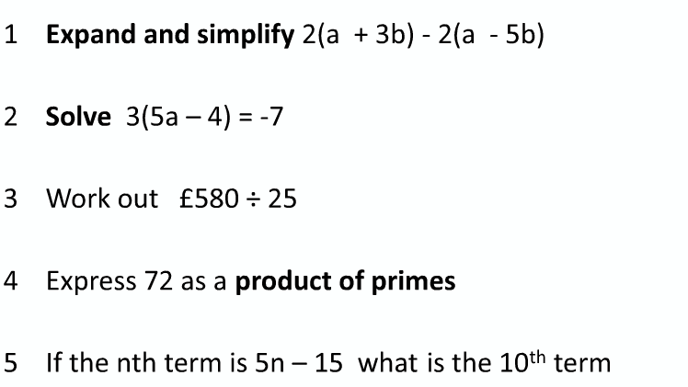
PRIOR KNOWLEDGE CHECK:
1. I am able to divide integers
THE MAIN EVENT
WORKED EXAMPLE #1:
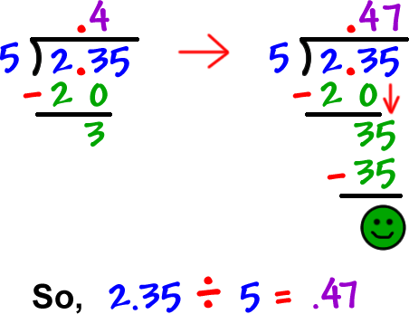

PRACTICE #1:

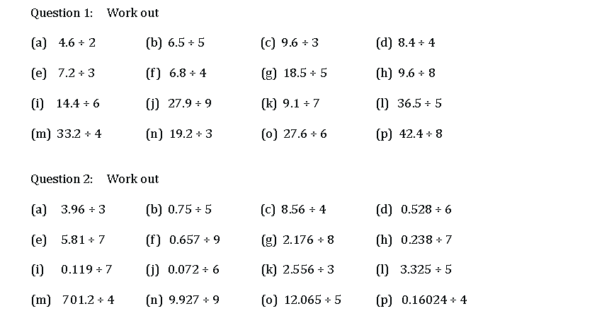

WORKED EXAMPLE #2:
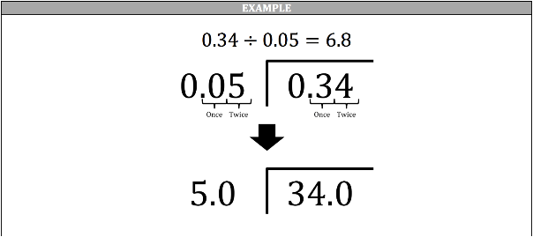
PRACTICE #2:
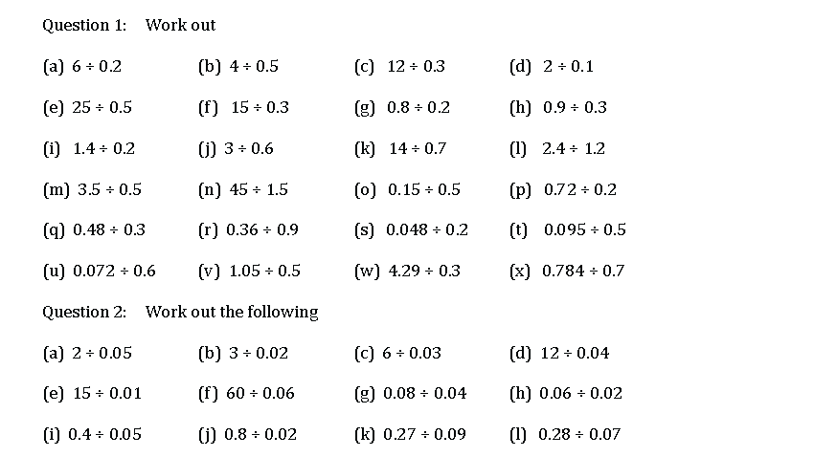

PRACTICE #3:

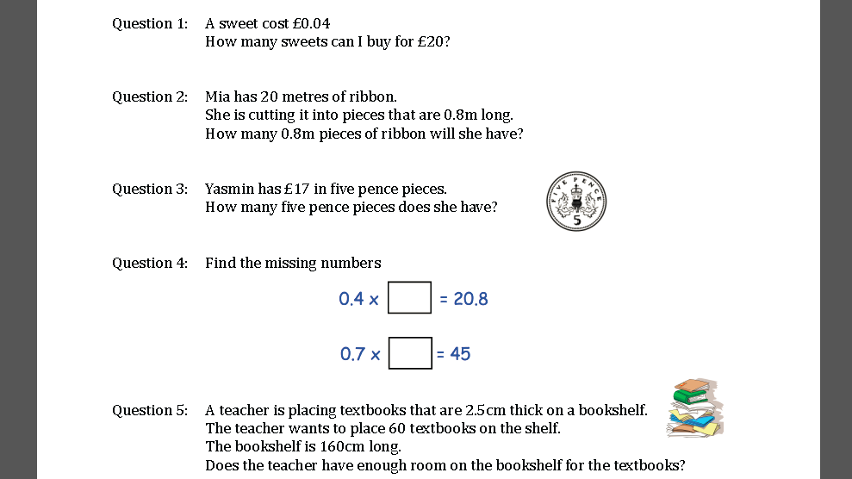

Learning Objective: | To be able to estimate answers to calculations that involve decimals | Name:
 |  | Date:
Do NOW Activity:
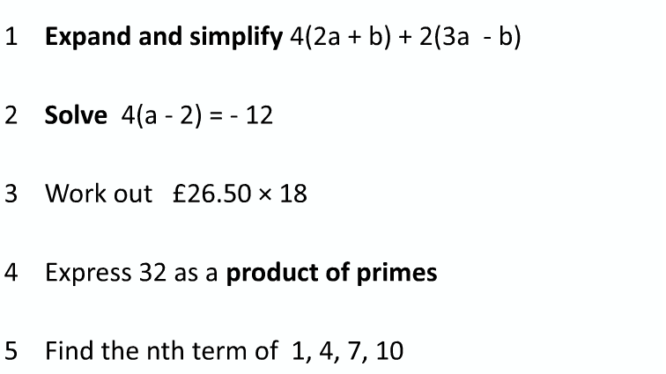
PRIOR KNOWLEDGE CHECK:
1. I am able to round values to one significant figure
THE MAIN EVENT
WORKED EXAMPLE #1:
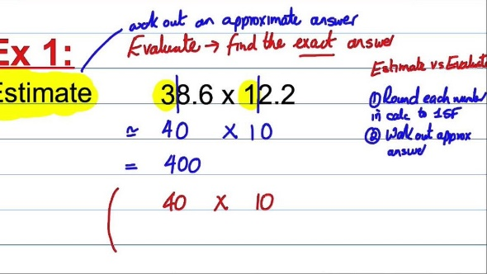

PRACTICE #1:

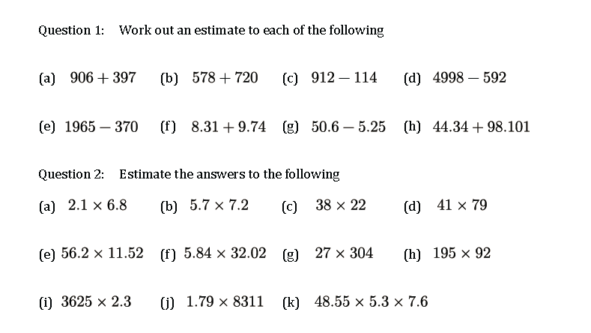
WORKED EXAMPLE #2:
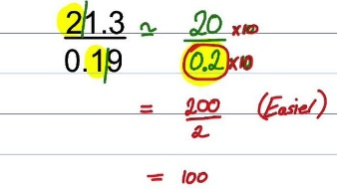
PRACTICE #2:

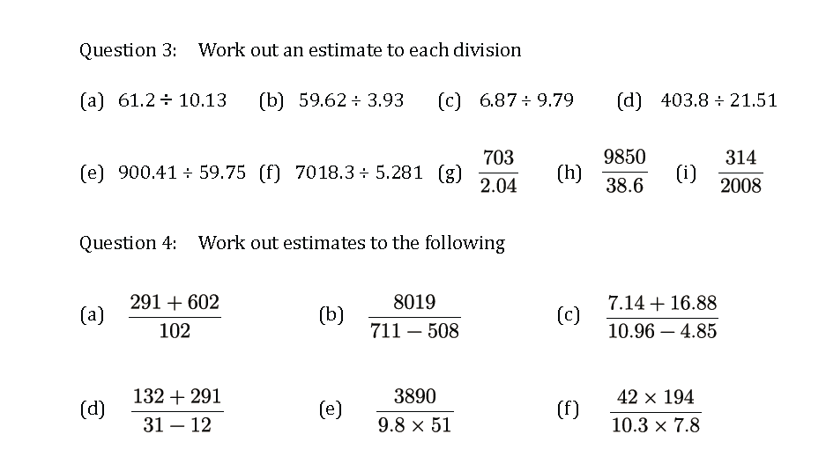

PRACTICE #3:

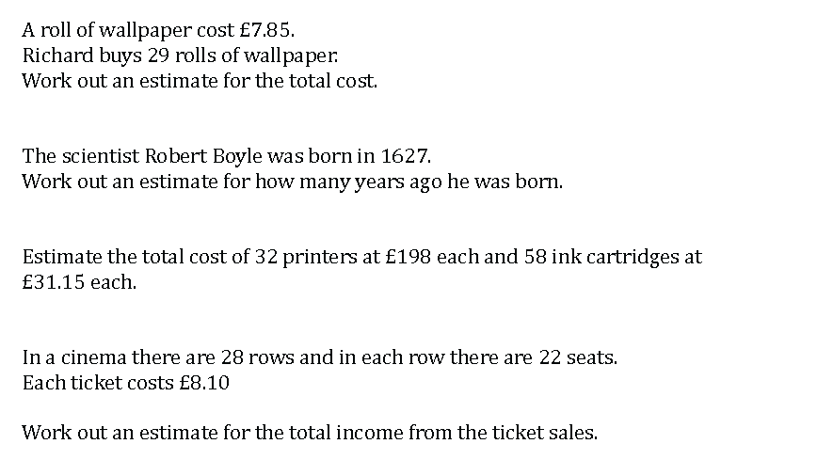

Learning Objective: | To be able to convert recurring decimals to fractions | Name:
 |  | Date:
Do NOW Activity:
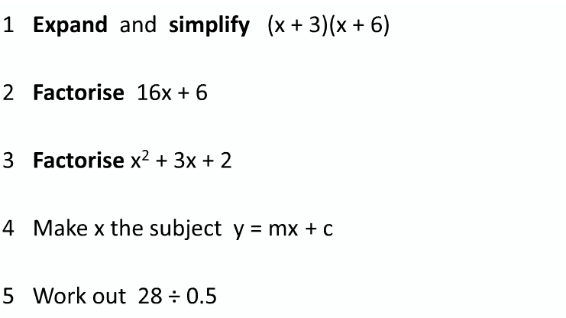
PRIOR KNOWLEDGE CHECK:
1. I am able to find the HCF of two numbers
THE MAIN EVENT
WORKED EXAMPLE #1:
Q1 Use method shown previously i.e. 1/3 would be 1$÷$ 3
Q2 0.44444… = 4/9 0.525252… = 52/99

PRACTICE #1:

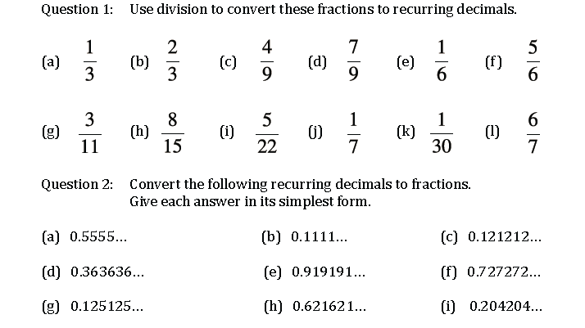

WORKED EXAMPLE #2:
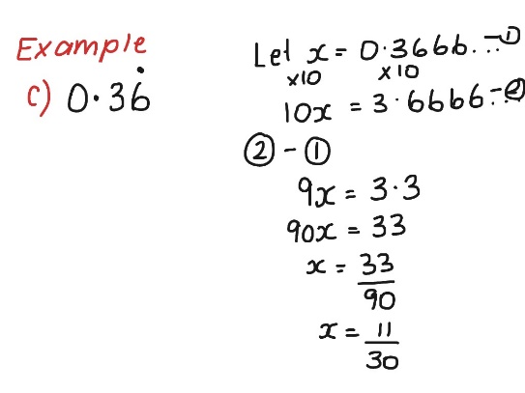
PRACTICE #2:

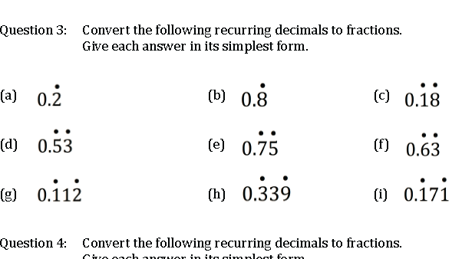

PRACTICE #3:

