Student Details

First Name Last Name
[____________________________________________________] [_______________________________________________]

Teacher’s Name
[_________________________________________________]

HOME LEARNING PACK
TERM 5
YEAR 10
HIGHER
Learning Objective: | To be able to calculate fractions of amounts | Name:
 |  | Date:
Do NOW Activity:
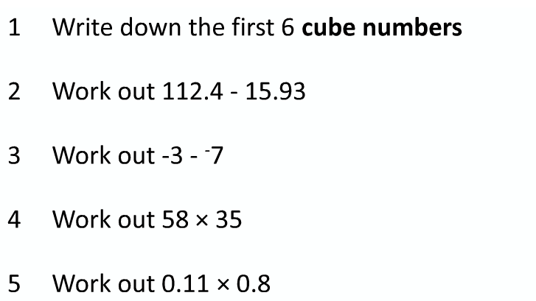
PRIOR KNOWLEDGE CHECK:
1. I am able to multiply and divide integers
THE MAIN EVENT
WORKED EXAMPLE #1:
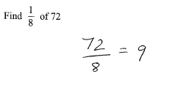

PRACTICE #1:

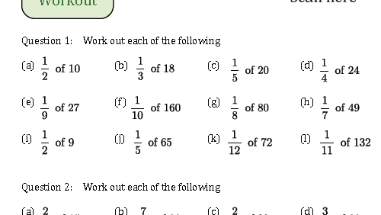

WORKED EXAMPLE #2:
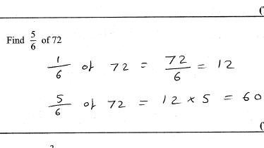
PRACTICE #2:

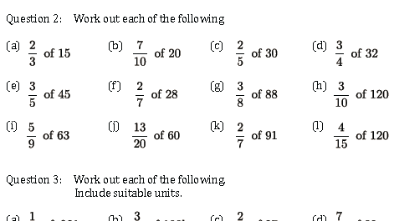
PRACTICE #3:

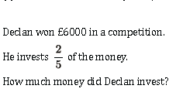

PRACTICE #4:
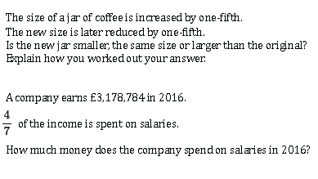

Learning Objective: | To be able to express one number as a fraction of another | Name:
 |  | Date:
Do NOW Activity:
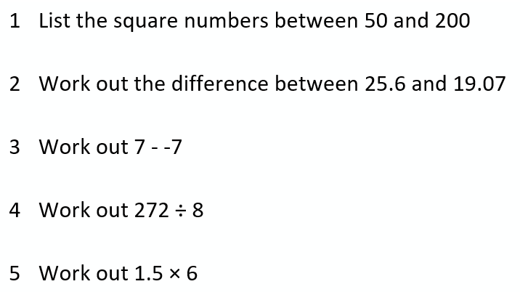
PRIOR KNOWLEDGE CHECK:
1. I am able to simplify fractions
THE MAIN EVENT
WORKED EXAMPLE #1:
5
20
Write £5 as a fraction of £20
÷ 5
÷ 5

1
4

PRACTICE #1:

- What is 10 as a fraction of 100?
- What is 5 as a fraction of 20?
- What is 9 as a fraction of 90?
- What is 50 as a fraction of 100?
- What is 6 as a fraction of 9?
- What is 15 as a fraction of 35?
- What is 16 as a fraction of 48?
- What is 20 as a fraction of 50?

WORKED EXAMPLE #2:
In a class of 30 pupils, 12 are girls. What fraction of the class are girls?

2
5
÷ 6
÷ 6
12
30

PRACTICE #2:

- In my pencil case I have 2 blue pens, 2 black pens and a green pen. What fraction of my pens are blue?

- There are 30 men and 20 women at a conference. What fraction of the people were men.

- I printed 60 assessments and 10 were on yellow paper. What fraction of the assessments were on yellow paper?

- I have 9 blue, 3 red, 6 green, and 11 yellow smarties. What fraction of the smarties are :
- Blue b) red c) Not blue

PRACTICE #3:

- The table below shows the colours of cars in the car park.
Car colour | Frequency
Black | 25
White | 10
Grey | 10
Red | 5

What fraction of the cars were

- Black b) white c) red d) Not grey
PRACTICE #4:
- Sophie did a survey on the year 8 pupils’ favourite flavour ice cream. She recorded her results in the table below.
Ice cream flavour | Tally | Frequency
Chocolate | | | | | | | | | | | | | | | | | 15
Vanilla | | | | | | | | | | | | | | | | | | | | | | 20
Strawbery | | | | | | | | | | | | 10
Mint chocolate chip | | | | | | | | 6
Salted caramel | | | | | | 4
Lemon sorbet | | | | | | | 5

- What is wrong with Sophie’s tallying method? What fraction of students liked
- Chocolate c) salted caramel d) vanilla

Learning Objective: | To be able to convert decimals to fractions and order fractions | Name:
 |  | Date:
Do NOW Activity:
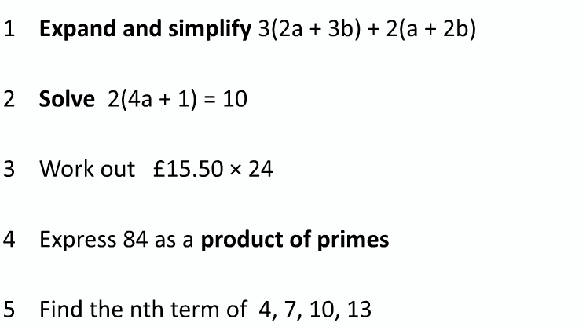
PRIOR KNOWLEDGE CHECK:
1. I am able to use the ‘bus stop’ method or long division
THE MAIN EVENT
WORKED EXAMPLE #1:
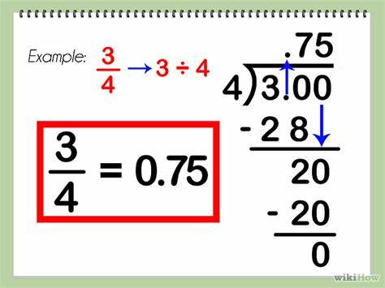

PRACTICE #1:

Convert the following fractions into decimals

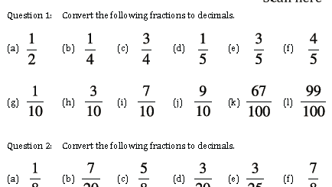

WORKED EXAMPLE #2:
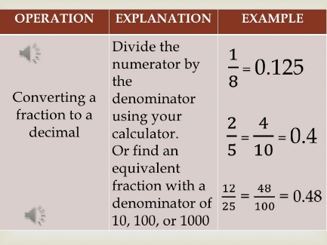
PRACTICE #2:

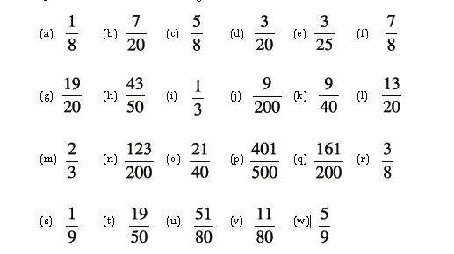

PRACTICE #3:

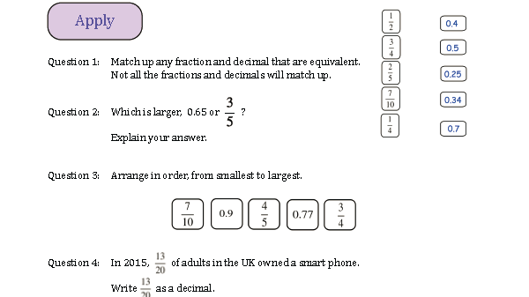

Learning Objective: | To be able to add & subtract decimals | Name:
 |  | Date:
Do NOW Activity:
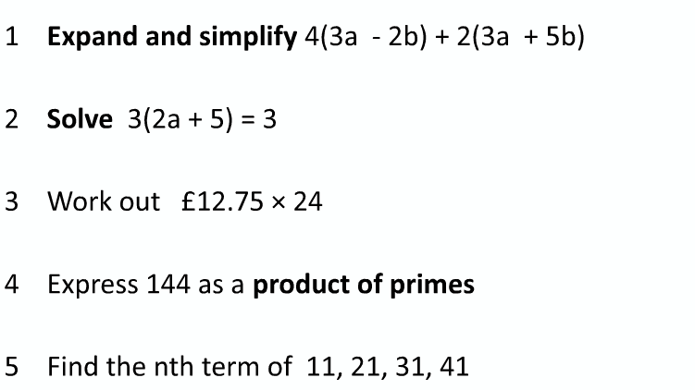
PRIOR KNOWLEDGE CHECK:
1. I am able to use the column method for addition
THE MAIN EVENT
WORKED EXAMPLE #1:
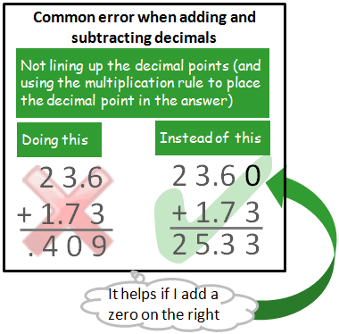

PRACTICE #1:

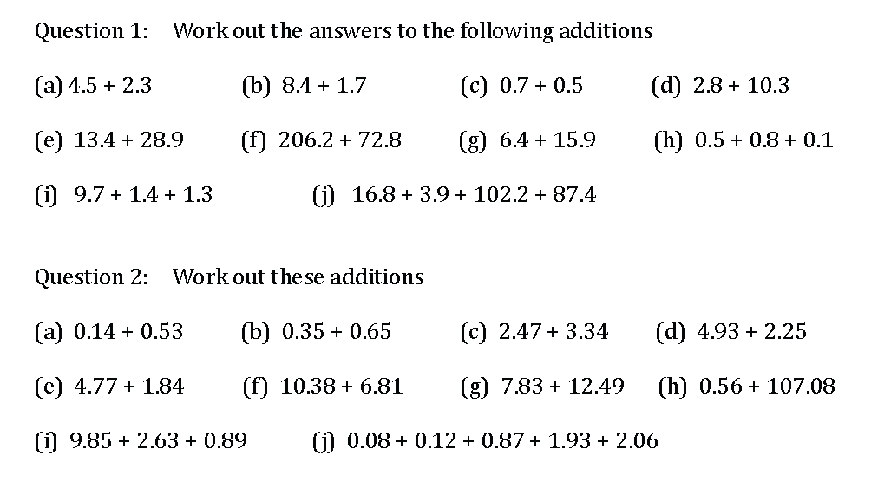

WORKED EXAMPLE #2:
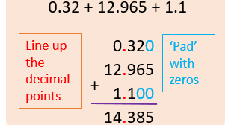
PRACTICE #2:

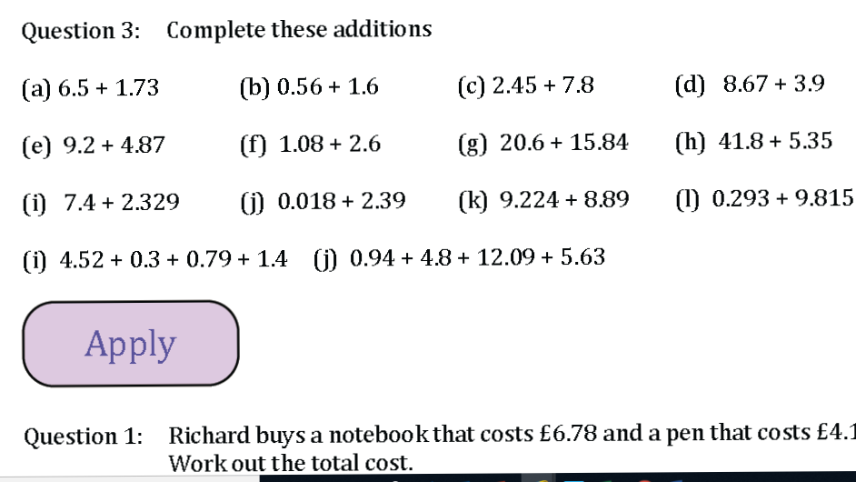

PRACTICE #3:

