Student Details

First Name Last Name
[____________________________________________________] [_______________________________________________]

Teacher’s Name
[_________________________________________________]

HOME LEARNING PACK
TERM 5
YEAR 10
FOUNDATION
Learning Objective: | To be able to divide decimals | Name:
 |  | Date:
Do NOW Activity:
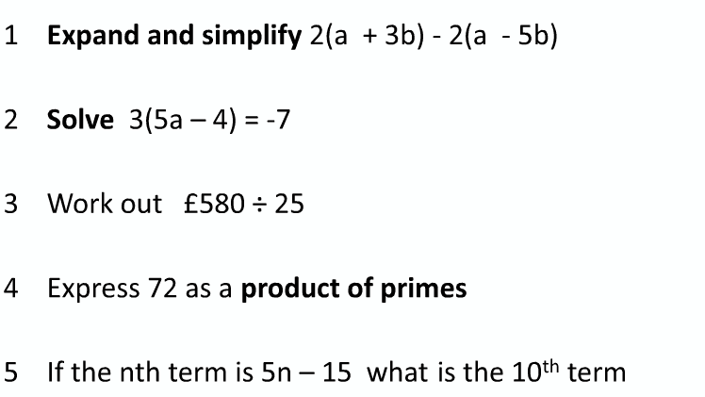
PRIOR KNOWLEDGE CHECK:
1. I am able to divide integers
THE MAIN EVENT
WORKED EXAMPLE #1:
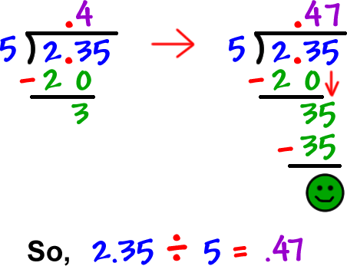

PRACTICE #1:

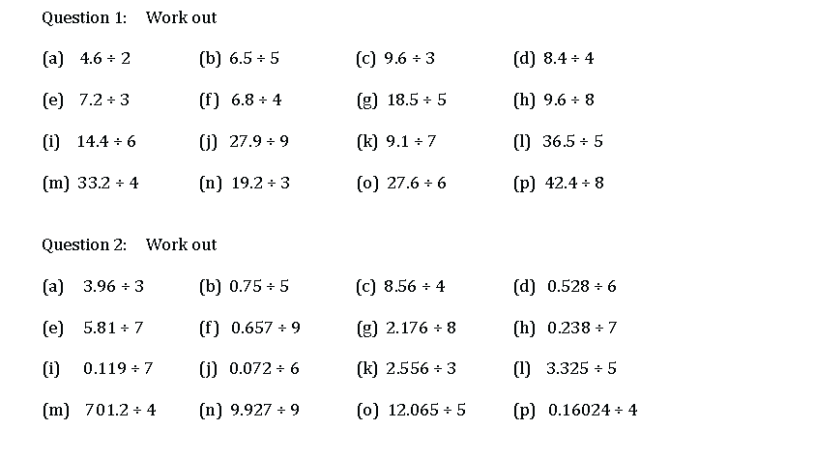

WORKED EXAMPLE #2:
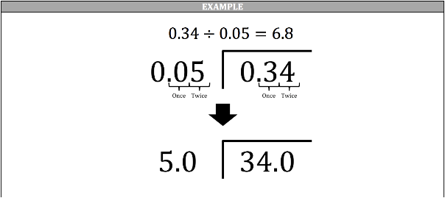
PRACTICE #2:
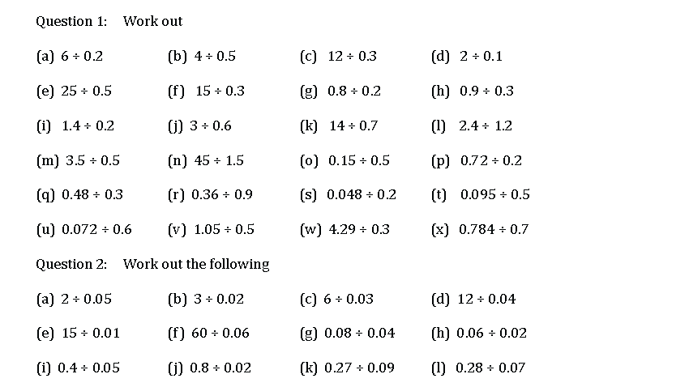

PRACTICE #3:

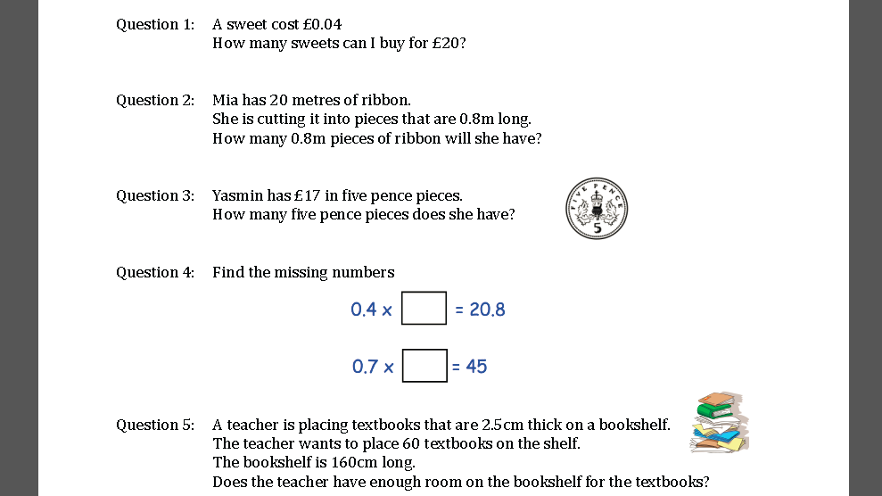

Learning Objective: | To be able to use a calculator to solve problems involving decimals | Name:
 |  | Date:
Do NOW Activity:
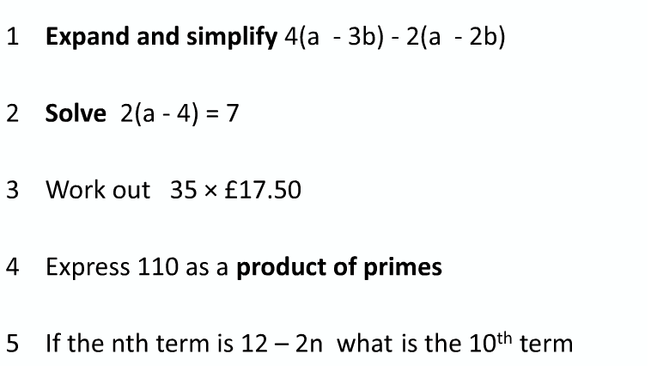
PRIOR KNOWLEDGE CHECK:
1. I am able to find the HCF of two numbers
THE MAIN EVENT
WORKED EXAMPLE #1:
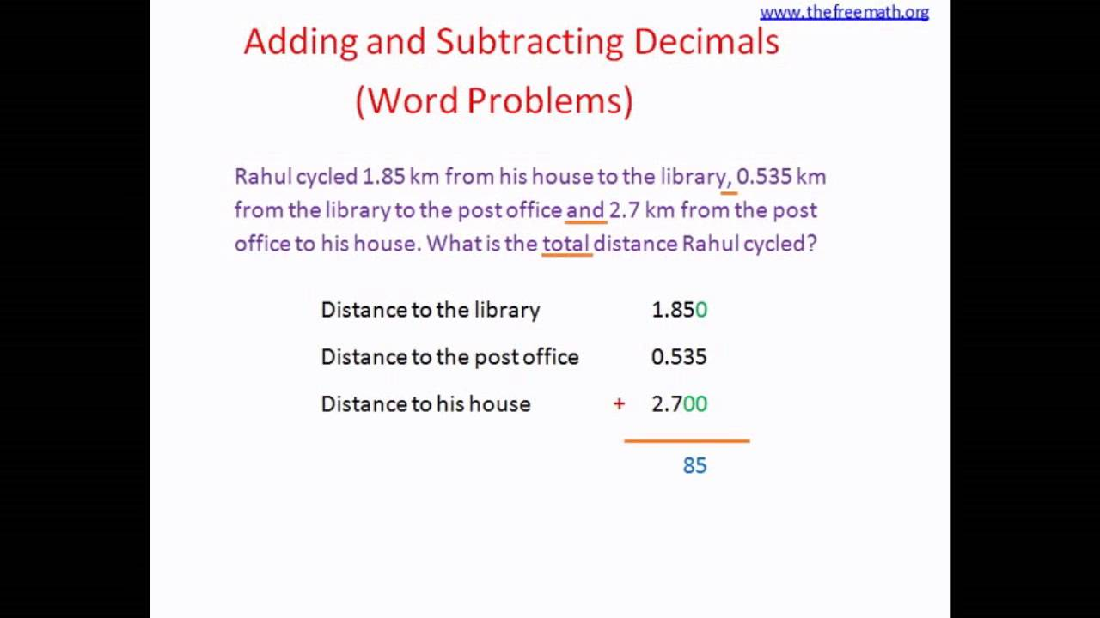

PRACTICE #1:

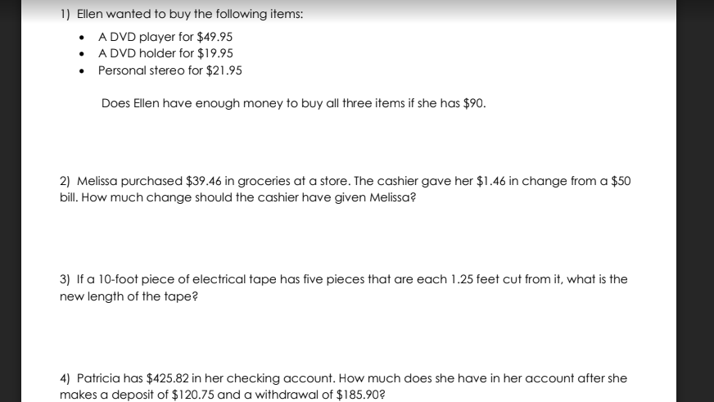

WORKED EXAMPLE #2:
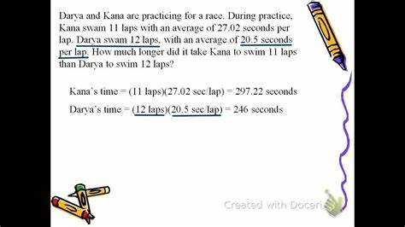
PRACTICE #2:

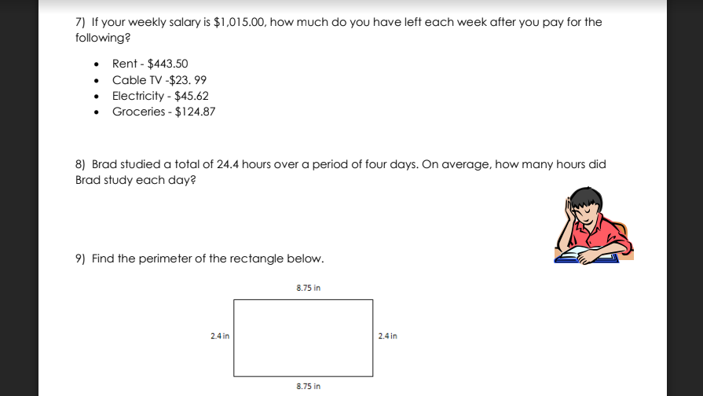

Learning Objective: | To be able to form algebraic expressions from worded problems | Name:
 |  | Date:
Do NOW Activity:
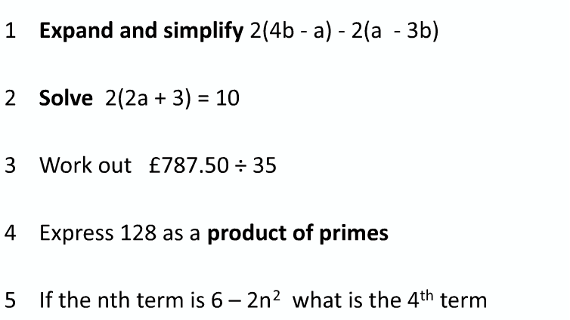
PRIOR KNOWLEDGE CHECK:
1. I am able to use a variable
THE MAIN EVENT
WORKED EXAMPLE #1:
5 more than x is….. x +5

K less than 3 is……... 3 - k

PRACTICE #1:

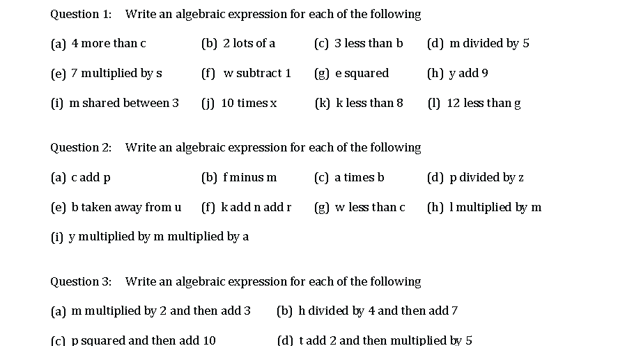

WORKED EXAMPLE #2:
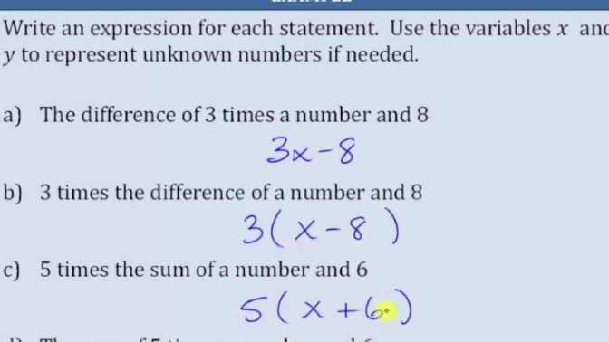
PRACTICE #2:

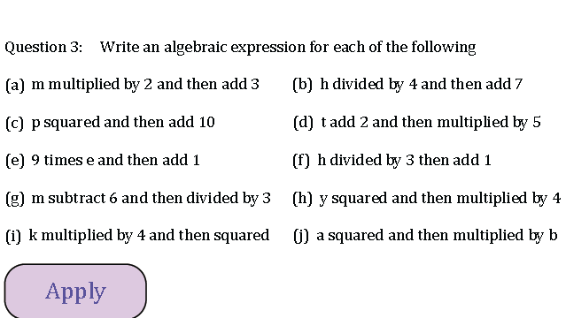
PRACTICE #3:

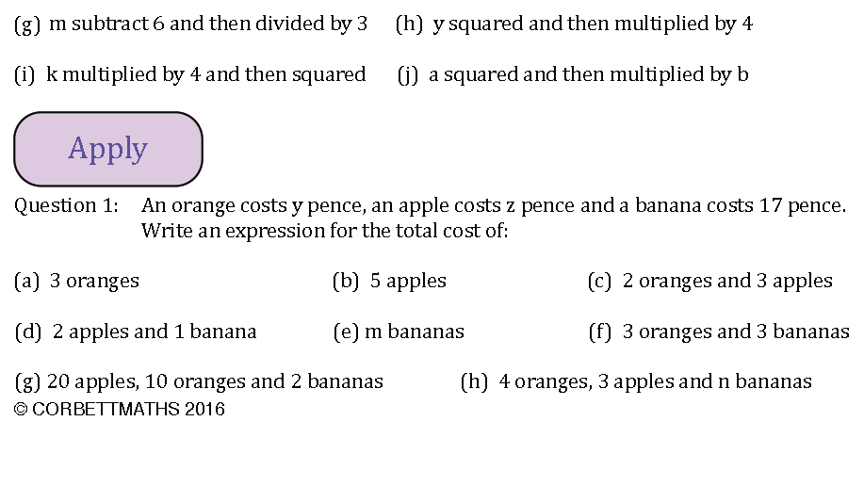

Learning Objective: | To be able to simplify algebraic expressions by collecting like terms | Name:
 |  | Date:
Do NOW Activity:
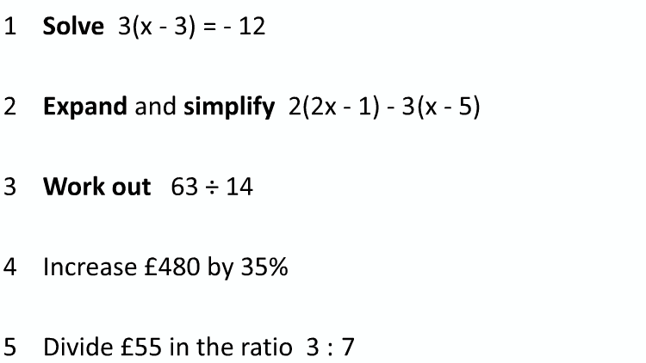
PRIOR KNOWLEDGE CHECK:
1. I am able to perform calculations with directed numbers
THE MAIN EVENT
WORKED EXAMPLE #1:
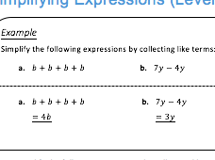
PRACTICE #1:
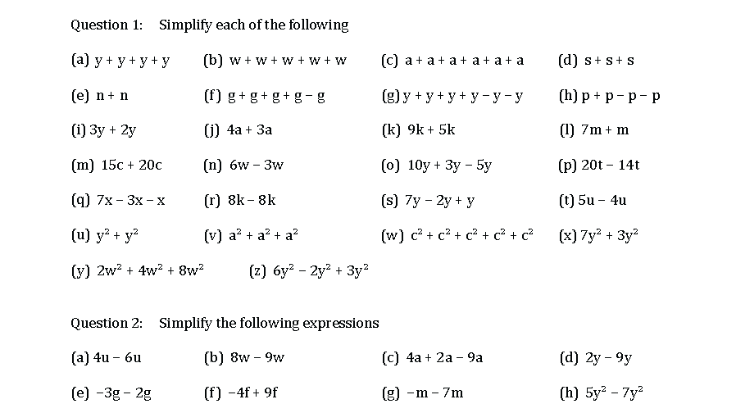

WORKED EXAMPLE #2:
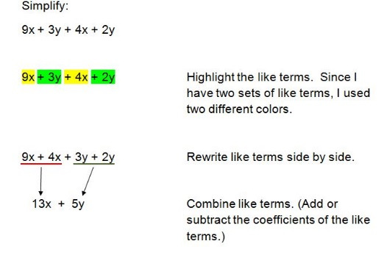
PRACTICE #2:

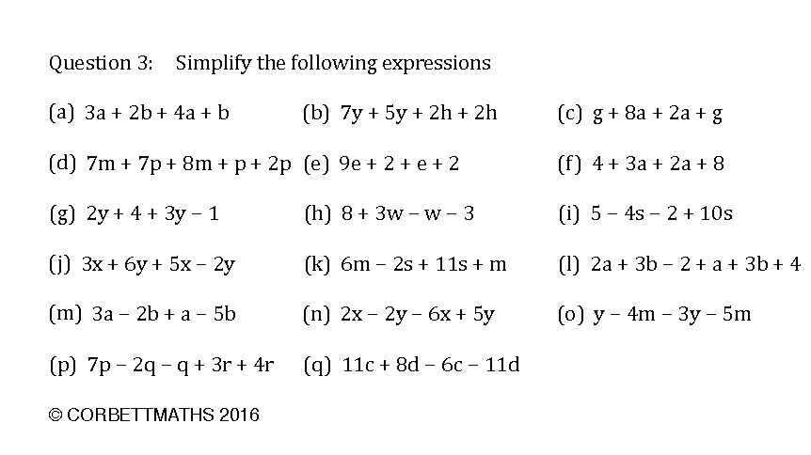

PRACTICE #3:

