First Name Last Name
[____________________________________________________] [_______________________________________________]

Teacher’s Name
[_______________________________________________________________]

HOME LEARNING PACK
TERM 5
YEAR 11
FOUNDATION – Grade 1 - 3

Write $\frac{15}{45}$ in  simplest form. | How many metres are in 5 kilometres? | List the factors of 18. | Round 5.682 to one decimal place.
Decrease £500 by 20%. | Find the value of  $5^{2}+2^{3}$. | Calculate $\frac{1}{12}÷\frac{9}{4}$. | List the first 5 prime numbers.
Calculate $\frac{2}{5}+\frac{1}{4}$ . | Find the value of  $5+\sqrt{81}×4$. | Write 100 as a product of prime factors. | Solve  $2x+7=22$.

Find the size of angle $x$. | Simplify $5x+2y+7x-y.$ | Find the area.  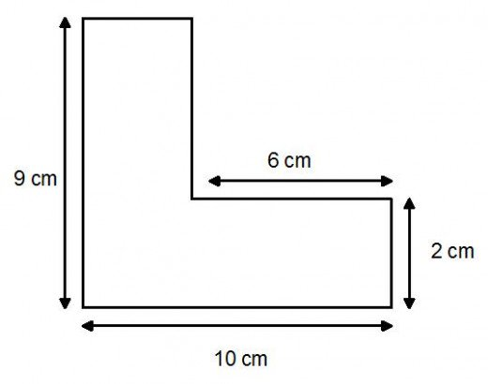 | Estimate the value of  $$\frac{56.32×12}{2.478+0.96}$$
 | Ben and Tyrell share £55 in the ratio 2:3. How much does Tyrell get? |  | Find the volume of the cuboid.  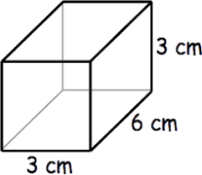
Solve  $5x-4=3x+12$. | What’s the interior angle of an equilateral triangle? | Expand $6x(2x+3)$.

Solve $\frac{x}{2}=8$. | Find the area.  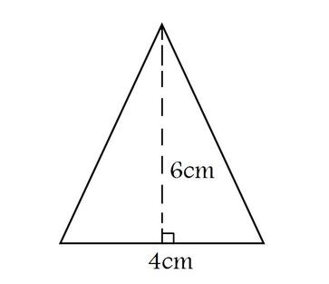 | There are 15 counters in a bag. 2 are green, the rest are blue. A counter is picked at random. Find the probability of picking a blue counter. | Find the circumference. Give your answer in terms of $π.$  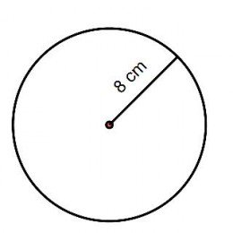
What type of correlation is shown here?  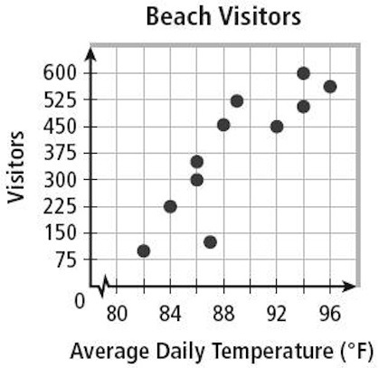 | If $a = 6$ and $b = 4$, find:  $$- a-b$$  $$- a+b$$  $$a+(-b)$$  $$a-(-b)$$ | What’s the lowest common multiple of 6 and 8? | Simplify $x^{4}×x^{8}$.
 |  | I scored 24 out of 50 on a test. What’s that as a percentage? | It costs £150 to buy 10 games. How much does it cost to buy 12 games?

Find the length w. | Find angle a and give reasons. | If a car travels 25 miles in 30 minutes, what is its speed in miles per hour? | Write 5 million in standard form.
Translate the  point A by $\left(\begin{matrix}3 \\ -2\end{matrix}\right)$. Label the translated point B.  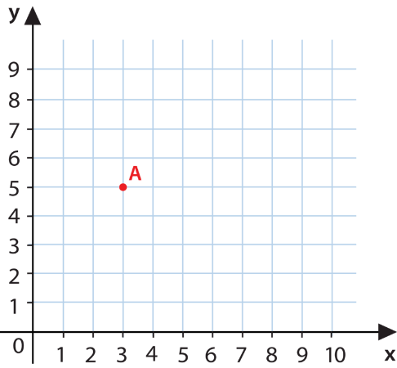  What are the coordinates of B? |  | What’s the next term in each sequence?  - 1, 1, 2, 3, 5, 8, …  - 3, 7, 11, 15, 19, …  c) 1, 2, 4, 8, 16, 32, … | These two cuboids are similar.  Find the lengths$p$ and $q$.  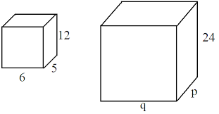
 | Solve $15<3+6x$.

