First Name Last Name
[____________________________________________________] [_______________________________________________]

Teacher’s Name
[_______________________________________________________________]

HOME LEARNING PACK
TERM 5
YEAR 11: NON-CALCULATOR
FOUNDATION PLUS – Grade 3 - 5

Write $\frac{15}{45}$ in its simplest form. | How many metres are in 5 kilometres? | Find the circumference. Give your answer in terms of $π.$  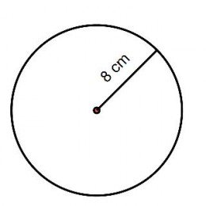 | Simplify $x^{4}×x^{8}$.
Decrease £500 by 20%. | Find the value of  $5^{2}×2^{3}$. | Calculate $\frac{1}{12}÷\frac{9}{4}$. | List the first 5 prime numbers.
Calculate $\frac{2}{5}+\frac{1}{4}$ . | Find the value of  $5+\sqrt{81}×4$. | Write 100 as a product of prime factors. | Solve  $2x+7=22$.

Find the value of $y$. | Expand $6x(2x+3)$. | Find the area.  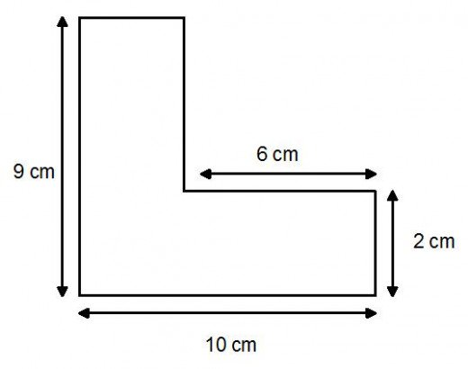 | Find the length w.
 | Ben and Tyrell share £55 in the ratio 2:3. How much does Tyrell get? |  | 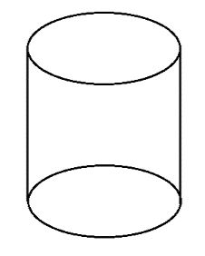  Find the volume of a cylinder with radius 4cm and height 10cm. Give an exact answer.
Solve  $5x-4=3x+12$. | Work out the interior angle of a regular octagon. | Expand and simplify  $(x+2)(x+5)$.

Factorise $5x^{2}+20xy$. | Find the area.  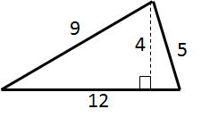 | Lucy flips two fair coins. What’s the probability she gets two tails? | What’s the gradient of the straight line with equation  $y=5-2x$ ?
What type of correlation is shown here?  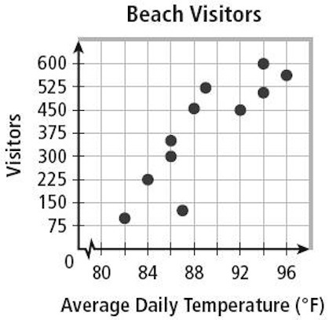 | If $a = 6$ and $b = 4$, find:  $$- a-b$$  $$- a+b$$  $$a+(-b)$$  $$a-(-b)$$ | What’s the lowest common multiple of 6 and 8? | I scored 24 out of 40 on a test. What’s that as a percentage?
 |  | Complete the blanks:  $$3^{3}$$  $$9$$  $$3^{1}$$  $$3^{0}$$  $$\frac{1}{3}$$ | It costs £150 to buy 9 games. How much does it cost to buy 12 games?

Multiply  $2×{10}^{5}$ by $7 ×{10}^{8}$.  Give your answer in standard form. | Find angle a and give reasons. | Solve $15<3+6x$. | If a man walks 1.3km in 15 minutes, what is his average speed in km/h?
Translate the  point A by $\left(\begin{matrix}3 \\ -2\end{matrix}\right)$. Label the translated point B.  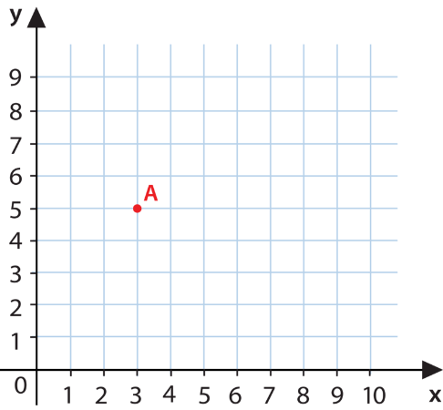  What are the coordinates of B? |  | Name each type of sequence:  - 1, 1, 2, 3, 5, 8, …  - 3, 7, 11, 15, 19, …  c) 1, 2, 4, 8, 16, 32, … | Find the length of the edge of a cube which has surface area $54cm^{2}.$
 | Factorise  $x^{2}+9x+8$. |  | Solve $x^{2}+6x=0$.

