Student Details

First Name Last Name
[____________________________________________________] [_______________________________________________]

Teacher’s Name
[_________________________________________________]

HOME LEARNING PACK
TERM 5
YEAR 7
Learning Objective: | Using a calculator | Name:
 |  | Date:
Do NOW Activity:
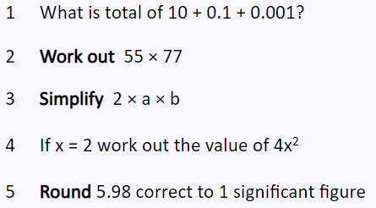
PRIOR KNOWLEDGE CHECK:
1. I can use a calculator to solve problems
THE MAIN EVENT
WORKED EXAMPLE #1:
PRACTICE #1:
Simplify each of the following calculations.

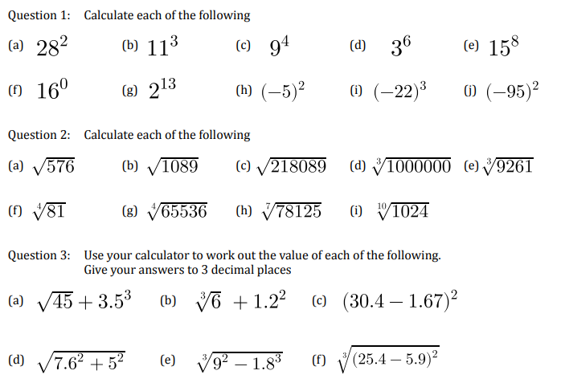

Practice #2:
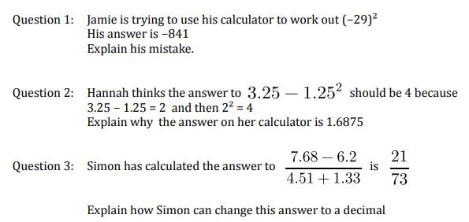

Exam type Question :

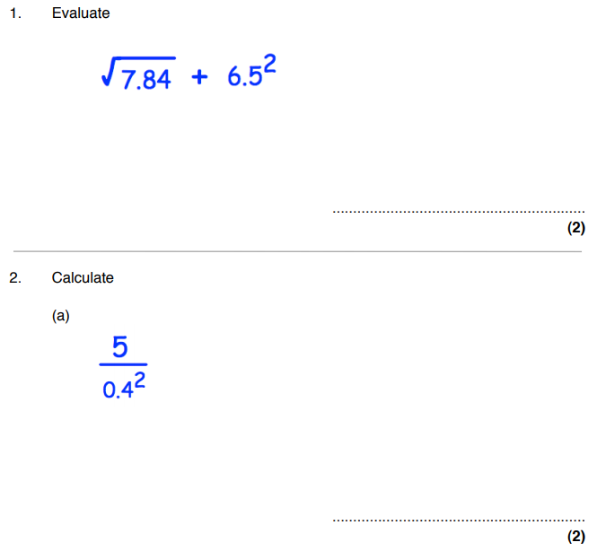

Learning Objective: | Writing numbers in index form | Name:
 |  | Date:
Do NOW Activity:
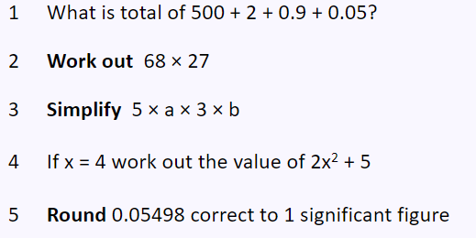
PRIOR KNOWLEDGE CHECK:
1. I can write numbers in index form.
THE MAIN EVENT
WORKED EXAMPLE #1:
PRACTICE #1:
Simplify each of the following calculations.

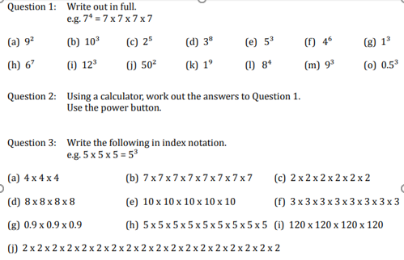

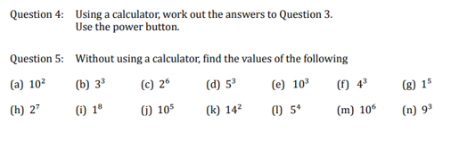

Practice #2:
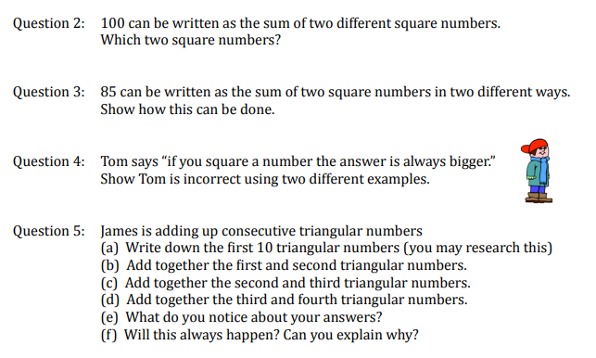

Exam type Question :
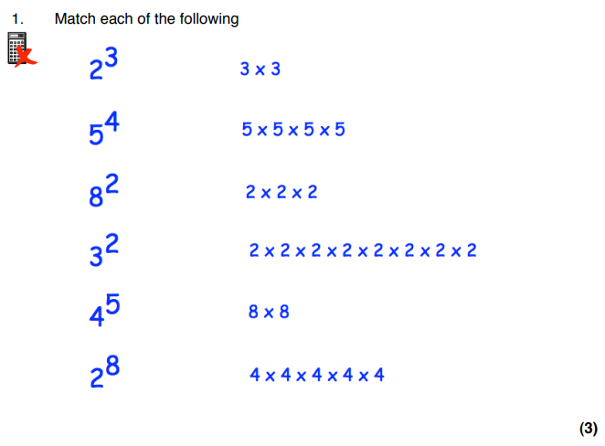

Learning Objective: | Fractions with diagrams | Name:
 |  | Date:
Do NOW Activity:
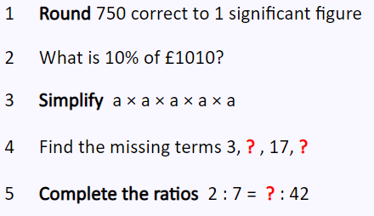
PRIOR KNOWLEDGE CHECK:
1. I can find fractions with diagrams
THE MAIN EVENT
WORKED EXAMPLE #1:
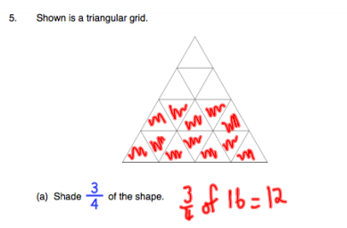
PRACTICE #1:
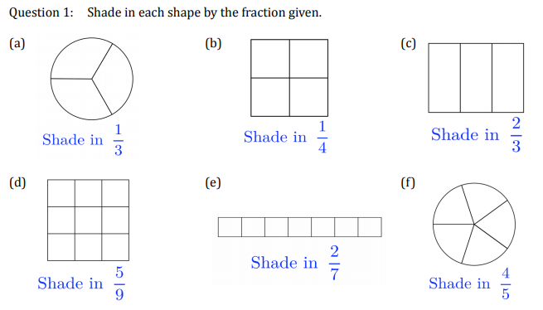
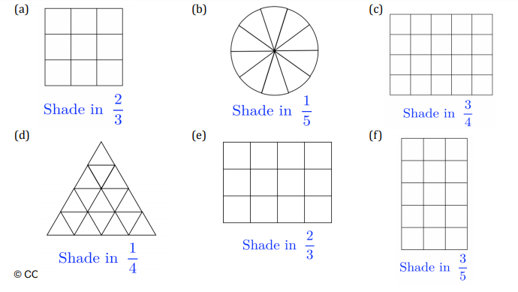

Practice #2:
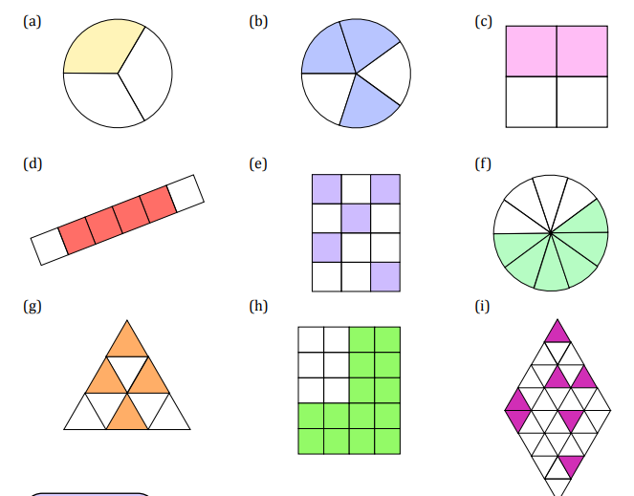

Exam type Question :

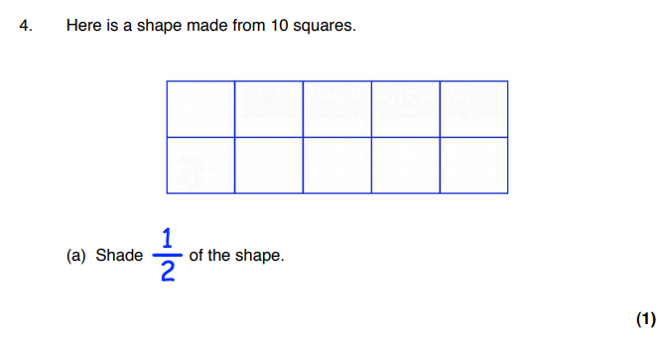

Learning Objective: | Equivalent Fractions | Name:
 |  | Date:
Do NOW Activity:
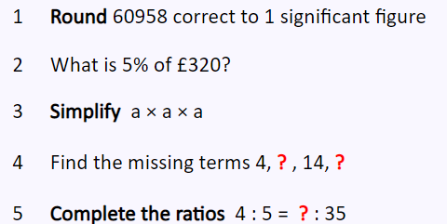
PRIOR KNOWLEDGE CHECK:
1. I can find equivalent fractions
THE MAIN EVENT
WORKED EXAMPLE #1:
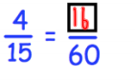
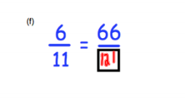
PRACTICE #1:
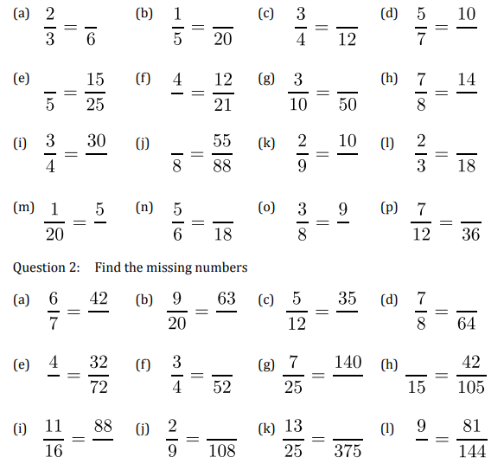

Practice #2:
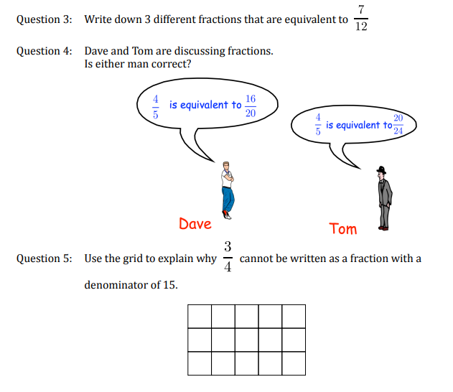

Exam type Question :

