Student Details

First Name Last Name
[____________________________________________________] [_______________________________________________]

Teacher’s Name
[_________________________________________________]

HOME LEARNING PACK
TERM 5
YEAR 7
Learning Objective: | Converting between fractions, decimals and percentages | Name:
 |  | Date:
Do NOW Activity:
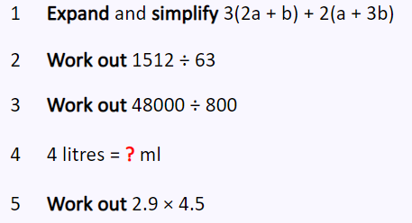
PRIOR KNOWLEDGE CHECK:
1. I can convert between fractions, decimals and percentages.
THE MAIN EVENT
WORKED EXAMPLE #1:
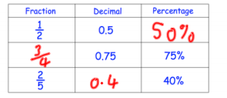
PRACTICE #1:
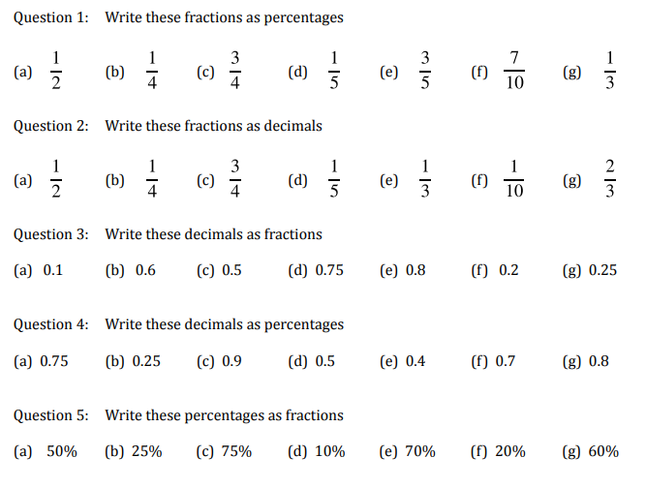

Practice #2:
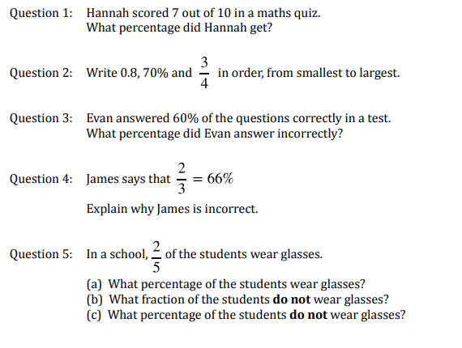

Exam type Question :
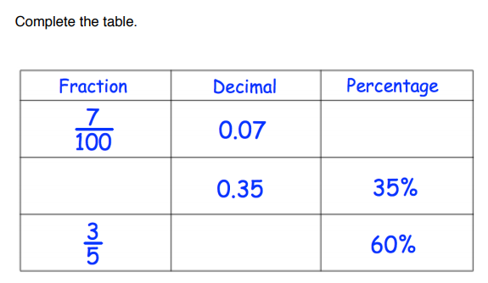

Learning Objective: | Converting between mixed numbers and improper fractions | Name:
 |  | Date:
Do NOW Activity:
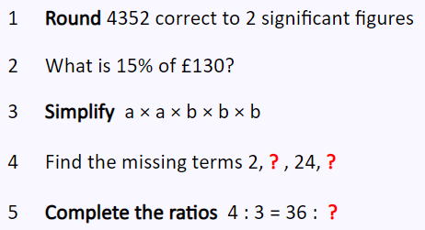
PRIOR KNOWLEDGE CHECK:
1. I can convert between mixed number and improper fractions.
THE MAIN EVENT
WORKED EXAMPLE #1:
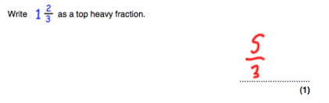
PRACTICE #1:

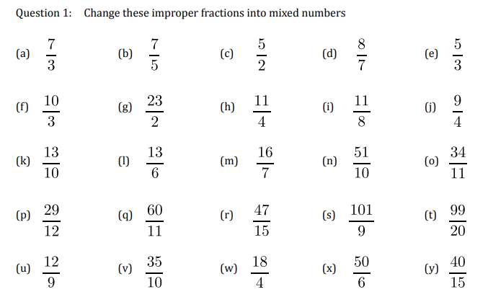

Practice #2:

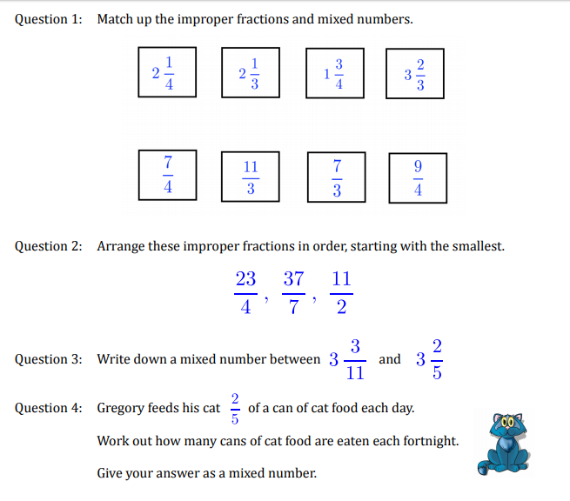
Exam type Question :

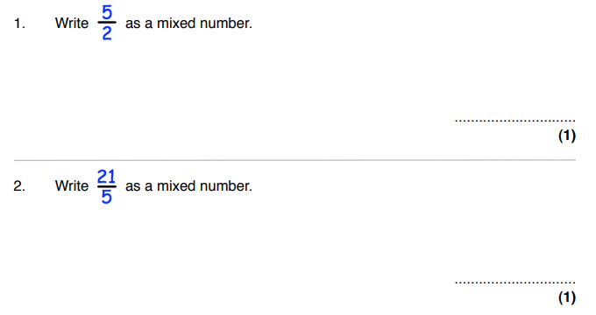

Learning Objective: | Compare and order fractions | Name:
 |  | Date:
Do NOW Activity:
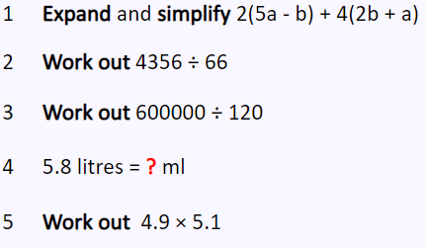
PRIOR KNOWLEDGE CHECK:
1. I can compare and order fractions.
THE MAIN EVENT
WORKED EXAMPLE #1:
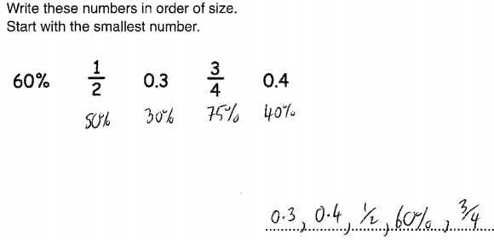
PRACTICE #1:
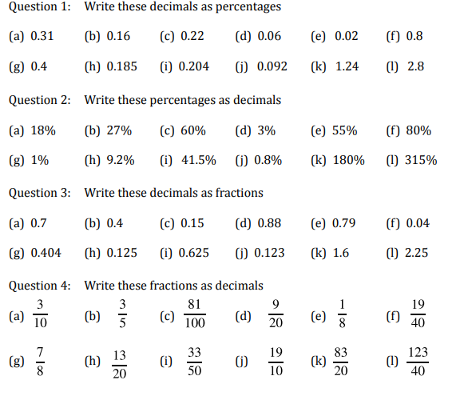
Practice #2:
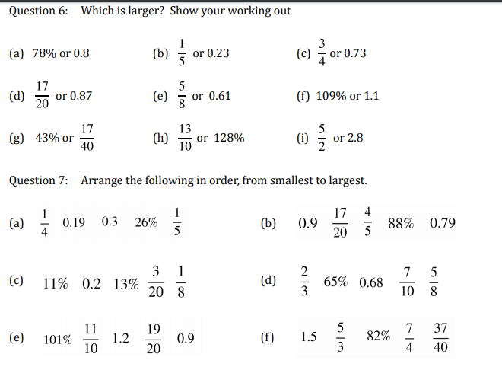

Exam type Question :

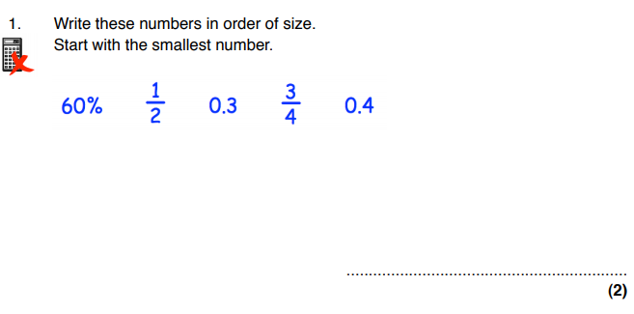

Learning Objective: | Express one quantity as a fraction of another | Name:
 |  | Date:
Do NOW Activity:
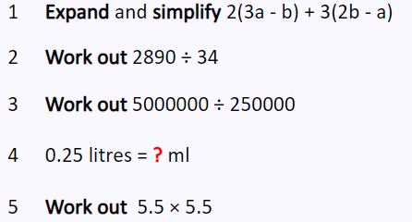
PRIOR KNOWLEDGE CHECK:
1. I can express one quantity as a fraction of another
THE MAIN EVENT
WORKED EXAMPLE #1:
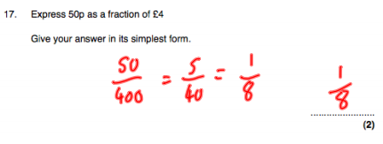
PRACTICE #1:
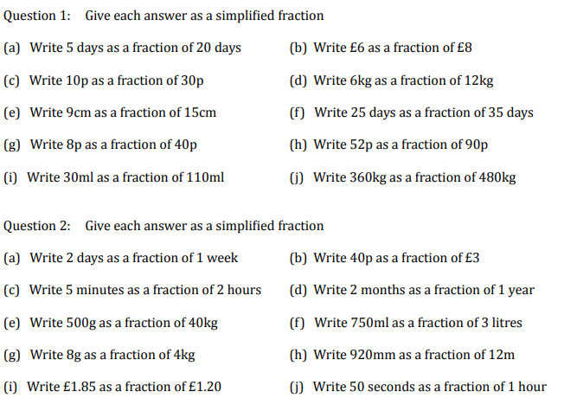

Practice #2:
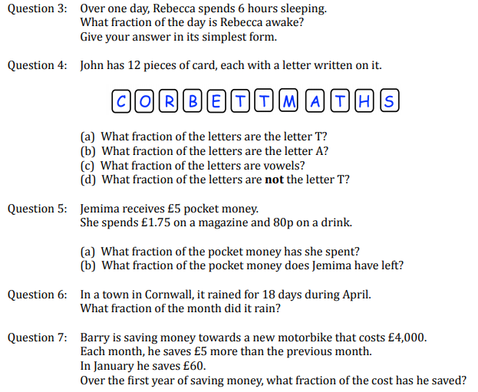

Exam type Question :
