Student Details

First Name Last Name
[____________________________________________________] [_______________________________________________]

Teacher’s Name
[_________________________________________________]

HOME LEARNING PACK
TERM 5
YEAR 9
Learning Objective: | Transformation  To be able to Describe a Rotation | Name:
 |  | Date:
Do NOW Activity:
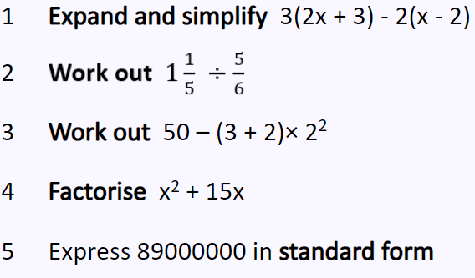
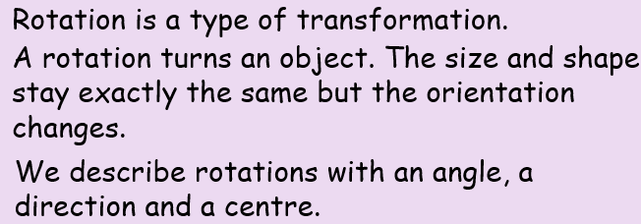
PRIOR KNOWLEDGE CHECK:
- I can find perpendicular bisector using a compass
- I can determine angle of rotation by looking at degree of turn on a side
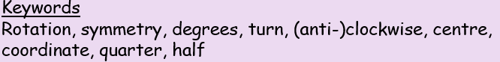

THE MAIN EVENT
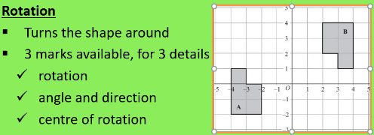
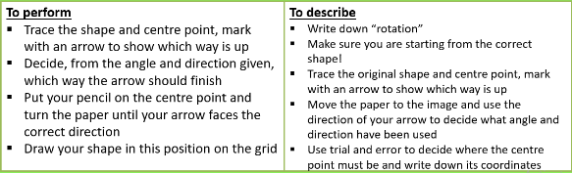
Centre of Rotation
- Find two corresponding edges in the two images
- Connect edges with a straight line
- Use a compass to find the perpendicular bisector to each line
- Where the bisectors cross is the centre of rotation
Example # 1:
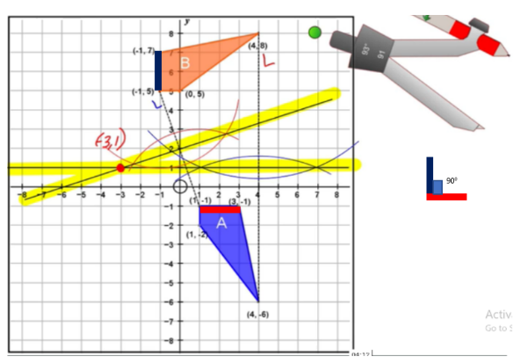
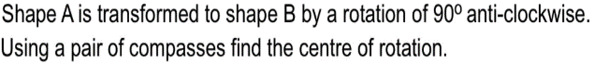
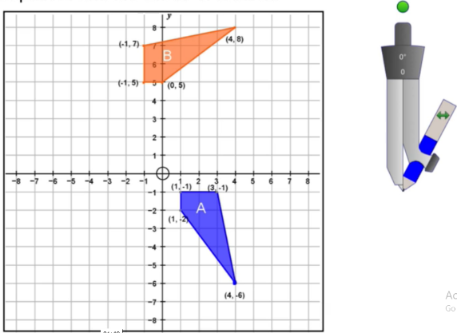

- Rotation
- Anticlockwise by 90⁰
- Centre of Rotation = (-3,1)

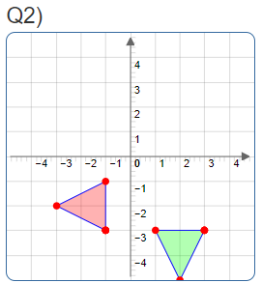
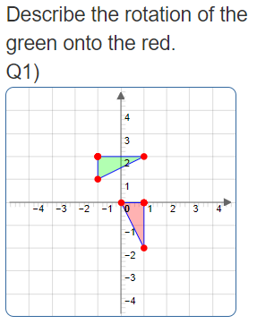
PRACTICE #1:

PRACTICE #2
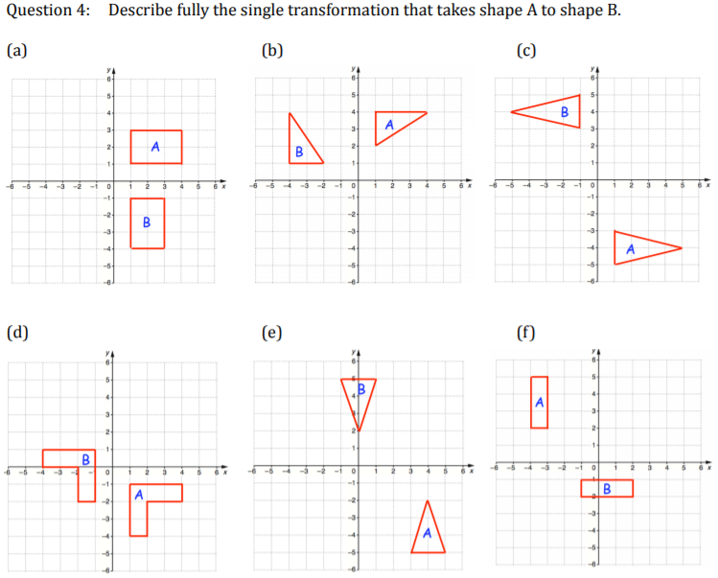

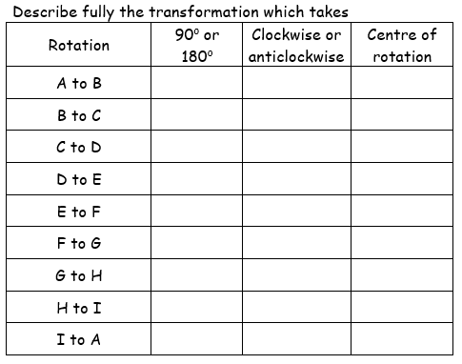
PRACTICE #3
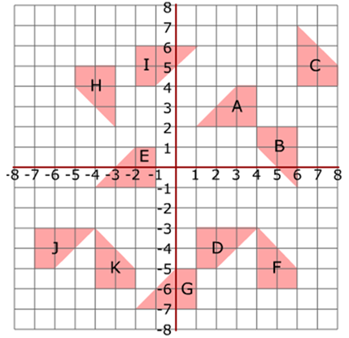

Learning Objective: | Transformation  To be able to work with Enlargements using positive scale factor | Name:
 |  | Date:
Do NOW Activity:
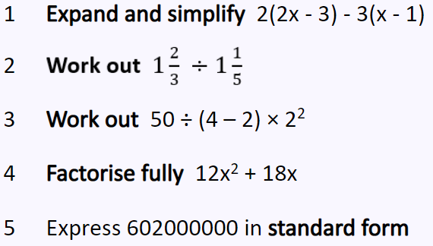
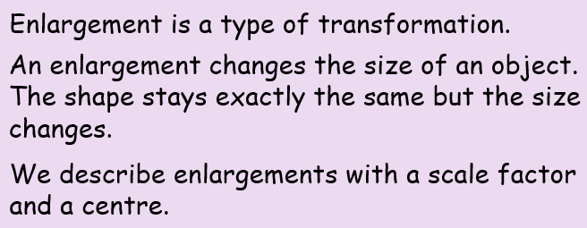
PRIOR KNOWLEDGE CHECK:
- I can find a multiplying factor between two numbers
- I can identify similar / congruent objects
THE MAIN EVENT
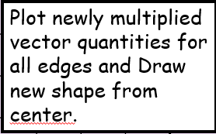
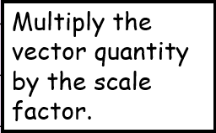
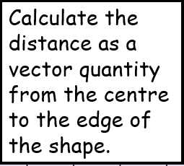
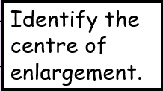

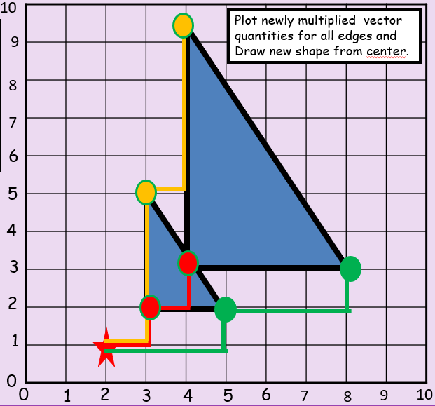
Example # 1:

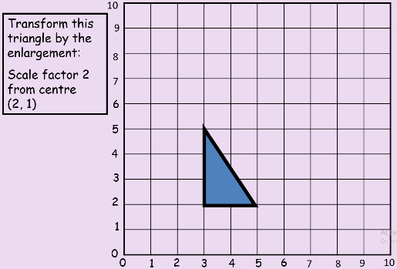

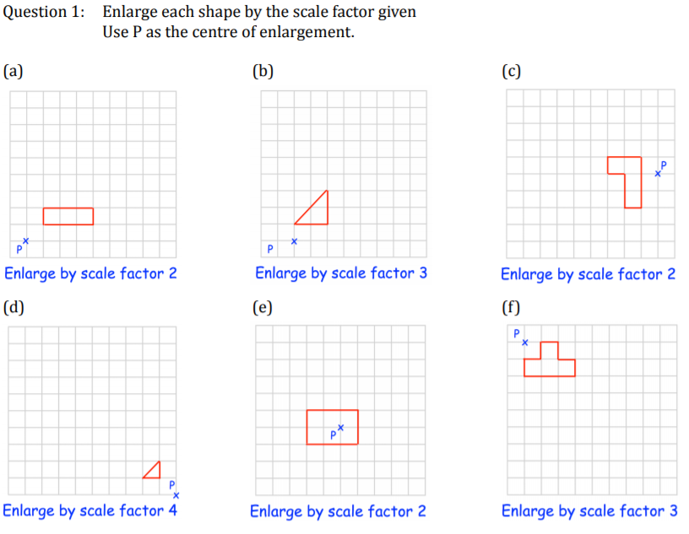
PRACTICE #1:

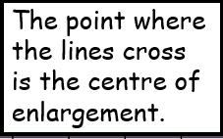
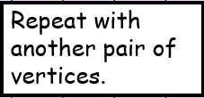
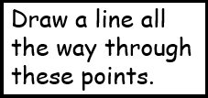
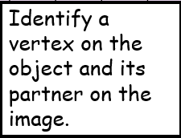
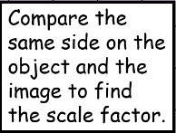
S.F = Image Object side
Original Object Side
EXAMPLE #2
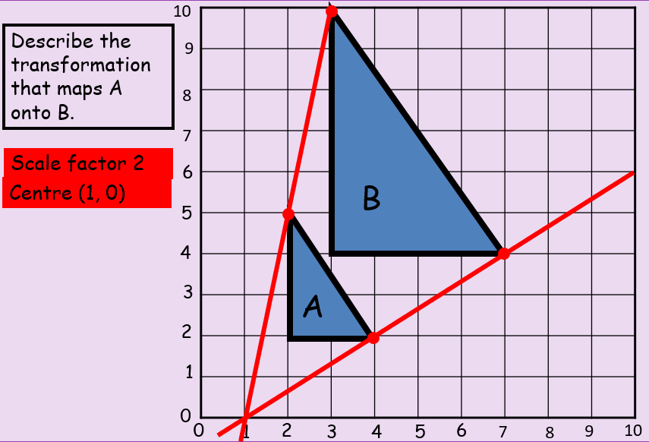
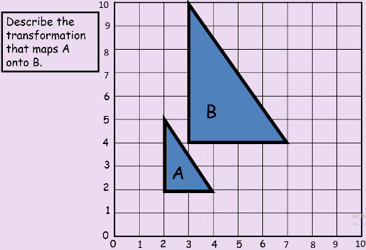

PRACTICE #2

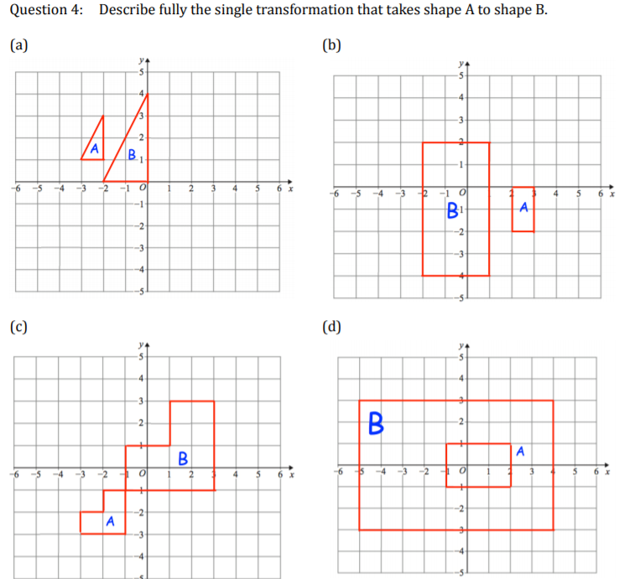

Learning Objective: | Transformation  To be able to work with Enlargements using Negative scale factor | Name:
 |  | Date:
Do NOW Activity:
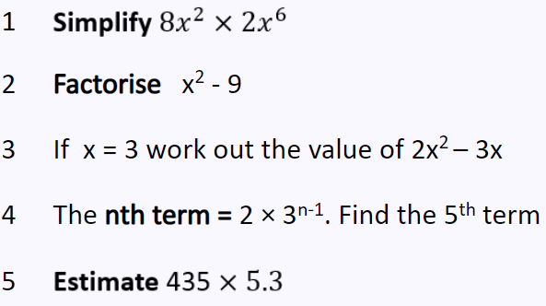
PRIOR KNOWLEDGE CHECK:
- I can identify enlargements
- I can describe enlargements with +ve scale factor
THE MAIN EVENT
Observation:
Enlarged shapes with negative scale factors appear flipped in opposite directions.
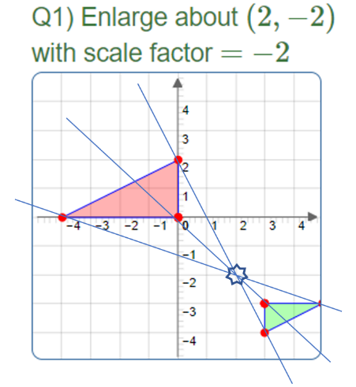
Example # 1:

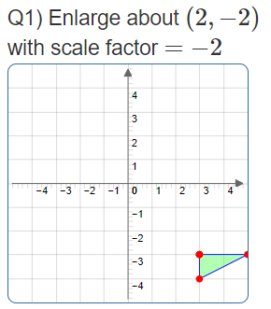

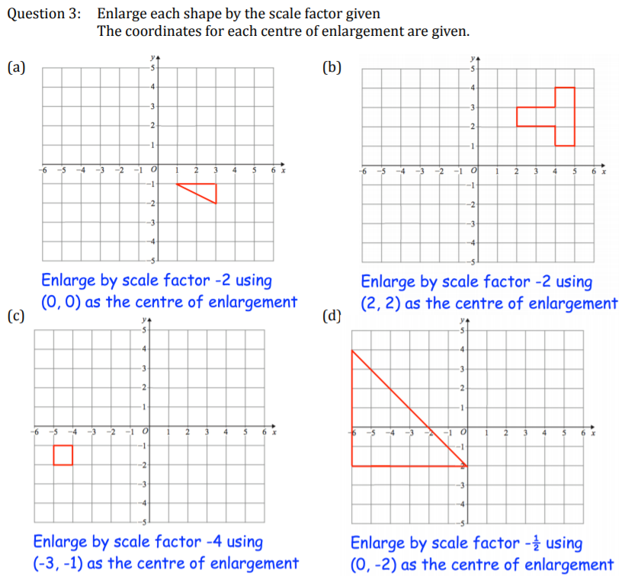
PRACTICE #1:

EXAMPLE #2
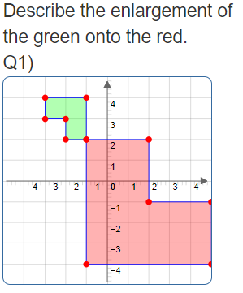

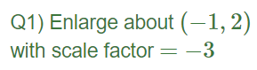

PRACTICE #2
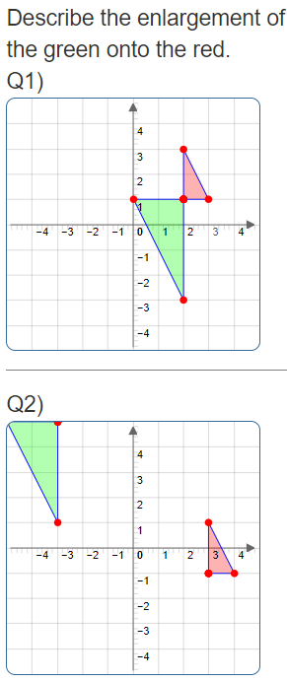
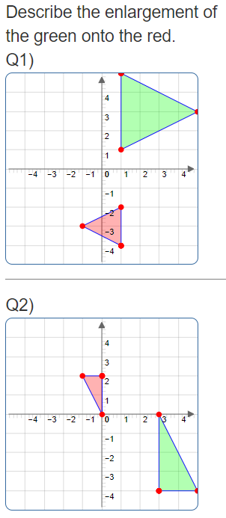
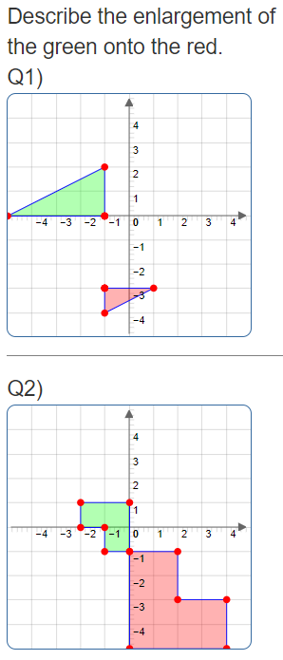
Q5)
Q3)
Q1)

Q6)
Q4)

PRACTICE #3
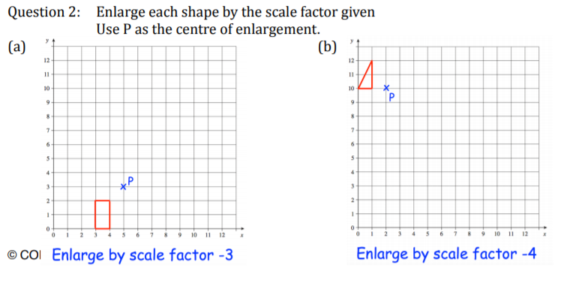
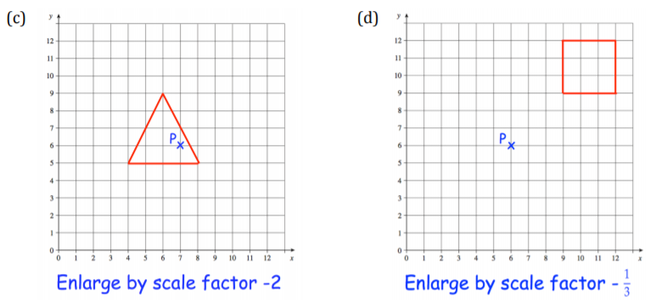

Learning Objective: | Transformation  To be able to work with Enlargements using fractional scale factor | Name:
 |  | Date:
Do NOW Activity:
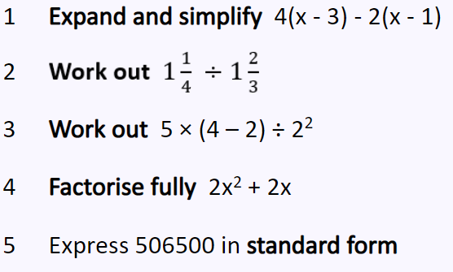
PRIOR KNOWLEDGE CHECK:
- I can identify enlargements
- I can describe enlargements with +ve scale factor
THE MAIN EVENT

Example # 1:
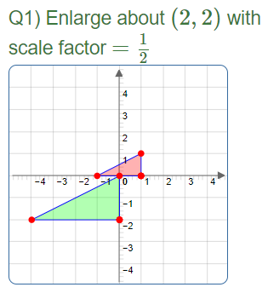
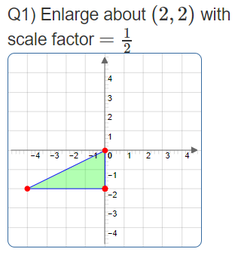

PRACTICE #1:
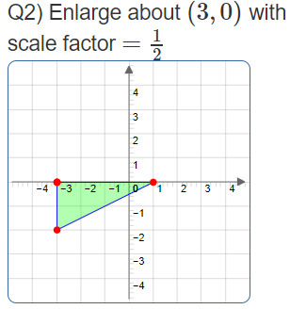
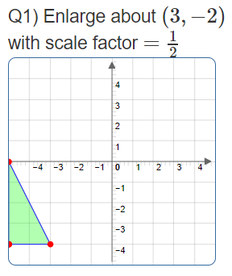
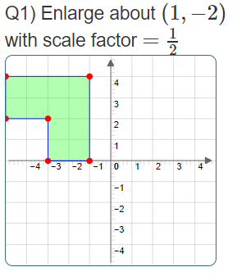
Q3)
Q2)

EXAMPLE #2

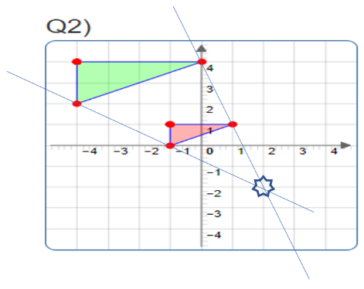
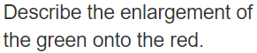
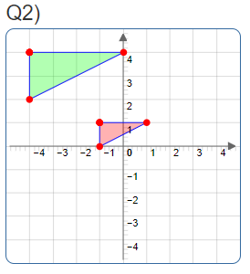
Q1)

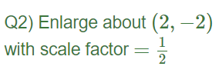

PRACTICE #2
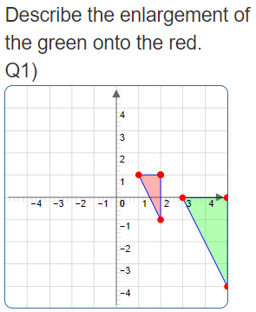
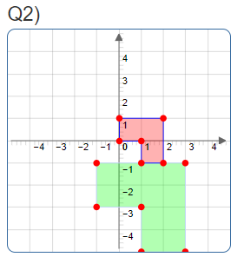
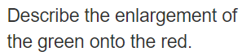
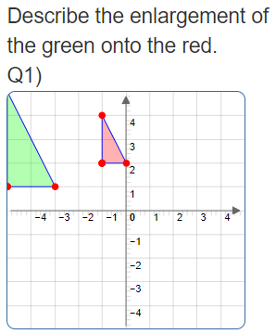

Q3)

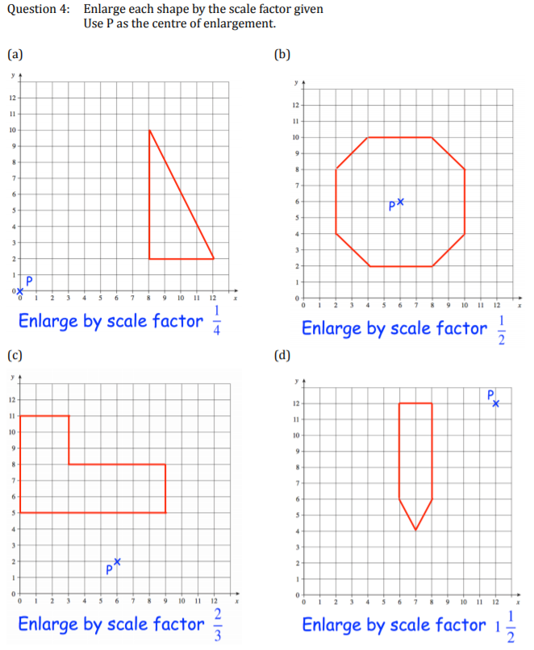
PRACTICE #3

