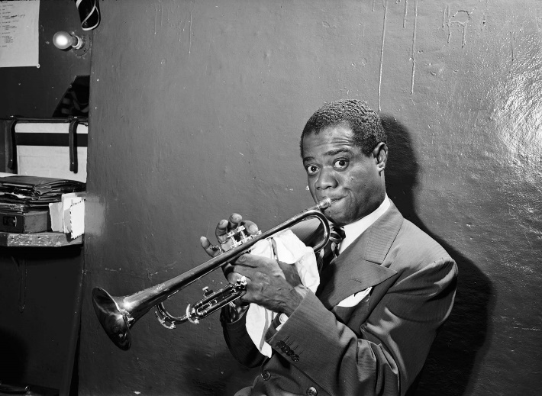
Introduction
Jazz is a style of Music that originated in the African-American communities of New Orleans, United States. It originated in the late 19th and early 20th centuries, and developed from roots in blues and ragtime. Since the 1920s, Jazz has become recognized as a major form of musical expression. Jazz has roots in West African cultural and musical expression, and in African-American music traditions including blues and ragtime, as well as European military band music. The most common instruments used in Jazz are: Piano, Trumpet, Trombone, Double Bass and Drums.
Louis Armstrong, One of the most Famous Jazz Musicians
Starter Activity:
- Which century did jazz start in?
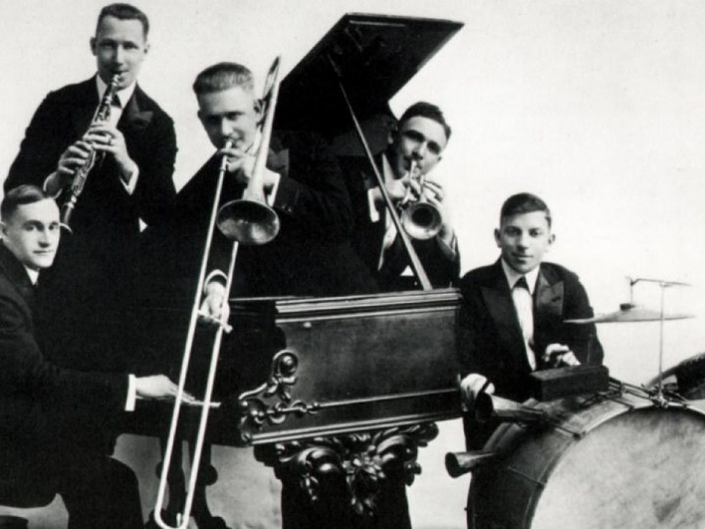
……………………………………………………..
2. Name 3 of the main instruments used in Jazz:
a) ………………………………………..
b) ………………………………………….
c) ………………………………………….

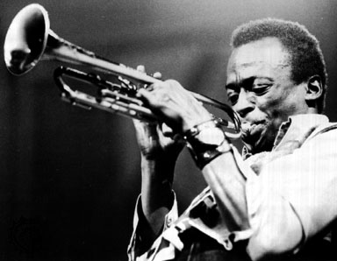
The Development Of Jazz
As Jazz became more and more popular around the world, new styles of Jazz started to emerge in certain cities. New Orleans jazz began in the early 1910s, combining earlier brass-band marches with a similar to Blues style improvisation.
In the 1930s, Jazz started to become much more complex in its arrangements and was mainly marketed as ‘Dance Music’. Kansas City jazz and Gypsy jazz were the prominent styles in the ‘Dance Music’ era of Jazz.
Bebop emerged in the 1940s, shifting jazz from danceable popular music toward a more technically challenging music which was played at faster tempos and used more chord-based improvisation.
Cool jazz developed near the end of the 1940s, introducing a calmer and smoother sound. It was much less technically difficult to perform than the Bebop Jazz sound.
Main Activity
- Which style of Jazz began in the 1910’s?
……………………………………………………………………….
- What were the 2 prominent styles of ‘Dance Music Jazz’?
a)……………………………………………….. b)………………………………………………………
3. What was the style of Jazz that was more ‘technically challenging’?
……………………………………………………………………………………..

