Do Now:
- What is the name of the main structure of the blues? : “THE …………….. BLUES”
- What instruments were used in the early development of the blues? :
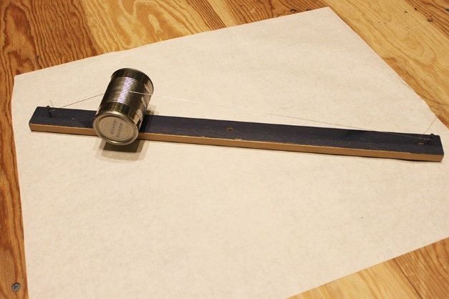
- …………….. b) ………………….
- What is the name of the instrument in this picture?

………………………………………………
Starter Activity:
The 12 Bar Blues follows some strict guidelines in its structure. There are always 12 bars and there are only ever 3 chords used. Let’s see if you can remember the structure from last week’s lesson. Some of the boxes are filled out for you to help you along the way.
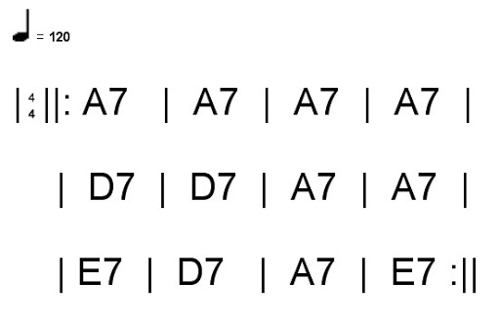

Main Activity: The 3 Main Types Of Blues
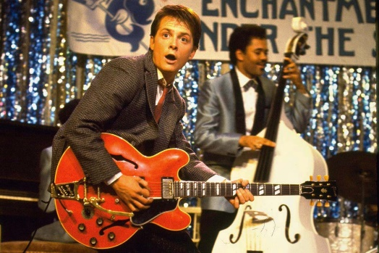
There are many different types of Blues Music across the world and throughout Blues History. Some are described from the instrumentation (Acoustic, Electric, Diddley Bow etc.) and sometimes types of blues are labelled geographically (Location. For example; Delta Blues, Chicago Blues, etc.). These are both valid ways to identify different sounds of the 12 bar blues. However Blues Musicians themselves rarely describe them in this manner. Instead, Blues Musicians will split the 12 bar blues into 3 Main Categories: FAST BLUES, SHUFFLE BLUES AND SLOW BLUES.
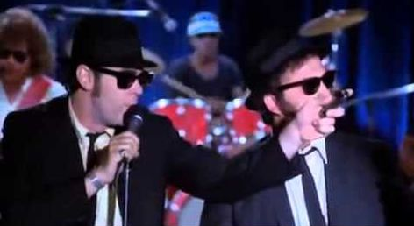
The ‘FAST BLUES’ is a straight 4/4 beat and is usually at a quick tempo. It is much more of a rock sounding blues and is somewhat similar to ‘Rock N Roll’. A famous example of a FAST BLUES would be Chuck Berry’s “Johnny B. Goode” which features in the classic film ‘Back To The Future’.
The ‘Shuffle Blues’ has more of a shuffle rhythm. Instead of a flat 4/4 beat, it is swung in its rhythm. Instead of counting “1,2,3,4” when performing this style of music, you would count “1 and, 2 and, 3 and, 4 and” with the ‘And’s twice as quick as the numbers.
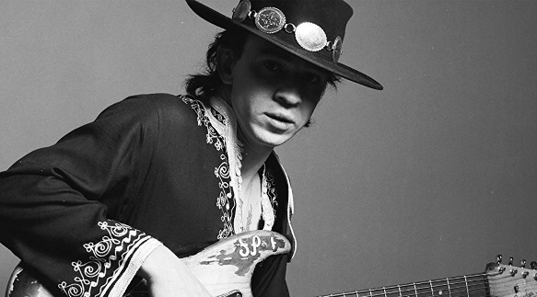
Last but not least, the ‘Slow Blues’ is as you might have expected; SLOW. The amount of time it takes to get through 12 Bars in a slow blues is considerably longer than the time it would take to get through 12 bars in a fast blues. The ‘Slow Blues’ is often performed in a 6/8 time signature, rather than a 4/4. In the slow blues, you would count the beats “1 2 3, 4 5 6” instead of “1, 2, 3, 4”.
Plenary: What are the 3 Main Types Of Blues? a) b) c)

