Let's make some musical instruments using recycled materials! You can make more than one if you like.

Guitar
To make a homemade guitar, simply stretch several large elastic bands around a cardboard box.
We chose a box with an open top, but a tissue box with a hole in the centre, works well, too.
Try and choose elastic bands that vary in width to ensure that all of your "guitar strings" will produce different tones and sounds when they're plucked.

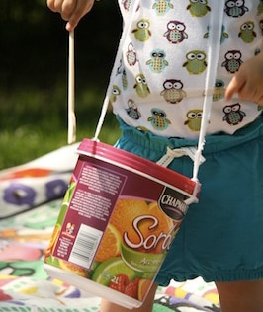
Drum
To make a homemade drum, you will need an empty ice cream tub and two drumstick like objects!
For the drumsticks, it really doesn’t matter what you use as long as it can make a sound! Just try not to use pens as they might create a lot of mess if they break.
Clean out your old ice cream tub and put the lid back on the box and you will have created your very own homemade drum!

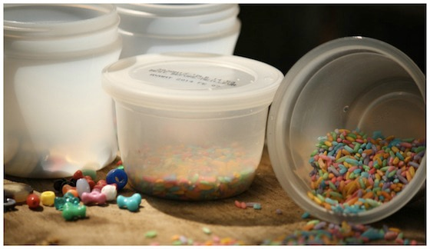
Maracas
To make your own maracas, you will need a small container! This can be any kind of container with a lid. Old takeaway boxes or sauce containers work great.
Try to find some small items to go into the containers! Dried rice, buttons, dried lentils or pasta would all be fine.
Make sure that your lids fit snugly. If you are worried about mess, tape the top of the lid shut.

ACTIVITY
Now that you’ve made your Musical Instrument, it’s time to play them with some Music! Play along to a piece of Music with your instrument and try and pick out a certain instrumental part in the song to follow. If you made a guitar, play along with the guitar or piano part of a song. If you made a drum or maracas, try and play along to the drum part of the song. Of course if you feel like it, try and sing along with the song if it has lyrics!

When you have done this, record what you played along to on the table below:

WEEK | INSTRUMENT | SONG | STYLE OF MUSIC | PART PLAYED
1
2
3
4
5

