Year 9, Lesson 3
Do Now:
- F in FITT stands for…….

- Two things that you can use to measure your intensity are…….

- An example of a type of exercise that you can do to help your muscular strength is ……

- If I selected 10 on the Borg Scale, this indicates my heart rate is (show workings out)…..

- ‘The ability of a sports performer to quickly and precisely move or change direction without losing balance or time’, is the definition for what component of fitness…..

Read through the following to gain an understanding of what additional principles of training is
Additional Principles of Training:
To help overload your training to make it harder and encourage your body to become better you need to use the acronym:
SPORVIARR

Specificity – training relates specifically to the sport that you are trying to improve
For example, a swimmer would not perform rugby training to improve their performance as it isn’t specific
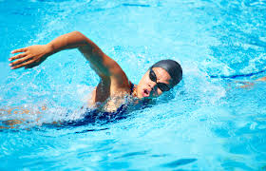

Progressive Overload – gradually increasing the intensity of the training so that it becomes harder
For example, week one you would lift 5kg weights, by week three you would be lifting 10kg weights

Reversibility – loss of physicality due to a lack of training
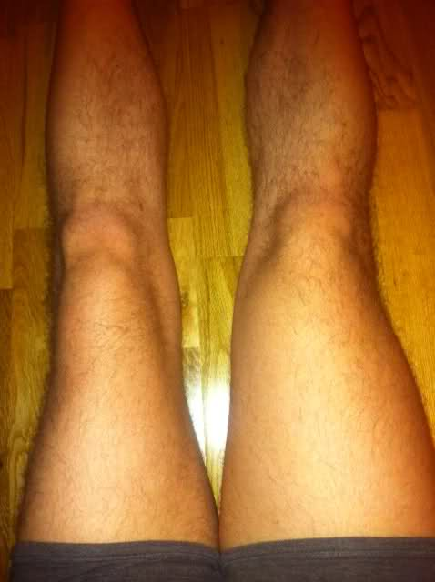
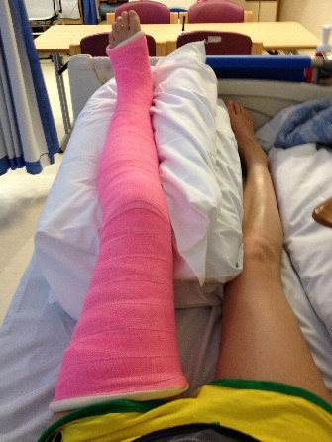
For example, you break your leg and can’t train for 6 weeks, this leg will become a lot weaker

Variation – to change training sessions up to help prevent boredom and maintain enjoyment
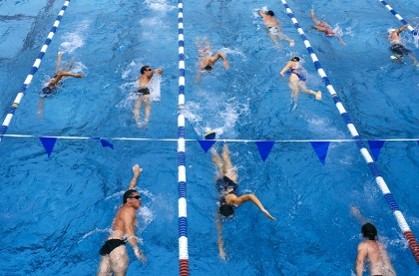
For example, a footballer may change their sessions between football training, running and swimming to help their aerobic endurance but to make it more interesting for them

Individual needs – training will need to meet the individual needs (medical conditions) and goals of the performer
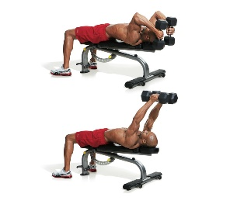
For example, if a boxer wants to improve the power of their punch they will need to focus on improving their arm strength

Adaptation – how the body changes to increase its ability to cope with the increase in demands of training
For example, through increasing the weight being lifted, the muscles in the arms will undergo hypertrophy and get bigger

Rest and Recovery - time away from training to allow the body to adapt and progress
For example, completing a training programme and each week including 2 rest days

Monday | Tuesday | Wednesday | Thursday | Friday | Saturday | Sunday
Training | Training | Training | Rest Day | Training | Training | Rest Day

Application of knowledge:
Apply the above information to answer these quick questions:
- State which one of the additional principles of training refers to avoiding boredom?
Answer:
- If I have a medical condition such as Asthma, what additional principle of training do I need to consider?
Answer:
- What additional principle of training must be included to allow our body to adapt to any training that we complete?
Answer:
- If I have suffered an injury, which additional principle of training could this result in occurring?
Answer:

Exam style questions:
Answer the following questions that could be asked in your exam:
1) Henry is coaching a pair of rowers. He is discussing the principles of training with them, ‘If you keep doing hard sessions over the next few weeks your heart and lungs will get stronger.’
Which one of the additional principles of training is Henry referring to? (1 mark)
(Please bold and change the colour of your answer)
Variation
Specificity
Adaptation
Reversibility

2) Elaine is a long-distance cyclist who uses the principles of training to improve her sporting performance
a) Explain why using progressive overload would lead to an improvement in Elaine’s sporting performance (2marks)
Consider: what is the definition of progressive overload
Consider: apply by providing an example of how it would help and why
Answer:

b) Explain why using specificity would lead to an improvement in Elaine’s sporting performance (2marks)
Consider: what is the definition of specificity
Consider: apply by providing an example of how it would help and why
Answer:

