Week 5 – Lesson 1 – Training Methods: Flexibility
INFORMATION SHEET
What is Flexibility?
Flexibility is a physical (health related) component of fitness. Flexibility is defined as the range of motion at a joint. This relates to all joints of the body; the ability to move a joint fluidly through its complete range of movement.

How do you train/increase Flexibility?
Static Stretching: (https://www.youtube.com/watch?v=7FCNFuyyWTA)
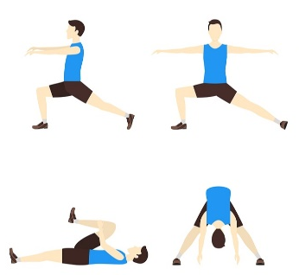
- 10-20 seconds
- Performed slowly – to the limit of the joints range of movement
- More beneficial after exercise (warm-down)
- Two types; Active & Passive
Static Stretching – Active: - - - - - - - - - - - - - - (Example )
- On your own
- Apply internal force (yourself) to stretch and lengthen the muscle
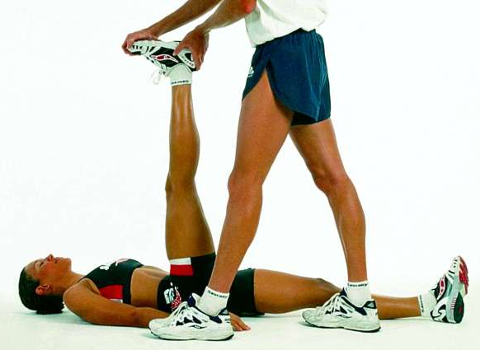
Static Stretching – Passive: - - - - - - - - (Example)
- With a partner or object
- Partner or object applies force to stretch and lengthen the muscle

Ballistic Stretching: (https://www.youtube.com/watch?v=0zhHwv34Qvo)
- Fast, jerky movements
- Past the limit of the joints normal range of movement
- Normally bobbing or bouncing movements
- Movement pattern specific to the sport/activity
- High chance of injury if not performed properly or under control
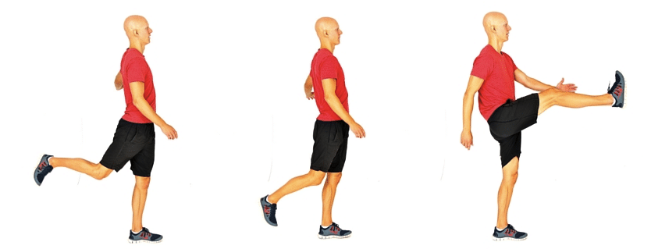

Proprioceptive Neuromuscular Facilitation (PNF) Stretching: (https://www.youtube.com/watch?v=CChTjADq6x8)
- With a partner
- Three stages
- Stage 1 – Passive stretch (explained, above)
- Stage 2 – Partner pushes against you while push back (contracting muscle)
- Stage 3 – Passive stretch further

Advantages | Disadvantages
- Cheap (no equipment needed)  - Effective method for increasing flexibility | - Requires a partner  - Experience of how to perform stretch safely is essential  - High risk of injury if not performed safely

Benefits of increased flexibility
- More energy is created from the muscle fibres (muscles are longer)
- Improved posture
- Movements are more efficient
- Reduced risk of injury
