Year 9, week 9
Do Now:
- The four training methods used to develop aerobic endurance are…..
- The training method best suited to a marathon runner is……
- The training method best suited to a footballer is ……… This is because….
- Speed is defined as…….
- F.I.T.T stands for……

Read through the following to gain an understanding of what the term speed is defined as and what training methods can be used to develop it.

Application of knowledge:
Speed is defined as distance divided by time taken, measured in metres per second (m/s). Speed is the rate at which an individual is able to perform a movement or cover a distance in a period of time or how quickly an individual can move.

The following fitness training methods are designed to improve a performer’s speed. Speed training can be made sport-specific and often takes the form of drills.

Hollow sprints

This technique involves completing a series of sprints separated by a ‘hollow’ period of jogging or walking.

A typical session could be as follows:

- Set out ten cones at 20-metre intervals.

Sprint 20m Walk 20m Sprint 20m Walk 20m

- Complete eight sets in total. If the intensity if too great, replace ‘hollow’ jog period with a walk instead.
Advantages | Disadvantages
No special equipment needed. | Performer may lose interest due to repetition.
Easy training method to organise and carry out. | Need to maintain focus and motivation throughout.
Training can be made sport-specific.

Acceleration sprints
Gradual increase from standing to steady to sprinting

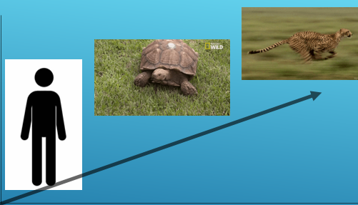
Advantages | Disadvantages
No special equipment needed. | Performer may lose interest due to repletion.
Easy training method to organise and carry out. | Needs careful planning.

Interval training
Interval training involves the individuals alternating work periods with rest and recovery periods. For speed training, the work intervals are shorter and more intense and the individual will work at a higher intensity close to their maximum possible level of physical effort.
Advantages | Disadvantages
No special equipment required. | Performer may lose interest due to repetition.
Can be tailored to specific sports. | Needs careful planning.
Distance, time and intensity can meet the individuals training needs.

Application of knowledge:
- What is Hollow sprints and can you provide an example of how it can be carried out?
- Identify one advantage and one disadvantage of Hollow sprints.
- Identify what Acceleration sprints involve?
- Identify one advantage and disadvantage of Acceleration sprints.
- What two components of fitness can interval training improve?

Exam question

Question-Name a sporting example of an athlete who would benefit from acceleration sprint training? (1 mark)

Answer

Justify your response (3 marks)

Answer

Evaluate the speed training methods (3marks)

Answer

