Year 9, week 10

Do Now:
- One component of fitness that Continuous training improves is…
- The training method used to improve Muscular strength is..
- Circuit training is defined as..
- Fartlek training is defined as..
- The main training methods used to improve speed are..

Fitness testing
Read through the following to gain an understanding of the importance of fitness testing and the administration of fitness tests (Pre-test, procedures, validity, reliability and practicality)

Why are fitness tests important?
Fitness testing provides a coach with baseline data results, which they can compare to normative published data in order to draw conclusions about an individual’s fitness level.
It will help the athlete to design a training programme as they will be familiar with their strengths and weaknesses.
Lastly fitness tests can give sports performers clear goals and targets for them to aim for.
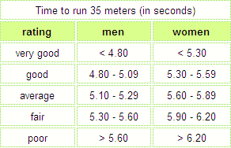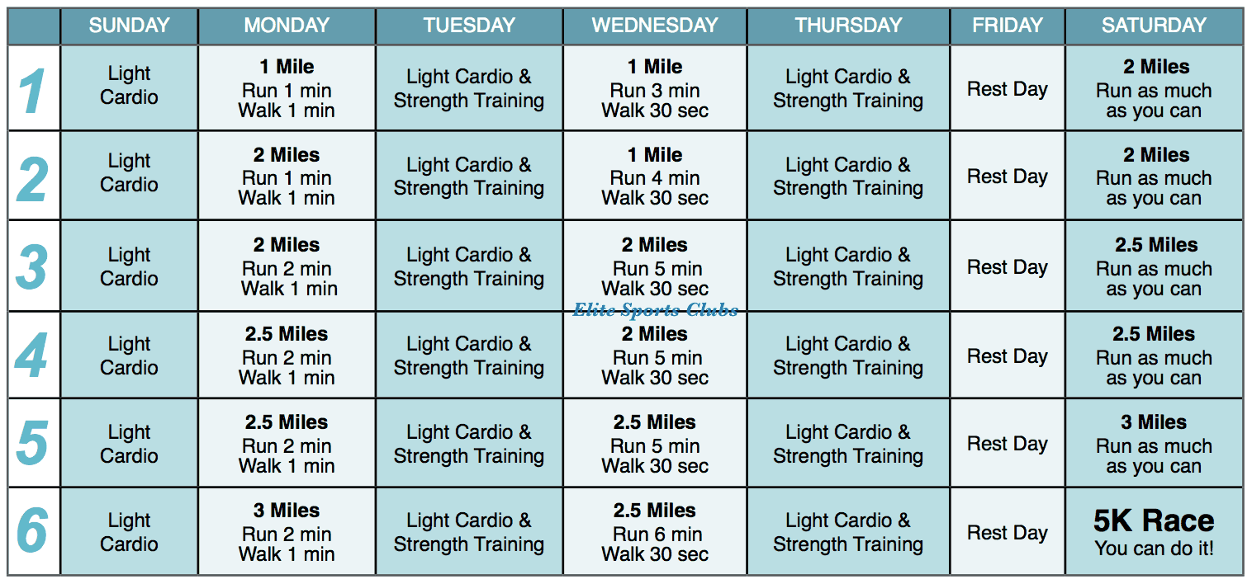
Pre-test procedures
What should be completed before participating in fitness tests:
- Consent forms should be completed by participants. Consent forms contain necessary information to undertake each fitness test such as the test method, requirements and risks and they also need to sign that they agree to complete the tests, however participants can withdraw their consent at any time.
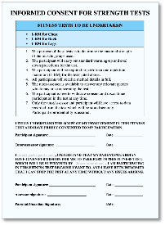
- Calibration of equipment needs to be considered this is the process of checking the accuracy of fitness testing equipment before it is used, by comparing it to a recognised standard. E.g comparing two measuring tapes to one another to check accuracy.
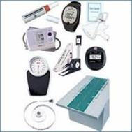
- Warm up should be completed before completing tests this should consist of an aerobic phase, stretching and skills as this will increase the body’s temperature, heart rate, breathing rate, and injury.
- Cool downs should be completed after completing fitness tests this could involve a light jog and stretches to bring your body gradually back to the pre-exercise condition. Cool downs can prevent muscle stiffness, injury and improve flexibility.

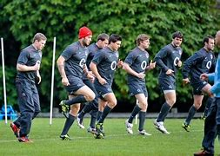

Validity
This is the accuracy of the fitness test results. E.g whether the results you have are a true reflection of what you were actually trying to measure. For example the multistage fitness test is not a valid test for testing flexibility it is however a valid test for measuring Aerobic endurance.

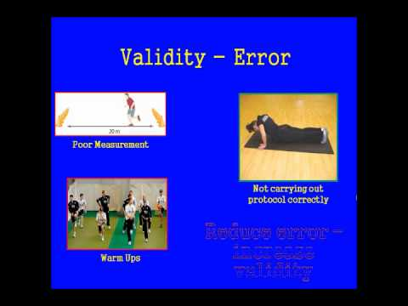
Reliability
Results should be consistent, if you were to carry out the same fitness method again, using exactly the same conditions and environment, you should expect the same results.
What effects the reliability of a test?
- Not using the same piece of equipment throughout.
- Not complete the test three times.
- Not using the same administrator to run the test.
- Human error which is when someone makes a mistake e.g the administrator may incorrectly measure 35m for the sprint test or they may start the stop watch too early or late which could give an incorrect test reading.

Practicality
This refers to how easy it is to carry out the test in terms of costs involved, time available and equipment required. E.g. can large groups be tested at once or do participants have to be tested individually because of a lack of resources.

Application of knowledge

1) Identify and describe two reasons why fitness testing is important?
2) Identify and describe four procedures that need to take place before you complete fitness testing.
3) What does the term Validity mean and explain why the 1 minute press up test is not a valid test to measure Aerobic endurance?
4) What does the term Reliability mean?

Exam questions

State two ways in which you can improve reliability of a fitness test (2 marks)

How could human error impact the Multi stage fitness test? (2 marks) 