Year 9, Lesson 1
Do Now:
Three components of PHYSICAL fitness are…
Three components of SKILL RELATED fitness are…
The most important component of fitness for a swimmer is…. This is because…
The least important component of fitness for a long jumper is…
Resting Heart rate is defined as…

Exercise Intensity:
Exercise intensity is determined by your heart rate unless working with weights. Heart rate is defined as ‘the number of times the heart beats in a minute (BPM)’.
There are two methods used to measure our heart rate other than checking your pulse manually, they are;

i) Heart rate monitors:
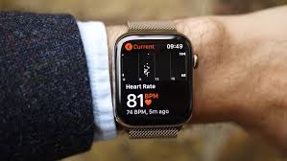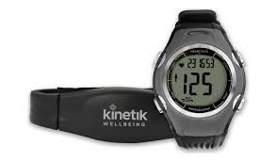
Advantage: Highly accurate Disadvantage: Can be expensive

ii) Borg Scale:
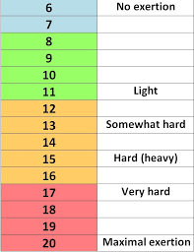
Method to use the Borg scale;

Step 1: Rate your levels of effort on the scale from 6 to 20.
Step 2: Multiply to perceived score by 10 to estimate HR.

Advantages: Quick, easy and free to use.
Disadvantages: Based on the individual’s opinion which compromises its validity. Therefore it isn’t 100% accurate.
As we use our heart rate to determine our exercise intensity, it is important we know our maximum heart rate to enable us to calculate our training thresholds.
Maximum heart rate is calculated using the following equation: 220 – Age (Years).

Training zones:
There are two key training zones we need to know;

i) Aerobic (60 – 85% of our HR max) Requires the presence of oxygen in energy production process.
(Key characteristics: Prolonged periods of steady state exercise. E.G. Marathon running)

ii) Anaerobic (85 – 100% of or HR max) Doesn’t require the presence of
(Key characteristics: Short bursts of maximal intensity exercise. E.G. Long jump)

Calculating training thresholds - To calculate your thresholds you take the following steps;

i) Multiply Max HR by the desired training zone percentage.
ii) Divide the outcome of the multiplication by 100.

E.G Mr Huggins (30 years old)
i) 60% = 190 x 60
ii) 11400 / 100 = 114.

Please watch the video on the following link https://www.youtube.com/watch?v=0EemXPwV1vM

Application of knowledge:
1. Calculate your maximum heart rate.
2. Calculate your aerobic training thresholds.
3. Which training zone is best suited to a long distance cyclist? Justify your answer.
4. Calculate the training zones for Mr Spocchia (39) & Your oldest relative / guardian.

Exam style questions:

1) Select which training programme best suits the athlete and justify why. (4 marks)

- Athlete – 20 Years old / Marathon runner. Wants to improve her race time.

Programme 1; Programme 2:
3 sessions a week 4 sessions a week
2 hour sessions 3 hour sessions
Target HR – 120 BPM. Target HR – 170 BPM

Points to consider:
- Which HR is best for a marathon runner?
- How long does a marathon roughly last?

2) Would you suggest the athlete uses the Borg scale or a HR monitor during their training programme to determine their exercise intensity? (4 marks)

Points to consider:
- Advantages and disadvantages of the methods used to measure exercise intensity.

