08/07/2020
Uses of Metals
Do Now: Answer the following questions
- Define ‘ion’.
- State the charge of non-metal ions.
- State whether metals form positive or negative ions, and give the name of these ions.
- Name two potential errors that could be made when carrying out paper chromatography.
- Round this number to 2 significant figures: 3829
Key information: Read the information below
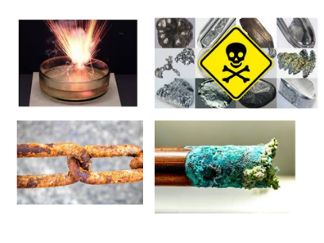
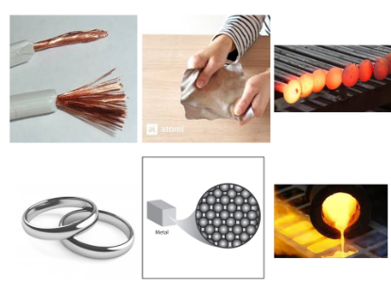
We have learned how to identify metals by their electronic structure. Remember that metals are found in the left hand side of the periodic table. Physical properties can be observed without the need for a chemical change (reaction) to occur. Metals tend to be: ductile (able to be stretched into wires), malleable (able to be rolled into thin sheets), electrically and thermally conductive, and lustrous (shiny). Metals also tend to be dense, compared to non-metals, and have high melting and boiling points.
Metals also have certain chemical properties. A chemical property of a metal can only be observed during a chemical change. Examples of chemical properties include reactivity, flammability, and toxicity. Many metals, for example, corrode when exposed to oxygen.
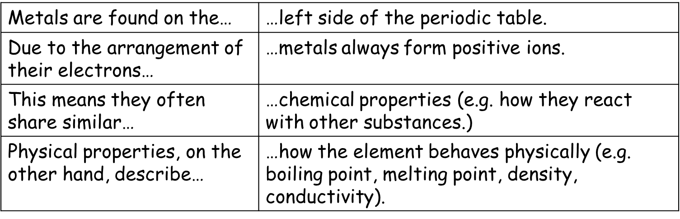
Key Knowledge: complete look, cover, write, check

Recall Quiz: Complete each of the following sentences
- The left side of the periodic table contains… while the right hand side is made up of…
- Metals always form positive ions, due to the fact they (gain/lose) electrons.
- The ways that different elements react with each other are described as their _____ properties.
- Two examples of metals’ physical properties are…
Application Task I do: Read the text about titanium and answer the three questions
Most aeroplanes are made out of aluminium, but fighter jets go so fast that the wings would melt. Titanium, however, has a higher melting point and is still strong and light (although a little more dense than aluminium). Titanium is used for bike frames, tennis rackets and for putting metal inside humans (e.g. a hip replacement or metal plate). Titanium resists corrosion even better than aluminium or stainless steel. If it were not so expensive, we’d use it for everything that we make from steel now!
- Explain why titanium is a good metal to use inside the human body. Titanium is strong and light, and resists corrosion, so titanium inside the body will last a long time.
- Compare aluminium and titanium. Titanium is a little denser than aluminium, has a higher melting point, and resists corrosion better.
- Evaluate the use of titanium in fighter jets (give advantages and disadvantages). One advantage is that titanium has a high melting point, so it can resist the heat generated by a jet’s engines. Titanium also resists corrosion, and so will last longer after being exposed to rain and atmospheric oxygen. Titanium is strong, while remaining light, so less energy is needed to keep the jet in the air. One disadvantage is that titanium is expensive, and so jets with more titanium parts will cost more money.

Application Task You do: Read the text about aluminium and answer the three questions
Aluminium is strong and light. Aluminium resists corrosion; that’s why aluminium foil stays so shiny. It can be made into sheets. Aluminium is not a transition metal. It is not as strong as steel, but it is has a much lower density (so it is lighter). Steel would be too heavy to make planes because it would require too much energy to get off the ground. Aluminium is used to make all passenger aeroplanes. It melts at quite a low temperature though so it can’t be used to make fighter jets because it would melt.
- Explain why aluminium is good to use for kitchen foil.
- Compare aluminium and steel.
- Evaluate the use of aluminium in aeroplanes (give advantages and disadvantages).
Application Task You do: Read the text about copper and answer the three questions
Copper is useful because it is such a good conductor of heat and electricity. It is also not very reactive. It is soft, bendy and ductile (can be made into wires). Some uses include saucepans and electrical wires. It doesn’t react with water so doesn’t corrode like iron and steel. This means it can be used for water pipes and plumbing. It is quite expensive though, but some buildings use it on the roof.
- Describe three properties of copper.
- Explain why
- Copper is used in wires.
- Copper is used for water pipes.
- Evaluate the use of copper for a roof (give advantages and disadvantages).
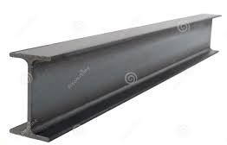
Application Task You do: Read the text about copper and answer the three questions
Iron is the most widely used metal in the world. It can be used to make steel. It can be made hard and tough so it is used for machinery, tools and bridges. It is also used for girders (which help to strengthen concrete in buildings). It can also be cut into sheets and shaped so is good to use for tins/cans and car bodies. The major drawback of using iron is that it rusts.
- Identify five uses of iron.
- Describe three properties of iron.
- Explain why iron would be bad to use for metal plates in the human body.
08/07/2020
Alloys
Do Now: Answer the following questions
- Give the definition of an isotope.
- State the charge of a boron ion.
- State the name of the element with 37 protons.
- Explain why the solvent line must be drawn in pencil for chromatography.
- Calculate the M_{r} of NaOH.
- Challenge: Calculate the relative atomic mass of an element which is found to contain 93.2% of atoms with the mass number 39, and 6.8% of atoms with mass number 41.
Key information: Read the information below and draw each diagram into your books
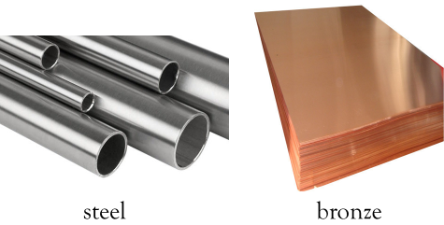
You won’t find steel or bronze on the periodic table, although most people would say that they’re metals. That’s because steel and bronze are not exactly metals, though they have many properties of metals. Steel and bronze are alloys. Alloys are solid mixtures containing at least one metal.
We make alloys for many reasons, but it’s always because we want to change the properties of the metal we’re alloying. The property we’ll focus on today is strength and malleability. Metals that are malleable can be flattened. Most pure metal elements are very malleable. This is great if you want to make thin sheets of a metal, like gold or aluminium foil. Let’s dive deeper and try to understand why pure metals are malleable.
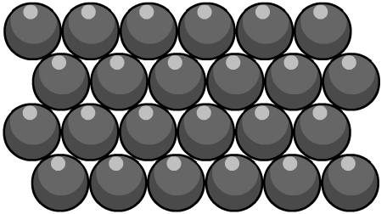
The atoms in a pure metal are all the same size, as they’re all the same type of atom. The atoms in a pure metal are arranged in densely-packed layers called a lattice structure. These layers can slide over each other, making pure metals very soft and malleable. When a force is applied to a pure metal, the layers can slide over each other, making pure metals very soft and malleable.
When another element, usually but not always another metal, is mixed with the original structure, the differently sized atoms break up the regular pattern of the pure metal atoms. This makes it harder for the layers of atoms to slide over each other.
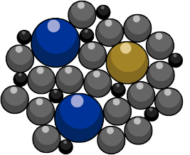
When another element, usually but not always another metal, is mixed with the original structure, the differently sized atoms break up the regular pattern of the pure metal atoms. This makes it harder for the layers of atoms to slide over each other. Steel is an alloy of iron and the non-metal carbon. Steel is much stronger and much less malleable than pure iron.

Key Knowledge: complete look, cover, write, check
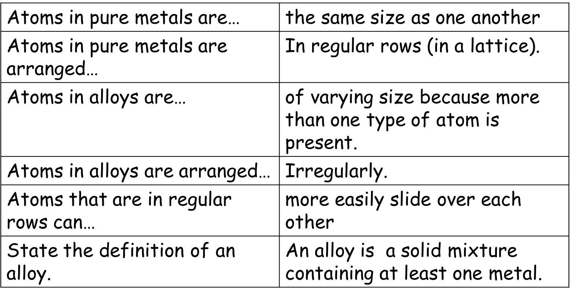
Recall Quiz: Complete each of the following sentences
- Sketch the atomic arrangement in a pure metal.
- Sketch the atomic arrangement in an alloy.
- Do atoms slide over each other more easily in metals or alloys?
- What determines whether the atoms are in regular rows or not?
Application Task I do
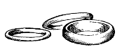
Jewellery made from pure gold is very soft. Gold jewellery is usually made from alloys, in which gold is mixed with other metals. Different alloys have different colours. The most common form of gold has a yellow colour, whereas white gold looks more like silver and rose gold has a rose pink appearance. The purity of the gold is measured in carats or by the fineness. Pure gold is 24 carats and has a fineness of 1000. The table shows some different alloys of gold used to make jewellery.
Purity of gold | Colour | Fineness | % gold | % silver | % copper | % zinc | % palladium
24 carat | yellow | 1000 | 100
22 carat | yellow | 917 | 91.7 | 5.5 | 2.8
18 carat | yellow | 750 | 75 | 16 | 9
18 carat | rose | 750 | 75 | 4 | 21
18 carat | white | 750 | 75 | 4 | 4 |  | 17
9 carat | yellow | 375 | 37.5 | 10 | 45 | 7.5
9 carat | white | 375 | 37.5 | 62.5
- What is an alloy?
- Why, is gold jewellery usually made out of gold alloys and not pure gold?
- Explain the link between the carat of gold and the percentage of gold in it.
- How do you think the price of 9-carat gold compares to 18-carat gold. Explain your answer.
- Use the data in the table to explain why 18-carat gold can have different colours.
- Describe the arrangement of atoms in pure metals.
- Describe the arrangement of atoms in an alloy.

