Lesson 5
02 June 2020
Ceramics

Read the information below, then answer the questions that follow.

Ceramics are non-metallic solids with high melting points and are used extensively to make useful materials that we use in everyday life. They are good conductors of heat and electricity, but are very brittle (snap easily, not flexible). We will be looking at three types of ceramics today: soda-lime glass, borosilicate glass, and clay. Soda-Lime glass is a type of ceramic because it is a non-metallic solid, and made without carbon. It is generally transparent, can be moulded when hot and can be brittle when thin. It is made from heating sand, limestone and sodium carbonate.
Borosilicate glass is made from sand and boron trioxide and has a higher melting point than soda-lime glass.
Clay is a soft, opaque material when it is dug out of the ground so it can be moulded by shaping the wet clay into different shapes. When it’s heated in a furnace at high temperatures, it hardens to make pottery or bricks.
Copy out the questions below and write your answers in full sentences.
Checkpoint questions:
- What 3 substances are heated to make soda-lime glass?
- What two substances are heated to make borosilicate glass?
- Define opaque. Which of the three ceramics is opaque?
Copy the key knowledge table into your exercise books.
Key knowledge- Do your look, cover, write check by learning the answers to the questions below.
Define ceramics. | Non-metallic solids with high melting points.
State two properties of ceramics. | Good conductors of heat and electricity, very brittle.
Explain how soda-lime glass is made. | By heating sand, limestone and sodium carbonate.
Explain how borosilicate glass is made. | By heating sand and boron trioxide. It has a higher melting point than soda-lime glass.
Describe clay. | Clay is a soft, opaque material, which is dug out of the ground.
Explain how clay ceramics are made. | By digging up and shaping wet clay, before heating it, which hardens it.
Complete the questions below in your exercise book.
Recall Quiz:
- We define ceramics as…
- One useful property of ceramics is that they are…
- However, they also tend to be very _____ (break easily).
- Soda-lime glass is made by heating ____, ____ and ____ together.

The Application task questions are based on the table below.
Application Task – I do

Explain why a manufacturer would be far more likely to make windows from soda-lime glass than clay. Use data from the table of properties in your answer. (1)
Answer: Soda-lime glass is transparent (see-through), while clay is opaque.

Application Task - We do
Write your answers to the questions in completed sentences in your exercise book.

Often, clay mugs will be covered in a layer of waterproof glaze before being used to carry liquids. Suggest why this might be.
Use data from the table of properties in your answer. (1)
Clay mugs must be covered in a waterproof glaze before carrying liquids ………………

Application Task – You do
Write your answers to the questions in completed sentences in your exercise book.

- Name the safety risk linked to handling and using ceramics. State one injury you might suffer.
- Suggest why borosilicate glass is often used to make boiling tubes in a science lab, rather than soda-lime glass.
Lesson 6
02 June 2020
Polymers

Read the information below to gain an understanding of polymers.

A monomer is a small molecule with a double bond (C=C). A polymer is a large chain of monomers joined together to form a very large molecule.
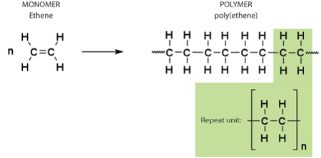
The properties of polymers depend on what monomers they are made from and the conditions under which they are made. For example: low density (poly)ethane (LDPE), a type of polymer, is made at a high temperature and pressure whereas High density (poly)ethane (HDPE) is made at low temperature and pressure. LDPE is used for bags and cling film as it is soft and flexible. HDPE is used for buckets and plastic bottles as it hard and rigid.
Copy the key knowledge table into your exercise books.
Key knowledge- Do your look, cover, write check by learning the answers to the questions below.
Define monomer. | Small molecule with a double bond (C=C).
Define polymer. | Lots of monomers joined together to form a very large molecule.
What do the properties of polymers depend on? | The type of monomer the polymer is made from and the conditions under which they are made.
What conditions are used for making low density (poly)ethane (LDPE). | High temperature and pressure.
What is LDPE used for? | Bags and cling films due to it being soft and flexible.
What conditions are used for making high density (poly)ethane (HDPE). | Low temperature and pressure.
What is HDPE used for? | Buckets and plastic bottles due to it being hard and rigid.

Complete each of the following sentences in your exercise books.
Recall Quiz:
- LDPE stands for…
- A monomer is…
- A polymer, on the other hand, is…
- The properties of HDPE are that it is ___ and ___.
- The properties of a polymer depend on…

Application Task – ‘I do’
Suggest which type of polymer you would use to make a bottle to hold chemicals. Justify your answer. (2)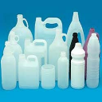
I would use HDPE to make a chemicals bottle because HDPE is hard and rigid, and so will be able to support the chemical and would not be at risk of breaking and spilling the contents.
Application Task – ‘We do’ Copy and complete the question in your exercise book.
Suggest which type of polymer you would use to make pieces of pliable packaging foam. Justify your answer. (2)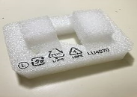
I would use _______ to make a pieces of pliable packaging foam because…..
Application Task – ‘You do’ Copy and complete the question in your exercise book.
Suggest which type of polymer you would use to make freezer bags. Justify your answer. (2) 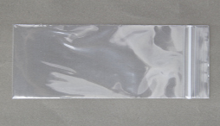
I would use ______ to make freezer bags because…

Independent Task- Complete the sentences in your exercise book
State which types of plastic would be used to make a) Juice cartons and b) water mains pipes. Justify your answer and compare the conditions required to produce each type of plastic. (6)
I would use ______ to make juice cartons because… This type of plastic is made at a ____ temperature and pressure.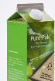
On the other hand, I would use ______ to make water mains pipes because…
This type of plastic is made at ____ temperature and pressure.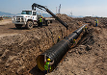

Plenary- Write your answers in complete sentences
- What is a polymer?
- What is a monomer
- State two things that could affect a polymer's properties.
- Give a difference in the structure of LDPE and HDPE.

