Changing states of matter
Do Now:
- What are the three states of matter
- What is the state of matter of an ice cube?
- What state of matter is the water that comes out of a tap?
- What state of matter is steam that comes out of a kettle?
- What temperature is the boiling point of water?

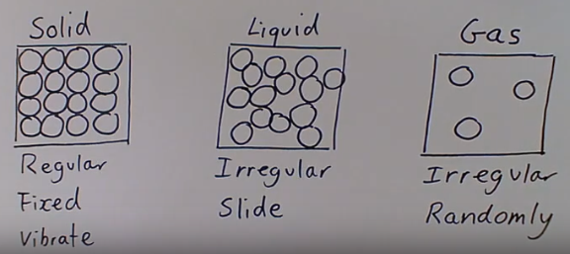 | Matter is anything that has mass and volume so basically any physical object. Matter can be in one of three states.  Take gold for example. Gold is matter. At room temperature it is a solid, all the gold particles are close together in a fixed positions in a regular arrangement. The particles don’t have much kinetic energy so they can only vibrate.  If you give the particles more energy by heating it up the particles move to an irregular arrangement because they can slide around each other. The solid gold would melt and you’d have liquid gold.  If you kept heating it up the gold would eventually vaporise becoming a gas.
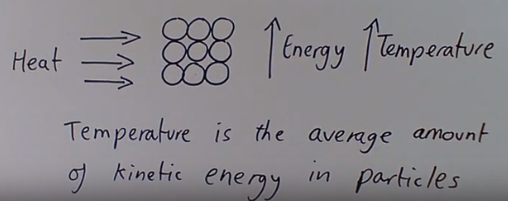 | When you heat matter, each particle gains kinetic energy. This increases the temperature of the substance.  For example if you put a bar of gold in an oven, each gold particle would gain kinetic energy. So the temperature of the gold bar would increase, because temperature is the average amount of kinetic energy in the particles.  So the more energy particles have the hotter the object is.
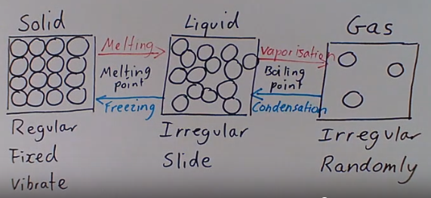 | By adding heat or removing heat (making it colder) you can change the state of an object.  If you heat solid gold to its melting point it will melt becoming a liquid. If you continue to heat it to its boiling point the gold will vaporise becoming a gas.  You could then allow the gold to cool down and condensation would occur turning back to a liquid when the temperature drops below the boiling point.  If you continue to cool the liquid gold below the melting point it will freeze becoming a solid.
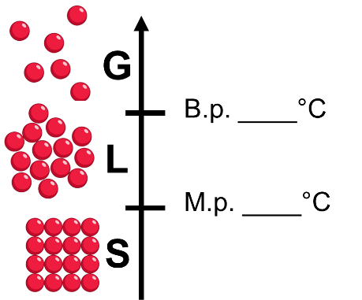  100  0 | We can picture what state of matter a substance will be at any temperature if we know its melting point (m.p.) and its boiling point (B.p.).  For example in the picture to the left, lets look at water.  If we want to know the state water will be in at 24°C, we look at the number line. We can see 24 is above 0 but below 100 so it will be a liquid.  How about at 120°C, well, 120 is above 0 and above 100 so it will be a gas.
Define matter. | Anything that has mass and volume.
Describe the particles in a solid. | In a regular, fixed position, but vibrating.
Describe the particles in a liquid. | Very close together, but able to slide past each other.
Describe the particles in a gas. | Far apart, and moving in random directions.
Define melting point. | The temperature at which a substance changes from solid to liquid.
Define boiling point. | The temperature at which a substance changes from liquid to gas.
What effect does an increase in temperature have on particles? | An increase in temperature causes the particles in a substance to move faster with greater kinetic energy.
Key Knowledge
Complete your look, cover, write, check

Recall quiz
- The three states of matter are…
- The arrangement of particles in a solid is…
- The arrangement of particles in a liquid is…
- In a gas the particles are……
- The boiling point of a substance is...
- As a substance is heated, the particles…
- Melting is…
- Condensing is…

Application Task – I Do
- In the image at right, what is the state of matter?
The state of matter is liquid.

- How can you tell?
The particles have an irregular arrangement, are free to change positions, but are still very close together.

Application Task – We Do  In the image at right, what is the state of matter?  The state of matter is _________  How can you tell?  The particles are ___________ in a ________ position, and are very _________ to each other. | 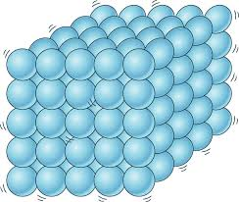
Application Task – You Do  In the image at right, what is the state of matter?  The state of matter is ________.  How can you tell?  The particles are ___________ and moving in ________ directions. | 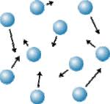

Atoms and Elements
Do Now:
- In which state of matter are the particles in a regular arrangement?
- In which state of matter do the particles move around quickly and in random directions?
- In what state of matter are the particles able to slide over each other?
- What is name for the change of state that happens when a liquid, like water, turns to a gas?
- The melting point of gold is 1064°C and the boiling point is 2970°C what state of matter will gold be at 560°C?

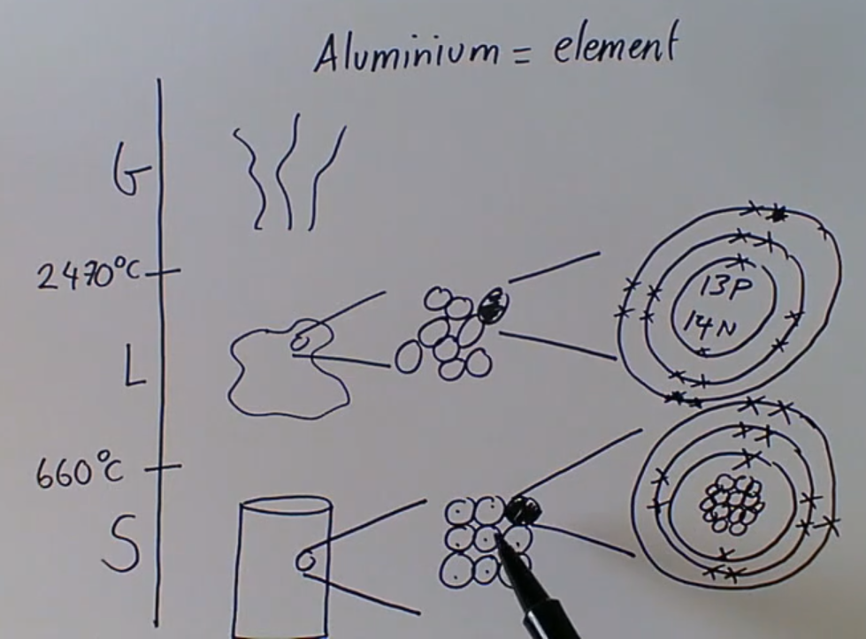 | Last lesson we looked at matter. We saw how if you heat a solid up it will melt to a liquid, and if you continue to heat it beyond the boiling point it will vaporise to a gas.  It is really important to know that the particles don’t change during changes of state. The particles just gain energy and move further apart.  If we look at a tin, like a tin of beans, the tin is made of aluminium. When it is solid the smallest particle that makes up the tin is an aluminium atom.  If we melt the can the aluminium atom is still exactly the same.  The smallest part of a chemical element that exists is an atom.  Substances that are made of only 1 type of atom are called elements.
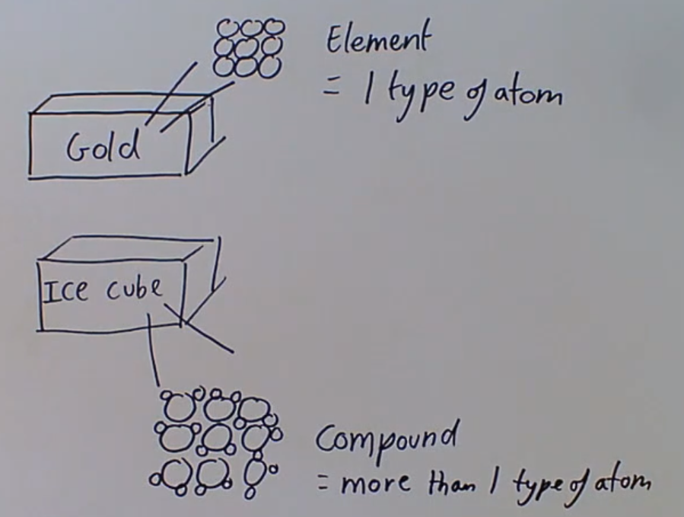 | Things we find on the periodic table like, carbon, oxygen, iron, copper, gold, chlorine etc are elements. They are made of only 1 type of atom.  Whereas many other things such as the water that makes up an ice cube is made up more than 1 type of atom chemically bonded together. Like water is made up of hydrogen and oxygen (H₂O) So we say these are compounds.
 |  | We can represent elements and compounds using particle diagrams. Here we can see examples of elements with only 1 type of atom and compounds where there are more than 1 type of atom.
Define ‘atom’ | The smallest part of a chemical element that exists
Define ‘element.’ | An element is a substance composed of only one type of atom.
During a change of state (such as melting or vaporisation) what happens to the atoms of a substance? | The atoms don’t change. The arrangement of the atoms changes.
How are the elements organised? | In the periodic table.
How do we represent elements? | Using their chemical symbol e.g. O for oxygen and Na for sodium.
Key Knowledge
Complete your look, cover, write, check

Recall quiz
- We define an element as a substance which is…
- We can represent elements with a _____ (e.g. O is the symbol used to represent __________).
- Define atom
- What happens to the atoms in aluminium when it melts?

Write whether 1 – 12 are elements or compounds:

Application task – I do:
What happens to the atoms in iron when it is melted?

When iron is melted the atoms do not change. They are still iron atoms.
However, the arrangement of the atoms does change.
Because the atoms gain kinetic energy and so move further apart.
The forces holding the atoms together weaken and the substance loses its regular arrangement becoming a liquid.
Application task – We do:
What happens to the atoms in magnesium when it is melted?
When….. is melted the atoms …... They are still magnesium atoms.
However, the ….. does change.
Because the atoms gain ……. and so ……..
The forces holding the atoms together ……. and the substance loses its …….. becoming a …….

Application task – You do:
What happens to the atoms in copper when it is melted?
When copper is melted the atoms …...
However, the ….. does change.
Because the atoms gain …….
The forces holding the atoms together ……. and the substance loses its …….. becoming a …….

Compounds and formulae
Do Now:
- Is O₂ an element or a compound?
- What is an element?
- What is an atom?
- What is the difference between an element and a compound?
- The melting point of substance X is -50°C and the boiling point is -20°C what state of matter will substance X be at -24°C?

Last lesson we looked at atoms and elements. We saw that an element is a substance made of only 1 type of atom and a compound is substance made up of more than 1 type of atom chemically bonded together.

Molecules are any substance where two or more atoms are bonded together.
If the atoms are the same type it is an element.
If the atoms are different types it is a compound.
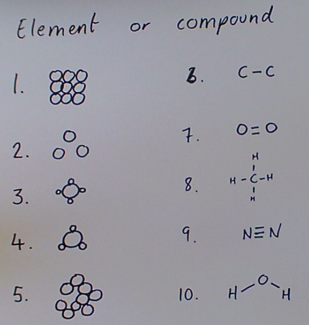 | As we saw last lesson we can represent molecules using circles to represent particles. We can also use the chemical symbol from the periodic table.  Number 1 is an element because there is only 1 type of atom (the black circle). Whereas, number 3 is a compound because there are 2 types of atom (2 different sized black circles).  Try and complete 1 – 10.
When we right chemical formulae, we use the chemical symbol from the periodic table to write the element (type of atom), like O for oxygen or He for helium.
Then we use a subscript number to show how many atoms of that element there are.
For example the bottom example.
Define ‘molecule.’ | Two or more atoms chemically joined together.
Define ‘compound.’ | Two or more different elements chemically joined together.
What does a chemical formula tell you? | The names of the elements in a molecule, and the number of atoms of each element.
What is a pure substance? | A pure substance consists only of one element or one compound.
What is a subscript? | A small number written to the right of a chemical symbol which states how many atoms of that element are present. For example: H₂O = 2 hydrogen atoms, 1 oxygen atom.
Key Knowledge
Complete your look, cover, write, check

Recall quiz
- What is a molecule?
- What is a compound?
- Is H₂O a compound or element?
- How many hydrogen atoms are there in H₂O?
- How many oxygen atoms are there in H₂O?

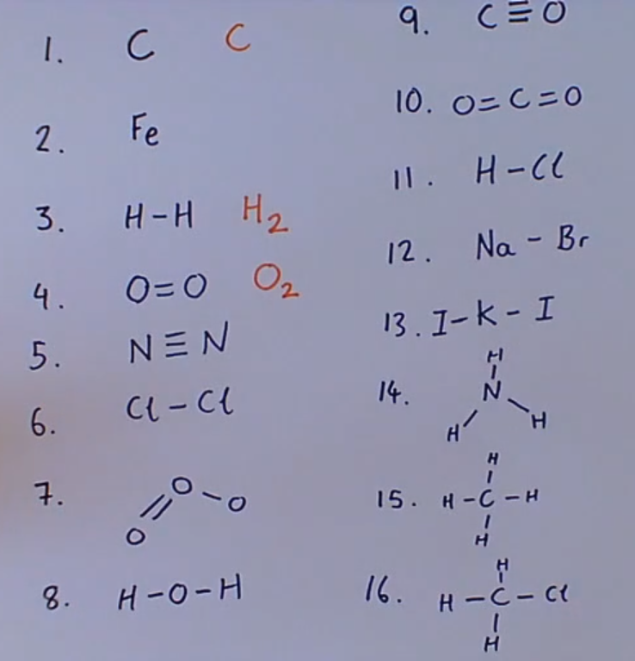 | Write the chemical formulae for 1 – 16:

Application task I do:  Explain whether this molecule a compound or element  This molecule is a compound.  I know this because it is made of two different types of atom, carbon and hydrogen.  Its chemical formula is C₅H₁₂ | 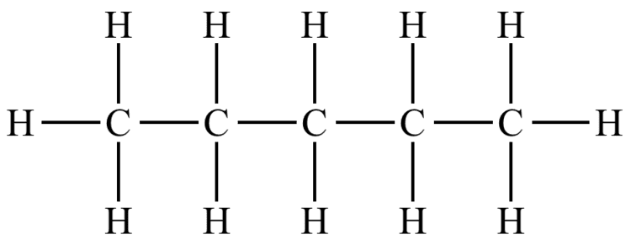
Application task – We do:  Explain whether this molecule a compound or element  This molecule is…..  I know this because …. | 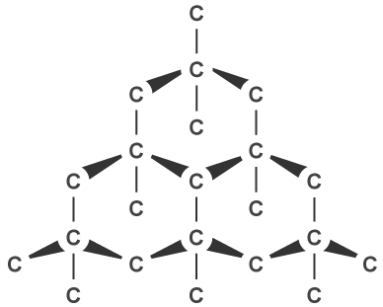
Application task – You do:
Explain whether this molecule a compound or element
This molecule is…..
I know this because ….
Its chemical formula is…

