17/06/2020
Changing Atomic Theories
Do Now: Answer the following questions
- If the ink in chromatography was waterproof, which solvent would you use? Why?
- Name the physical process that separates two substances with different boiling points.
- Name the compound CH₄
- Name the process of a solid turning into a gas.
- Define the term dependent variable.
- Challenge: Explain why crystallisation allows us to separate salt and water.
Key information: Read the information below and draw each diagram into your books
In the early 1800s, scientists first began to suspect that the elements were composed of tiny particles. The first scientist to propose such a model was John Dalton. His model was simple: atoms are solid spheres with a mass unique to the element they belong to.
This model of the atom wouldn’t change for around a hundred years. Then, in the early 1900s, a scientist named J.J. Thomson discovered the electron. He believed that the negatively-charged electrons were embedded in a sphere of positive charge, like plums in a plum pudding, creating the ‘plum pudding model’.
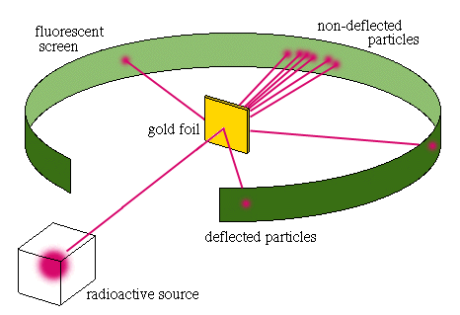
A few years later, Ernest Rutherford designed an experiment to test this model. First, he needed a material which was extremely thin. He chose gold, as gold can be rolled into foil only a few atoms thick. Next, he set up a piece of equipment that would fire alpha particles at the gold foil. Alpha particles are positively charged. If the plum pudding model was accurate, all the alpha particles should have passed directly through the gold foil. This was not what happened. Instead, while most of the particles did pass straight through, a few were deflected and changed paths, and some even bounced back.
- Most particles passed straight through, therefore most of the atom is empty space
- Some particles were deflected slightly, therefore there is some positive mass on the centre (nucleus)
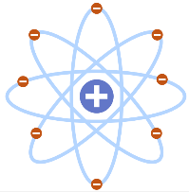
- A small number of particles deflected completely, therefore the positive centre is dense
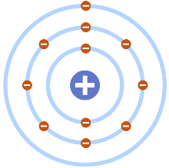
These findings prompted Rutherford therefore proposed the nuclear model of the atom.
This model would be developed by a scientist named Niels Bohr, who showed that the electrons actually orbit in discrete energy levels. Later experiments led to the idea that the positive charge of any nucleus could be subdivided into a whole number of smaller particles, each particle having the same amount of positive charge. The name proton was given to these particles.
Still later, the experimental work of James Chadwick provided the evidence to show the existence of neutrons within the nucleus. This was about 20 years after the nucleus became an accepted scientific idea.
Key Knowledge: complete look, cover, write, check
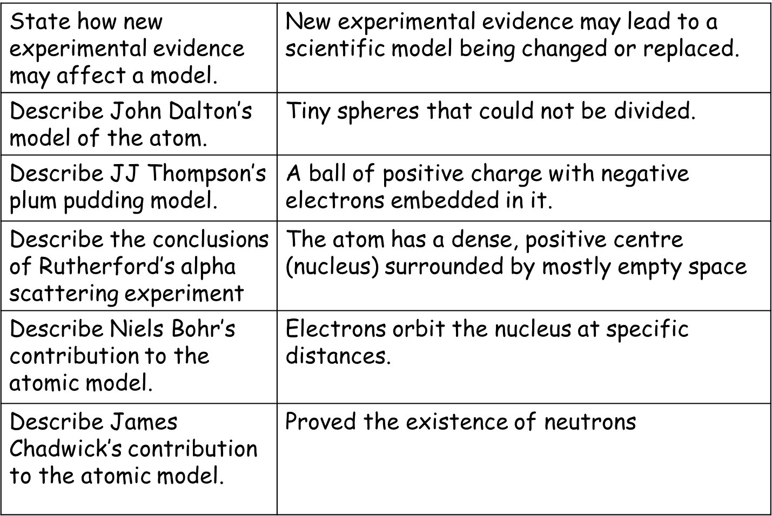
Recall Quiz: Complete each of the following sentences
- The plum pudding model describes the atom as…
- The alpha scattering experiment showed that while most of atom is empty space, the mass is concentrated in the ___________, which has a _______________ ________.
- Niels Bohr developed the nuclear model by showing that…
- The scientist responsible for proving the existence of neutrons was…
- The current model of the atom contains three particles: _________, ___________, and _____________.
Application Task I do and You do
- Suggest why models, such as that of the atom, are useful in science. A model is used to help scientists visualise things they cannot see, making them simpler and easier to explain.
- Why have ideas about atoms changed over time?
- We now know that atoms contain three types of subatomic particle. Suggest why this would have surprised earlier scientists who first studied atoms.
- Name the three sub-atomic particles and outline where each is found within an atom.
- Between 1897 and 1906, Thomson carried out a number of experiments and discovered electrons. Thomson used his discovery to devise his plum pudding model of the atom. Outline the main ideas of the plum pudding model.
- Which, if any, of the original ideas about the atom as a solid sphere do we no longer believe to be correct? Explain your answer.
- Describe the results of the alpha scattering experiments, and state what this led scientists to conclude about the nature of the atom.
17/06/2020
Protons, Neutrons and Electrons
Do Now: Answer the following questions
- Where on a chromatogram do you draw the solvent front?
- Name the scientist responsible for discovering the neutron.
- Describe the plum pudding model.
- Name the particles fired at gold foil in Rutherford’s experiment.
- Calculate the R_{f} value of a substance which moves 14 mm, if the solvent moved 79 mm.
- Challenge: Explain why we use models of the atom, rather than actual images.
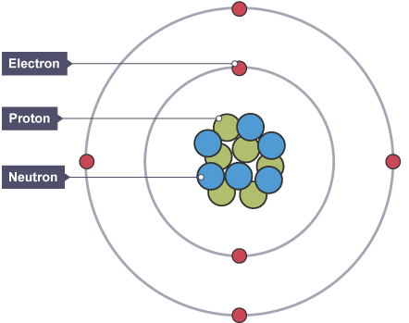
Key information: Read the information below and draw each diagram into your books
In the nucleus (centre) of an atom, we have protons and neutrons. Around the outside of the atom, we find the electrons.
The mass of these subatomic particles is very small, so it doesn’t make sense to describe their mass in units of kilograms. Instead, we will say that both protons and neutrons have a relative mass of 1, while electrons have almost no mass. Two of these particles also have an electric charge. Protons have a positive charge of +1, and electrons have a negative charge of -1. Neutrons are neutral, and have no charge.
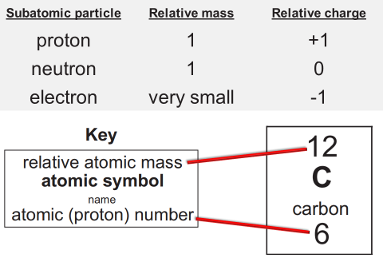
We can use the periodic table to figure out how many protons, neutrons, and electrons there are in an atom of a given element. Each box on the periodic table is called a cell. The larger number in the cell is the atomic mass. This is the number of protons and neutrons combined. The bottom number is the atomic number. This gives the number of protons in the atom.
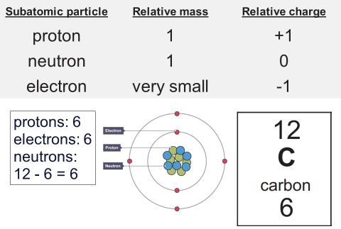
To work out the number of protons, you need to look at the atomic number. In this case, carbon has six protons. Atoms have an overall neutral charge, because the number of positive protons and negative electrons is the same. So carbon also has six electrons. The number of neutrons in an atom may be different to the number of protons and electrons. The mass number is the number of protons and neutrons together. So to work out the number of neutrons, simply subtract the number of protons (the atomic number) from the mass number. In this case, 12-6 tells you that carbon also has 6 neutrons.
It’s important to remember that atoms are incredibly small. While some atoms are bigger than others, the radius of an atom is about 0.1 nm (1 × 10⁻¹⁰ m). That’s one ten billionth of a metre across. The radius of the nucleus is even smaller than that: at (1 × 10⁻¹⁴ m) it is less than 1/10,000 of the radius of an atom.

Key Knowledge: complete look, cover, write, check
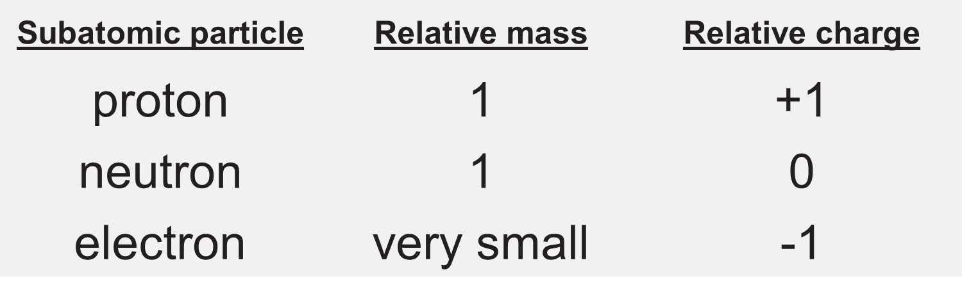
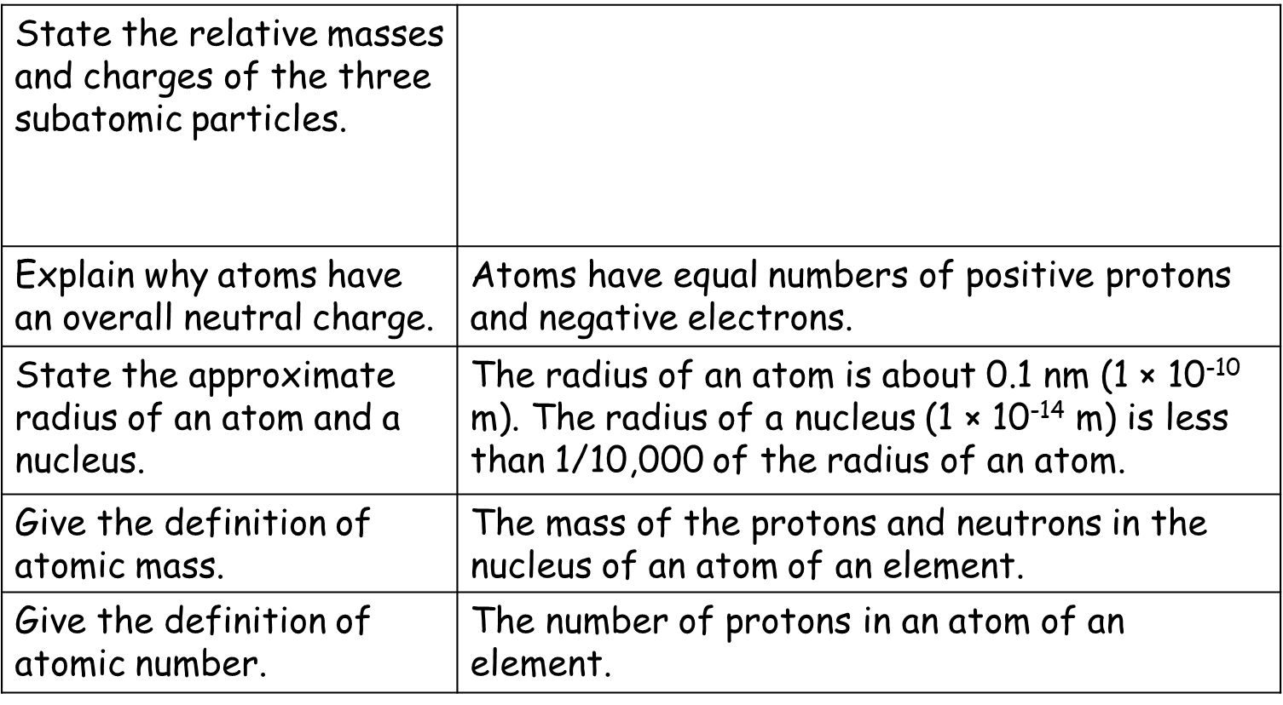
Recall Quiz: Complete each of the following sentences
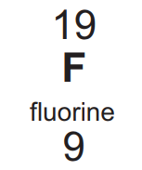
- Protons and neutrons are found in the __________ of an atom.
- The charge of an electron is ________.
- The radius of an atom is around ___________.
- The atomic mass is the number of ____________ + ______________.
- The atomic number of fluorine is _________. Fluorine’s atomic mass is ________.
Application Task I do
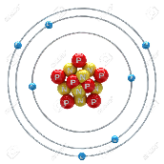
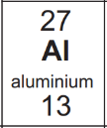
- How many protons, neutrons, and electrons are in an atom of aluminium? Protons: 13, Electrons: 13, Neutrons: 14
- The image at right represents an atom of what element? Nitrogen
Application Task You do
- Write the following terms in order from smallest to largest: neutron, molecule, electron, nucleus, atom
- State the mass, charge, and location of the following: (a) proton (b) neutron (c) electron
- Use the periodic table to write symbols for atoms of the following elements
  - 19 protons, 20 neutrons, 19 electrons
  - 8 protons, 8 neutrons, 8 electrons
  - 1 proton, 0 neutrons, 1 electron
  - 80 electrons
  - 53 protons
- Give the names of the following elements:
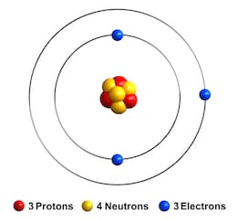
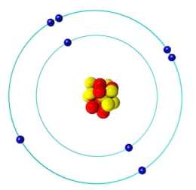
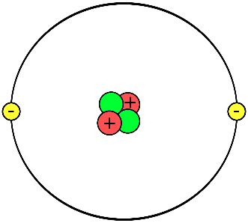
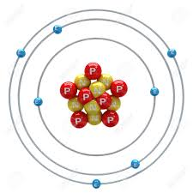
a b c d

