Isotopes and Relative Atomic Mass
Do Now: Answer the following questions
- The line at the bottom of a chromatogram is drawn in ______ because…
- Explain the connection between the group number and electron structure.
- Name the state of matter which has no definite shape or volume (solid/liquid/gas).
- Explain why, in paper chromatography, some substances move further up the paper.
- Calculate the mean of the following lengths to two s.f.: 5 cm, 60 mm, 7 cm, 50 mm.
- Challenge: Explain why scientific ideas change over time
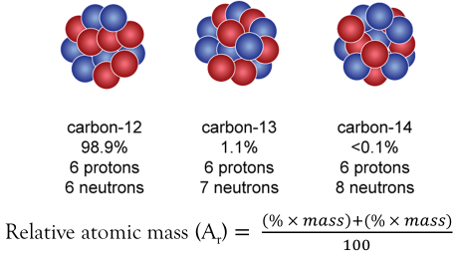
Key information: Read the information below and draw each diagram into your books
Atoms of the same element can be different to each other in a few ways. What they must have in common is the number of protons. All atoms of the same element have the same number of protons.
The number of neutrons in an atom, however, can vary. An isotope is a different ‘version’ of an element with a certain number of neutrons.
Adding or taking away neutrons doesn’t change what the element is. It does, however, change the mass number of that atom. For example, the element carbon exists as three naturally occurring isotopes, each with a different mass. We can sometimes write isotope names the way you see here, with the mass written after the name of the element.
You can see that carbon-12 is by far the most abundant isotope of carbon, with an abundance of 98.9%. Carbon-13 and carbon-14 are much less common isotopes. The mass number can tell us the number of protons and neutrons in the nucleus of a single isotope. This is what you mostly see on your periodic tables. But what if I want to know the average mass of all the different isotopes which naturally occur? This is called the relative atomic mass.
To calculate relative atomic mass use: Relative atomic mass (Ar) = (% x mass) + (% x mass)/100
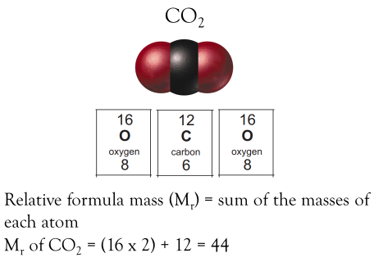
We can also calculate the mass of a molecule if we know the mass of each individual atom. We’ll use the mass numbers from the periodic table for this to keep things easy. The mass of a molecule is all the relative formula mass, or M_{r}. M_{r} is the sum of all the atomic masses in a molecule.

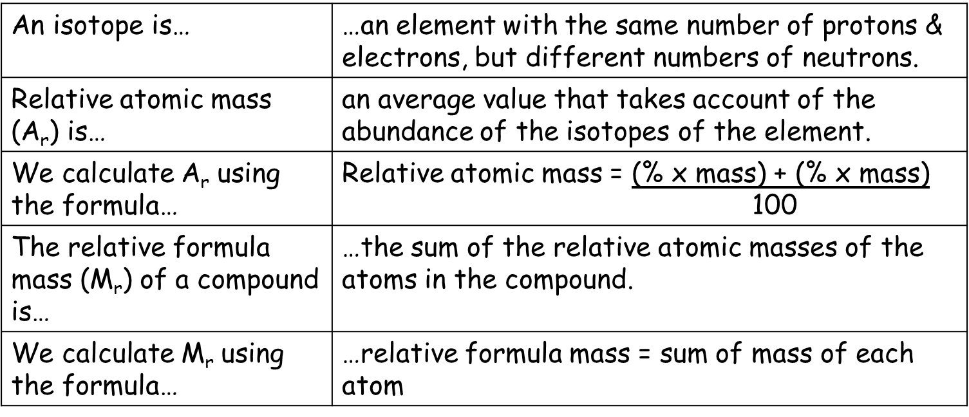
Key Knowledge: complete look, cover, write, check

Recall Quiz: Complete each of the following sentences
- What is the difference between the isotopes helium – 4, helium – 3, and helium – 5?
- What is the mass number of an atom?
- What is the A_{r} of an element?
- What is the formula for A_{r}?
- What is relative formula mass (M_{r}), and how is it calculated?
Application Task I do
- Calculate the relative formula mass (M_{r}) for the following compounds:
a.CO₂
(a) Mass numbers: C = 12, O = 16. Working out: (12) + (16 x 2) = 44
Application Task You do
- Calculate the relative formula mass (M_{r}) of the following compounds:
  - LiF b. C₂H₄ c. NaHCO₃ d. KNO₃ e. H₂SO₄ f. Zn(CN)₂ g. Al₂O₃
- NH₄NO₃ i. C₄H₁₀ j. Mo(CO)₆
Application Task I do
- Calculate the relative atomic mass (A_{r}) of boron if the relative abundance of isotopes is as follows. Give your answer to two decimal places. ¹⁰B = 19.90% ¹¹B = 80.10%
E: $Ar=\frac{\left(\% × mass\right)+(\% × mass)}{100}$
Application Task You do
Calculate the relative atomic mass (Ar) of the following elements to 2 d.p.
- Nitrogen: ¹⁴N = 99.63% & ¹⁵N = 0.37%
- Magnesium: ²⁴Mg = 78.99% & ²⁵Mg = 10.00% & ²⁶Mg = 11.01%
- Silicon: ²⁸Si = 92.23% & ²⁹Si = 4.68% & ³⁰Si = 3.09%
V: Ar? % = 19.90% Mass = 10 % = 80.10 Mass = 11
E: $Ar=\frac{\left(19.90 ×10\right)+(80.10 ×11)}{100}$
R: Don’t need to
R: 10.801
Y: 10.80

Development of The Periodic Table
Do Now: Answer the following questions
- Name the separation technique used to separate substances with different boiling points.
- State the definition of an element.
- Explain how to calculate relative formula mass.
- Explain how to increase the strength of an electromagnet.
- The speed of light is 300,000,000 m/s. Give this number in standard form.
- Challenge: Compare the plum pudding model with the atomic model of the atom.
Key information: Read the information below
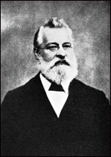
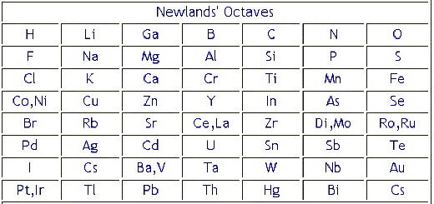
Before the discovery of protons, neutrons and electrons, scientists attempted to classify the elements by arranging them in order of their atomic weights.
The early periodic tables were incomplete, because many elements had not been discovered, and some elements were placed in inappropriate groups if the strict order of atomic weights was followed. An example of this approach was John Newlands’ Law of Octaves.
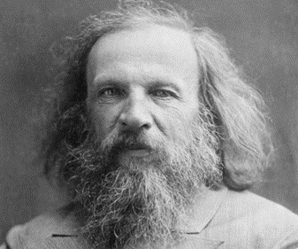
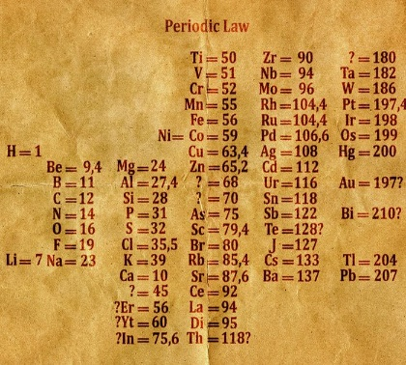
Dmitri Mendeleev was a Russian chemist. He overcame some of the problems by leaving gaps for elements that he thought had not been discovered and in some places changed the order based on atomic weights.
Elements with properties predicted by Mendeleev were discovered and filled the gaps. Knowledge of isotopes made it possible to explain why the order based on atomic weights was not always correct. The modern periodic table is not arranged in order of atomic weight, but in order of increasing atomic number.
Key Knowledge: complete look, cover, write, check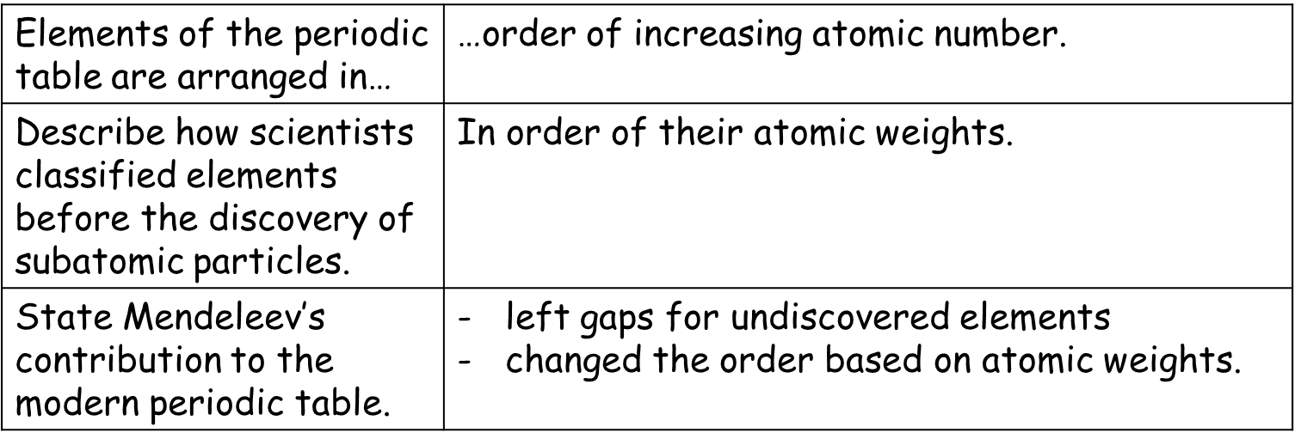
Recall Quiz: Complete each of the following sentences
- Who is credited with developing the modern periodic table?
- What was this scientist’s unique contribution?
- How, were earlier collections of the elements typically organised?
- How is the modern periodic table organised?
Application Task: I do
Suggest two reasons why other chemists did not accept Newlands’ ideas.
Chemists do not accept Newland’s ideas because there are no gaps for undiscovered elements or elements still being discovered. There are also some boxes that have 2 elements.
Application Task: You do
- In the 1860s scientists were trying to organise elements.
Figure 2 shows the table published by John Newlands in 1865. The elements are arranged in order of their atomic weights.
Figure 3 shows the periodic table published by Dmitri Mendeleev in 1869.
Mendeleev’s table became accepted by other scientists whereas Newlands’ table was not.
Evaluate Newlands’ and Mendeleev’s tables.
You should include: (1) a comparison of the tables (2) reasons why Mendeleev’s table was more acceptable. Use Figure 2 and Figure 3 and your own knowledge.

