Ions of Metals and Non-metals
Do Now: Answer the following questions
- State why Mendeleev left gaps in his periodic table.
- State the definition of an isotope.
- State the numbers of protons, neutrons and electrons present in an atom of magnesium.
- List the equipment you would need to obtain salt from a solution of salty water.
- Calculate 8 as a percentage of 92 (1 d.p.).
- Challenge: Explain why we don’t use any units for the mass of an atom.
Key information: Read the information below and draw each diagram into your books
We’re going to look at the first metal on the periodic table, lithium. Here is lithium’s electronic structure, which we’ve already learned how to draw. So far, we’ve taught you that atoms have equal numbers of protons and electrons. But atoms can gain or lose electrons and become ions.
The most stable arrangement of electrons for an atom is to have the outermost shell completely full. Atoms “want” to have a full outer shell. Atoms can achieve this by either losing their outermost electrons, exposing the full shell underneath, or gaining enough electrons to make a full outer shell. Let’s look at what lithium does.
Lithium only has one electron in its outer shell, so it is much easier to lose that one, than gain 7. When that electron is lost, there is now one more proton (3) than there are electrons (2). The overall charge of the particle is no longer neutral, this particle has an overall positive charge of 1+. It is no longer an atom, it is an ion. We show this by drawing brackets around the diagram, and writing the charge above and to the right. Beryllium has two electrons in its outer shell. It will lose those two electrons and form an ion with a 2+ charge. Metals always lose electrons and form positive ions.
What about non-metals?: Fluorine has seven electrons in its outer shell. Fluorine only needs to gain one electron, which we represent here with a dot. Fluorine now has one more electron than it has protons, and so has an overall charge of 1-. Oxygen has six electrons in its outer shell. Oxygen will gain two electrons to get to a full outer shell, to form an ion with a 2- charge. Non-metals gain electrons to make negative ions. When non-metals form ions, we change the ending of the element name to –ide. For example: oxygen becomes oxide.

Key Knowledge: complete look, cover, write, check
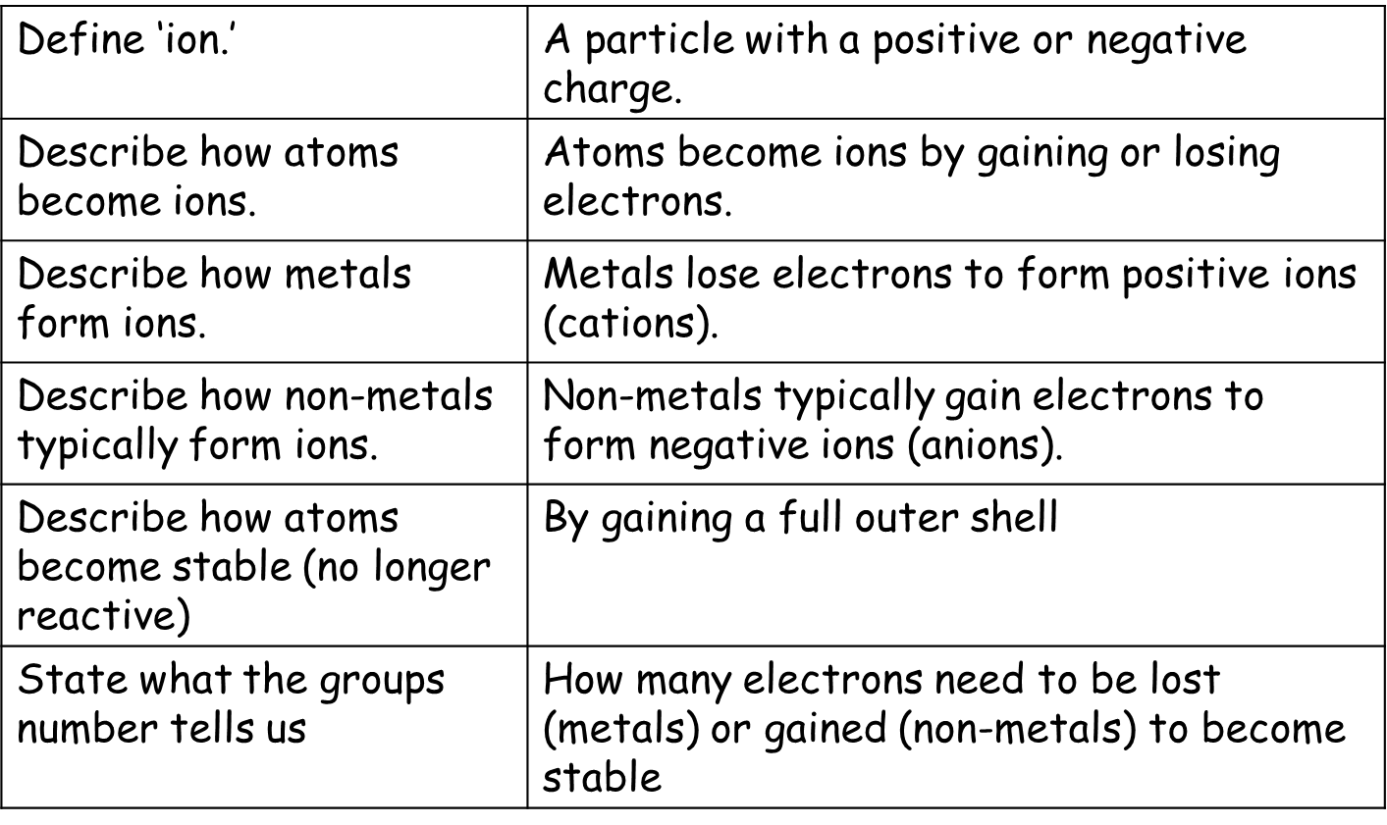
Recall Quiz: Complete each of the following sentences
- How are atoms different from ions?
- What type of ions do metals form?
- How do non-metals form ions?
- Do metals tend to gain or lose electrons?
Application Task I do
- Will sodium gain or lose electrons? Sodium will lose electrons
- How many electrons will sodium lose or gain? Sodium will lose one electron
- What is the charge of a sodium ion? 1+ or Na+
Application Task You do
- State the chemical symbol and charge of the following (ex. sodium = Na⁺, oxygen = O^{2–}):

  - potassium
  - rubidium
  - magnesium
  - calcium
  - boron
  - aluminium
  - nitride
  - phosphide
  - sulfide
  - bromide
  - iodide
- Given the following electronic configurations of atoms, what would the charges of their ions be?

  - Li: 2,1
  - Na: 2,8,1
  - K: 2,8,8,1
  - Be: 2,2
  - Mg: 2,8,2
  - Ca: 2,8,8,2
  - B: 2,3
  - Al: 2,8,3
  - N: 2,5
  - P: 2,8,5
  - O: 2,6
  - S: 2,8,6
  - F: 2,7
  - Cl: 2,8,7

- State the electron configuration for the following ions. Include brackets and charge. (ex. sodium = [2,8]⁺, chlorine = [2,8,8]–
  - Lithium e. Boron
  - Potassium f. Aluminium
  - Magnesium g. Nitride
  - Calcium h. Calcium

Uses of Metals
Do Now: Answer the following questions
- Define ‘ion’.
- State the charge of non-metal ions.
- State whether metals form positive or negative ions, and give the name of these ions.
- Name two potential errors that could be made when carrying out paper chromatography.
- Round this number to 2 significant figures: 3829
Key information: Read the information below
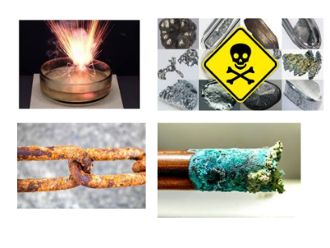
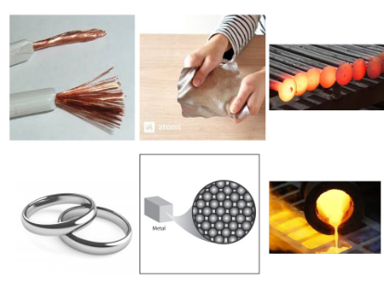
We have learned how to identify metals by their electronic structure. Remember that metals are found in the left hand side of the periodic table. Physical properties can be observed without the need for a chemical change (reaction) to occur. Metals tend to be: ductile (able to be stretched into wires), malleable (able to be rolled into thin sheets), electrically and thermally conductive, and lustrous (shiny). Metals also tend to be dense, compared to non-metals, and have high melting and boiling points.
Metals also have certain chemical properties. A chemical property of a metal can only be observed during a chemical change. Examples of chemical properties include reactivity, flammability, and toxicity. Many metals, for example, corrode when exposed to oxygen.
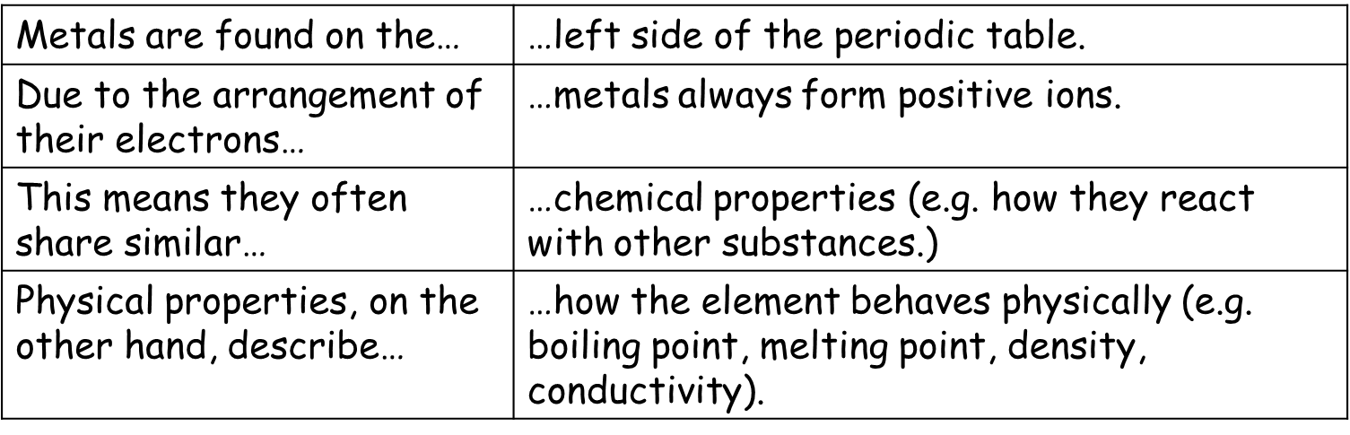
Key Knowledge: complete look, cover, write, check

Recall Quiz: Complete each of the following sentences
- The left side of the periodic table contains… while the right hand side is made up of…
- Metals always form positive ions, due to the fact they (gain/lose) electrons.
- The ways that different elements react with each other are described as their _____ properties.
- Two examples of metals’ physical properties are…
Application Task I do: Read the text about titanium and answer the three questions
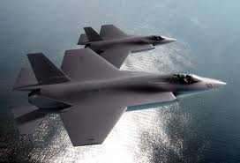
Most aeroplanes are made out of aluminium, but fighter jets go so fast that the wings would melt. Titanium, however, has a higher melting point and is still strong and light (although a little more dense than aluminium). Titanium is used for bike frames, tennis rackets and for putting metal inside humans (e.g. a hip replacement or metal plate). Titanium resists corrosion even better than aluminium or stainless steel. If it were not so expensive, we’d use it for everything that we make from steel now!
- Explain why titanium is a good metal to use inside the human body. Titanium is strong and light, and resists corrosion, so titanium inside the body will last a long time.
- Compare aluminium and titanium. Titanium is a little denser than aluminium, has a higher melting point, and resists corrosion better.
- Evaluate the use of titanium in fighter jets (give advantages and disadvantages). One advantage is that titanium has a high melting point, so it can resist the heat generated by a jet’s engines. Titanium also resists corrosion, and so will last longer after being exposed to rain and atmospheric oxygen. Titanium is strong, while remaining light, so less energy is needed to keep the jet in the air. One disadvantage is that titanium is expensive, and so jets with more titanium parts will cost more money.

Application Task You do: Read the text about aluminium and answer the three questions
Aluminium is strong and light. Aluminium resists corrosion; that’s why aluminium foil stays so shiny. It can be made into sheets. Aluminium is not a transition metal. It is not as strong as steel, but it is has a much lower density (so it is lighter). Steel would be too heavy to make planes because it would require too much energy to get off the ground. Aluminium is used to make all passenger aeroplanes. It melts at quite a low temperature though so it can’t be used to make fighter jets because it would melt.
- Explain why aluminium is good to use for kitchen foil.
- Compare aluminium and steel.
- Evaluate the use of aluminium in aeroplanes (give advantages and disadvantages).
Application Task You do: Read the text about copper and answer the three questions
Copper is useful because it is such a good conductor of heat and electricity. It is also not very reactive. It is soft, bendy and ductile (can be made into wires). Some uses include saucepans and electrical wires. It doesn’t react with water so doesn’t corrode like iron and steel. This means it can be used for water pipes and plumbing. It is quite expensive though, but some buildings use it on the roof.
- Describe three properties of copper.
- Explain why
- Copper is used in wires.
- Copper is used for water pipes.
- Evaluate the use of copper for a roof (give advantages and disadvantages).
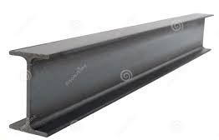
Application Task You do: Read the text about copper and answer the three questions
Iron is the most widely used metal in the world. It can be used to make steel. It can be made hard and tough so it is used for machinery, tools and bridges. It is also used for girders (which help to strengthen concrete in buildings). It can also be cut into sheets and shaped so is good to use for tins/cans and car bodies. The major drawback of using iron is that it rusts.
- Identify five uses of iron.
- Describe three properties of iron.
- Explain why iron would be bad to use for metal plates in the human body.

