Lesson 3 02 June 2020
Scientific Equipment

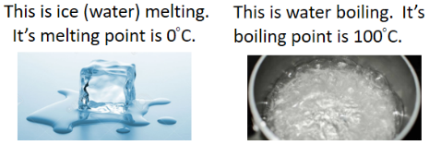
Read the information below, then answer the questions that follow.
The melting point of a substance is the point at which it changes from a solid to a liquid.
The boiling point of a substance is the point at which it changes from a liquid to a gas.
Temperature is a measure of the amount of kinetic energy that particles have.
As we heat a solid, the particles will absorb the energy and use it to move more – they gain kinetic energy. This means the temperature will increase.
When the particles reach their melting point, instead of absorbing more energy and moving more, the energy causes the forces of attraction between the particles to weaken and the arrangement of particles to change to an irregular arrangement. This will mean the substance will change from a solid to a liquid – i.e. melting. The energy is being used to weaken the forces of attraction (break the bonds) rather than being used by the particles to move more, so the temperature will stay constant.
Copy out the questions below and write your answers in full sentences.
Checkpoint questions:
- State the melting point of water.
- Define temperature.
- Explain why the temperature will stay constant when the particles reach melting point.
Copy the key knowledge table into your exercise books.
Key knowledge- Do your look, cover, write check by learning the answers to the questions below.
Name the temperature at which a solid turns into a liquid or a liquid turns into as solid | melting point
Name the temperature at which a liquid turns into a gas or a gas turns into a liquid | boiling point
Explain why the temperature does not change at the melting and boiling points | the thermal energy is being used to break the forces between the particles
State what the forces between particles in a solid do | hold the particles in a fixed position
State what the forces between particles in a liquid do | mean that almost all the particles are touching
Define “Latent Heat“ | The energy needed for a substance to change state

Complete the sentences below in your exercise book.
- The temperature at which a liquid turns into a gas or a gas turns into a liquid is the…
- At the melting and boiling points, the temperature does not change because…
- Forces between particles in a solid…
- Latent heat is…
- Latent means hidden, explain why this might be given to a substance changing state?
Complete the below application tasks in your exercise book.
Application Task – I Do
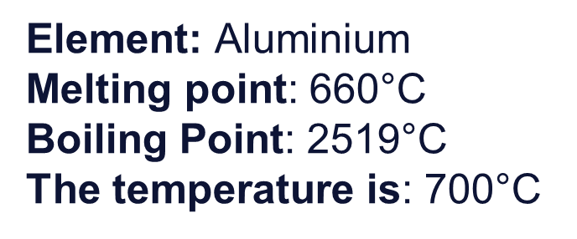
Aluminium will be a liquid at 700°C because this temperature is higher than its melting point so it will have melted and turned into a liquid, but lower than its boiling point, so it will not have evaporated and become a gas.
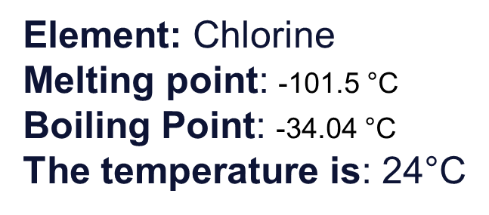
Chlorine will be a gas at 24°C because this temperature is higher than its melting point so it will have melted and turned into a liquid and higher than its boiling point so chlorine will have evaporated and become a gas.

Application Task – You Do
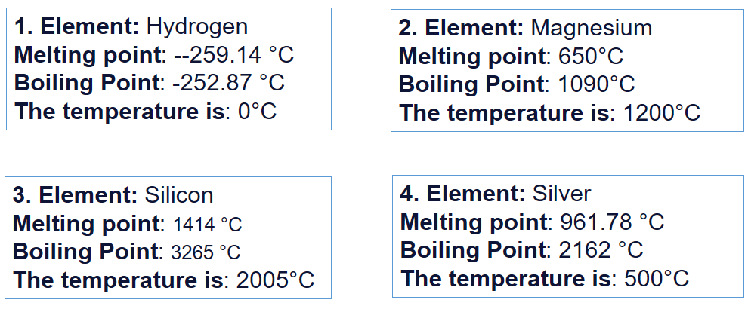
Complete the below application tasks in your exercise book using full sentences.
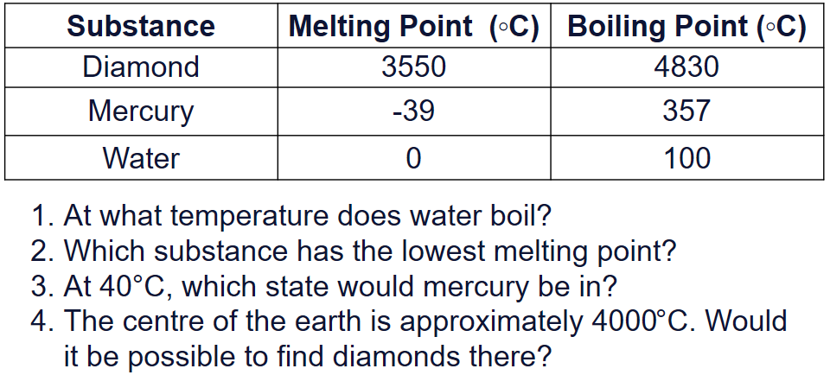
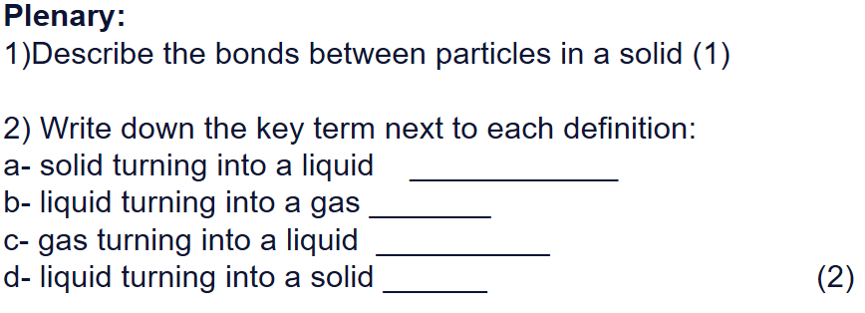

Lesson 4
02 June 2020
Melting and Boiling Points

Read the information below, then answer the questions that follow.
In science, it is important to be able to identify key scientific equipment from a picture. All students should be able to describe the role of each piece of scientific equipment and explain which piece of equipment is the best to use linking to accuracy and reliability.
A Bunsen burner is used to heat substances. When we draw scientific equipment we use a simple scientific diagram so it is clear which piece of equipment we are referring to.
This is a tripod, gauze, and a heat proof mat. We place the gauze on top of the tripod and then place the substance that we are heating on top of the gauze. Their job is to keep the object stable so it doesn’t spill. The gauze also stops the flame from directly touching the substance. The heat proof mat is designed to stop the tripod or Bunsen burner from burning the table when it gets hot.
We place chemicals when we want to carry out a reaction into a glass tube known as a test tube. For example, we might want to test to see if something is an acid or an alkali so we would measure out a certain volume of the substance and pour it into the test tube.
This is a boiling tube. This is a tube made from a special material that is heat proof. We use boiling tubes if we need to heat up small volumes or masses of substances during a reaction. For example, we might want to add some metal oxide to the boiling tube and hold it over the Bunsen flame to observe the changes. It is a bit bigger than a test tube.
A measuring cylinder is used to measure the volume of a liquid, they come in a range of different sizes and you need to pick the correct one for the volume of liquid you need.
A beaker is used to hold substances before you use them, we don’t use them to measure volumes of liquids.
We use a conical flask to mix chemicals.
Copy out the questions below and write your answers in full sentences.
Checkpoint questions:
- Why would you use a heat proof mat?
- Which material is a test tube made from?
- Explain the difference between a test tube and a boiling tube.
Copy the key knowledge table into your exercise books.
Key knowledge- Do your look, cover, write check by learning the answers to the questions below.
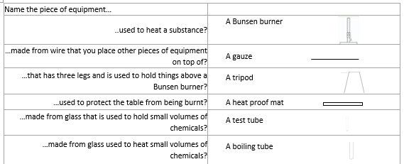
Complete the sentences below in your exercise book.
- A Bunsen burner is used for….
- A piece of equipment we used to keep us safe is…
- The piece of equipment we use to heat small quantities of liquid is…
- A conical flask is used for…
- A beaker is used for…
Complete the below application tasks in your exercise book.
Application Task – I Do
Name this piece of equipment, describe what it is used for and draw it’s symbol.

Challenge: what is it’s resolution?
Model answer:
This is a measuring cylinder. It is used for mixing liquids. It’s symbol is
It’s resolution is 50ml.

Application Task – You Do
Annie finds the piece of equipment on the right of the picture in the lab. Name it, describe what it is used for and draw it’s symbol.

Challenge: why might she choose to use the piece of equipment on the left instead?

Complete the below application tasks in your exercise book using full sentences.

